上海电力大学

数据库应用课程设计



**题　　目: 选题三 教务管理系统的设计与实现**

**学生姓名： 龚释冰**

**学 号： 20211576 班 级： 2021222**

**院　　系：　　 计算机科学与技术学院**

**专业班级： 软件工程专业2021222**

**2023年 6 月 20 日**

目录

一、需求分析 3

（1）问题描述 3

（2）系统功能描述 3

（3）安全性与完整性方面要求 4

二、概念结构设计 5

三、逻辑结构设计 9

**（**1）模式设计 9

（2）子模式设计 12

四、数据库的物理设计 18

五、数据库设计实现及运行 18

（1）数据库的创建 18

（2）数据表的创建 18

（3）视图的创建 21

（4）存储过程的定义实现 25

（5）触发器的定义实现 30

（6）自行设计各模块中所涉及的操作语句 34

（7）原子性事务显示定义：无 139

六、系统详细设计及实现 139

（1）系统功能模块说明 139

（2）每个模块的关键语句及关键技术说明 140

七、总结 216

八、源代码 216

一、需求分析

（1）问题描述

系统功能大致有：

教师端：授课列表查询，对应课程赋分。

学生端：信心查询，已选课列表；选课；查询成绩。

管理员端：对学院、专业、班级、教师、学生信息的维护；对教师授课情况的维护；对学生可选课程的维护；对教师学生信息的查询；添加教务管理人员账号。

连接方法：通过登陆界面区分不同用户，分别打开各自的界面（区分选项是id），根据权限大小分别对应不同的界面。

（2）系统功能描述

对自己所负责的功能模块，可画出所设计模块的操作流程；并分析所需要存储的数据信息。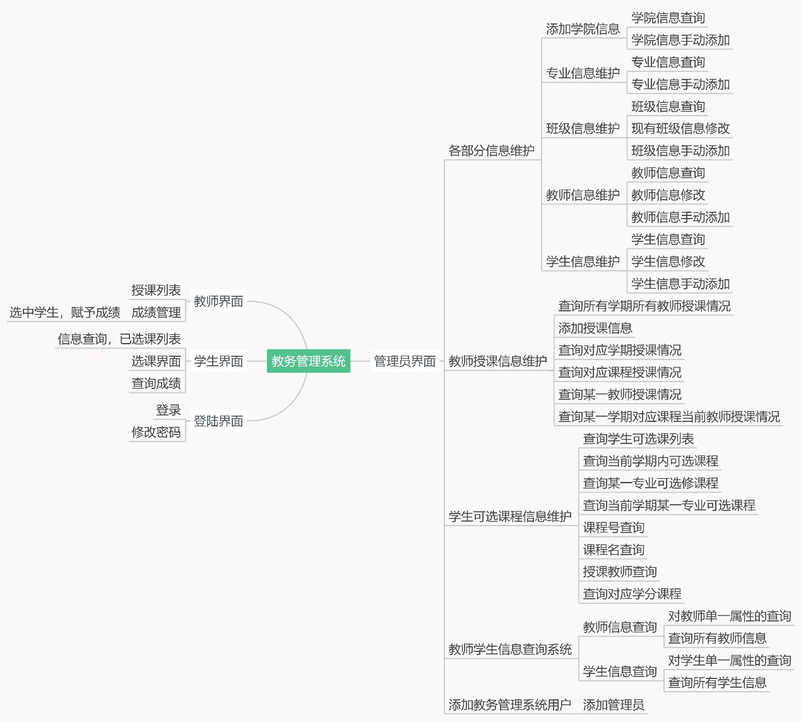

1、Academy_20211576存储Aca_no，Aca_name，Aca_introduction。

2、Sdept_20211576存储Sde_no，Sde_name，Sde_introduction，Aca_no，Aca_name

3、Class_20211576存储Class_no，Sde_no，Entrance_date，Num

4、Student_20211576存储Sno，Sname，Sex，Birth，Entrance_date，Class_no，Home_addr，Sde_no，Postcode，AttendanceStatus。

5、Course_20211576存储Cno，Aca_no，Cname， Total_perior，Credit。

6、Teacher_20211576存储Emp_no，Emp_name，Sex，Sde_no，Position。

7、Position_20211576存储Position。

8、Course_Teacher_20211576存储Emp_no，Cno，Cname。

9、Course_Available_20211576存储Semester，Emp_no，Cno，Course_Offered_Sde_no，Cname，Credit，Stu_Total，Stu_chosen。

10、Course_chosen_20211576存储Semester，Emp_no，Sno，Cno，Course_Offered_Sde_no，

Cname，Credit，Stu_Total，Stu_chosen。

11、SC_20211576存储Semester，Sno，Cno，Emp_no，Sde_no，Grade,Ji_Store。

12、Password_20211576存储id， name， position， password。

（3）安全性与完整性方面要求

（一）没有定义显示定义原子事务

（二）没有定义存储过程

（三）定义了以下功能的触发器

1（trg_UpdateEntranceDate_Class）当Class_20211576表中加入新数据时，会在添加数据后自动将入学时间Entrance_date更改为同年9/1；

2（check_records_CourseAvail_Course_CourseTea）当向Course_Available_20211576添加数据时，先判断其对应的组合在Course_20211576,Course_Teacher_202111576中是否存在，若不存在，添加失败并报错；

3（trg_insert_from_course_chosen_to_SC）当向Course_chosen_20211576中插入数据时，会在插入成功后在SC_20211576中插入对应信息；

4（update_stu_chosen）当向Course_chosen_20211576中插入数据时，会更新在Course_Available_20211576中的对应行的Stu_chosen(Stu_chosen+=1);

5（add_teacher_password）当向Teacher_202111576中插入数据时，会先判断这条信息在Password_20211576中是否存在，若存在，则在Password_20211576中插入对应数据，并设置默认密码为123456；

6（delete_Teacher_Password）当要删除Teacher_20211576中的信息时，执行instead of delete操作，先分别删除Course_chosen_20211576,Password_20211576,Course_Available_20211576,Course_Teacher_20211576这几张表中对应的信息，最后再删除Teacher_20211576中的信息；

7（trg_NewStudent）当向Teacher_202111576中插入数据时，在Password_20211576中插入对应数据，并设置默认密码为123456；

8（delete_Student_Password）当要删除Teacher_20211576中的信息时，执行instead of delete操作，先分别删除Course_chosen_20211576,Password_20211576,SC_20211576这几张表中对应的信息，最后再删除Student_20211576中的信息；

9（trg_delete_info）当删除Academy_20211576中信息时，先删除Password_20211576中属于Academy_20211576中对应删除学院的专业的教师和学生的信息，再删除Class_20211576中对应删除学院对应专业名下的班级，再删除SC_20211576中对应删除学院的对应专业的考试成绩信息，再删除Course_chosen_20211576中对应删除学院的对应专业的已选课信息，再删除Student_20211576对应删除学院的专业的学生信息，再删除Teacher_20211576中对应删除学院的专业的教师信息，再删除Sdept_20211576中对应删除学院所属的专业信息，再删除Course_Available_20211576中对应删除学院的对应专业的可选课程，再删除Course_Teacher_20211576中对应删除学院的对应课程及对应的教师授课信息，最后在删除Course_20211576中对应删除学院开设的课程信息。

10（delete_course_trigger）首先在SC_20211576表中删除与该课程相关的成绩信息，在Course_chosen_20211576表中删除与该课程相关的选课信息，在Course_Available_20211576表中删除该课程的开课信息，在Course_Teacher_20211576表中删除该课程的任课信息，最后在Course_20211576表中删除该课程的基本信息

11（delete_course_teacher_trigger）首先删除SC_20211576中与该课程相关的成绩信息，然后删除Course_chosen_20211576中与该课程相关的选课信息，然后删除Course_Available_20211576中该课程的开课信息，最后删除Course_Teacher_20211576中该课程的任课信息。

12（delete_course_available_trigger）首先删除SC_20211576中与该课程相关的成绩信息，然后删除Course_chosen_20211576中与该课程相关的选课信息，最后删除Course_Available_20211576中该课程的开课信息。

13（delete_course_chosen_trigger）首先删除SC_20211576中对应的成绩信息，再删除Course_chosen_20211576中的已选课信息。

（四）对不同用户采取登陆时鉴别身份的操作

对管理员用户给予全部操作权限，对学生仅提供视图读取权限，对教师，在对学科进行赋分时给予更新权限，当输入成绩后，对已赋分部分仅有视图读取权限，对除赋分以外的其他操作仅有视图读取权限。

二、概念结构设计

画出系统整体的E-R模型；并对模型中所出现的实体及属性等信息加以说明。

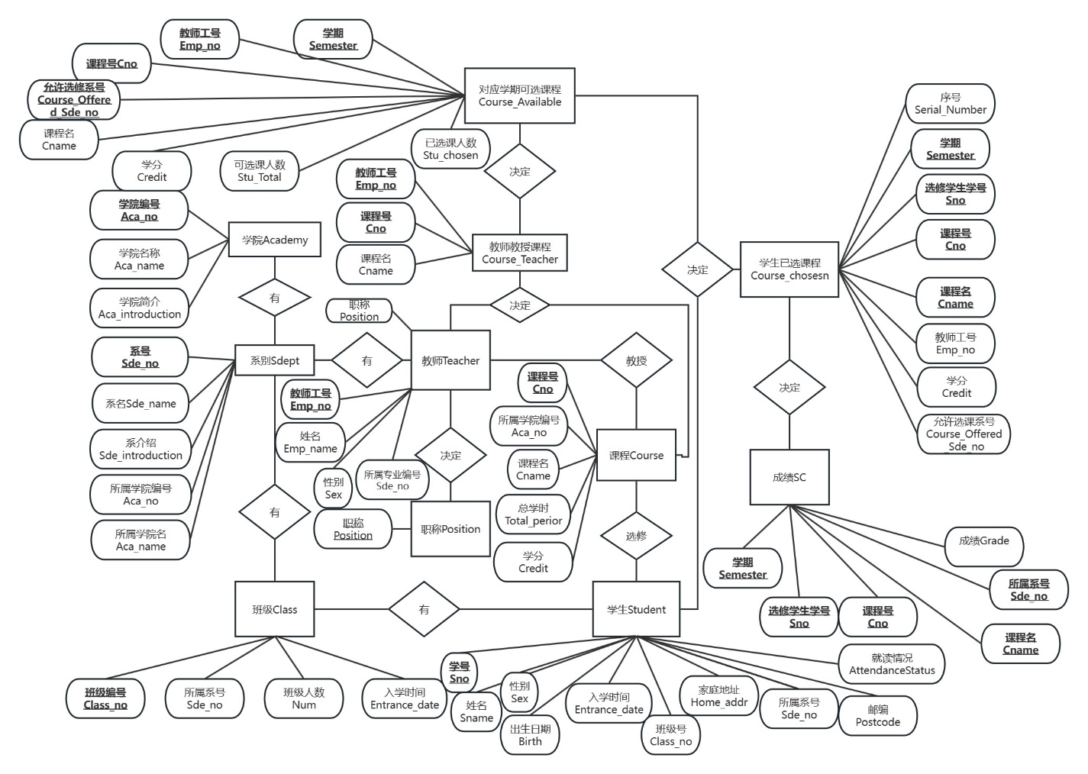

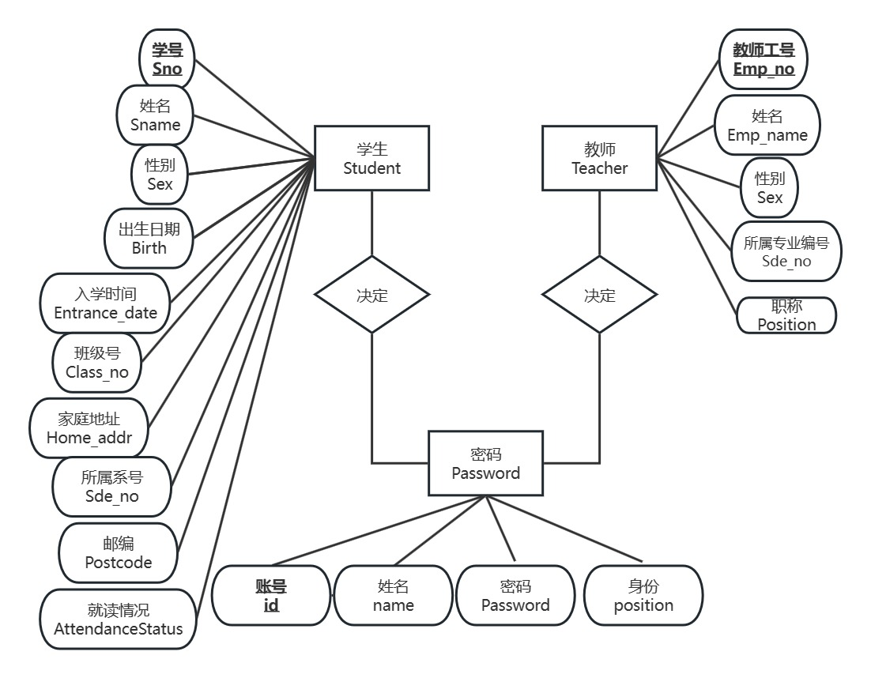

实体及属性：

实体1、Academy_20211576

|  |  |  |  |  |
| --- | --- | --- | --- | --- |
| 属性 | 类型 | 宽度 | 允许空值 | 说明 |
| Aca_no | char | 3 | 否 | 学院编号 |
| Aca_name | varchar | 20 | 否 | 学院名 |
| Aca_introduction | char | 100 | 是 | 学院介绍 |

实体2、Sdept_20211576

|  |  |  |  |  |
| --- | --- | --- | --- | --- |
| 属性 | 类型 | 宽度 | 允许空值 | 说明 |
| Sde_no | char | 3 | 否 | 系号 |
| Sde_name | Char | 20 | 否 | 系名 |
| Sde_introduction | Char | 100 | 是 | 系介绍 |
| Aca_no | Char | 3 | 否 | 所属学院编号 |
| Aca_name | char | 20 | 是 | 所属学院名 |

实体3、Class_20211576

|  |  |  |  |  |
| --- | --- | --- | --- | --- |
| 属性 | 类型 | 宽度 | 允许空值 | 说明 |
| Class_no | char | 3 | 否 | 班级号 |
| Sde_no | char | 3 | 否 | 所属系号 |
| Entrance_date | smalldatetime | 100 | 否 | 入学时间 |
| Num | int |  | 是 | 班级人数 |

实体4、Student_20211576

|  |  |  |  |  |
| --- | --- | --- | --- | --- |
| 属性 | 类型 | 宽度 | 允许空值 | 说明 |
| Sno | char | 9 | 否 | 学号 |
| Sname | Varchar | 8 | 否 | 姓名 |
| Sex | Char | 2 | 否 | 性别 |
| Birth | Smalldatetime |  | 是 | 出生日期 |
| Entrance_date | Smalldatetime |  | 是 | 入学时间 |
| Class_no | Char | 7 | 是 | 所属班级号 |
| Home_addr | Varchar | 40 | 是 | 家庭地址 |
| Sde_no | Char | 3 | 否 | 所属专业号 |
| Postcode | Char | 6 | 是 | 邮编 |
| AttendanceStatus | char | 20 | 是 | 就读状态 |

实体5、Course_20211576

|  |  |  |  |  |
| --- | --- | --- | --- | --- |
| 属性 | 类型 | 宽度 | 允许空值 | 说明 |
| Cno | char | 10 | 否 | 课程号 |
| Aca_no | Char | 3 | 否 | 所属学院编号 |
| Cname | Varchar | 40 | 否 | 课程名 |
| Total_perior | Smallint |  | 是 | 总学时 |
| Credit | Float |  | 是 | 学分 |

实体6、Teacher_20211576

|  |  |  |  |  |
| --- | --- | --- | --- | --- |
| 属性 | 类型 | 宽度 | 允许空值 | 说明 |
| Emp_no | char | 9 | 否 | 工号 |
| Emp_name | varchar | 8 | 否 | 姓名 |
| Sex | Char | 2 | 是 | 性别 |
| Sde_no | Char | 10 | 否 | 所属系号 |
| Position | char | 10 | 否 | 职称 |

实体7、Position_20211576

|  |  |  |  |  |
| --- | --- | --- | --- | --- |
| 属性 | 类型 | 宽度 | 允许空值 | 说明 |
| Position | char | 20 | 否 | 职称 |

实体8、Course_Teacher_20211576

|  |  |  |  |  |
| --- | --- | --- | --- | --- |
| 属性 | 类型 | 宽度 | 允许空值 | 说明 |
| Emp_no | char | 9 | 否 | 工号 |
| Cno | Char | 10 | 否 | 课程号 |
| Cname | Varchar | 20 | 是 | 课程名 |

实体9、Course_Available_20211576

|  |  |  |  |  |
| --- | --- | --- | --- | --- |
| 属性 | 类型 | 宽度 | 允许空值 | 说明 |
| Semester | char | 20 | 否 | 学期 |
| Emp_no | Char | 9 | 否 | 工号 |
| Cno | Char | 10 | 否 | 课程号 |
| Course_Offered_Sde_no | Char | 10 | 否 | 允许选修系的系号 |
| Cname | Varchar | 20 | 是 | 课程名 |
| Credit | Tinyint |  | 是 | 学分 |
| Stu_Total | Tinyint |  | 是 | 可选课学生数 |
| Stu_chosen | tinyint |  | 否 | 已选学生数 |

实体10、Course_chosen_20211576

|  |  |  |  |  |
| --- | --- | --- | --- | --- |
| 属性 | 类型 | 宽度 | 允许空值 | 说明 |
| Semester | char | 20 | 否 | 学期 |
| Emp_no | Char | 9 | 否 | 工号 |
| Sno | char | 9 | 否 | 学号 |
| Cno | Char | 10 | 否 | 课程号 |
| Course_Offered_Sde_no | Char | 10 | 否 | 允许选修系的系号 |
| Cname | Varchar | 20 | 是 | 课程名 |
| Credit | Tinyint |  | 是 | 学分 |

实体11、SC_20211576

|  |  |  |  |  |
| --- | --- | --- | --- | --- |
| 属性 | 类型 | 宽度 | 允许空值 | 说明 |
| Semester | char | 20 | 否 | 学期 |
| Sno | Char | 9 | 否 | 学号 |
| Cno | char | 10 | 否 | 课程号 |
| Emp_no | Char | 9 | 否 | 授课教师工号 |
| Sde_no | Char | 10 | 否 | 允许选修系的系名 |
| Grade | tinyint |  | 是 | 分数 |
| Ji_Store | float |  | 是 | 绩点 |

实体12、Password_20211576

|  |  |  |  |  |
| --- | --- | --- | --- | --- |
| 属性 | 类型 | 宽度 | 允许空值 | 说明 |
| id | char | 9 | 否 | 学号/工号 |
| name | Varchar | 8 | 否 | 姓名 |
| position | Char | 20 | 否 | 职称 |
| password | char | 20 | 是 | 密码 |

三、逻辑结构设计

**（**1）模式设计

按系统整体E-R模型，写出关系模式；并利用数据字典加以描述。

1、Academy_20211576

|  |  |  |  |  |  |  |
| --- | --- | --- | --- | --- | --- | --- |
| 列名称 | 类型 | 宽度 | 允许空值 | 缺省值 | 约束 | 主键 |
| Aca_no | char | 3 | 否 |  | 主键约束 | 是 |
| Aca_name | varchar | 20 | 否 |  |  |  |
| Aca_introduction | char | 100 | 是 | 无 |  |  |

2、Sdept_20211576

|  |  |  |  |  |  |  |  |
| --- | --- | --- | --- | --- | --- | --- | --- |
| 列名称 | 类型 | 宽度 | 允许空值 | 缺省值 | 约束 | 主键 | 外键 |
| Sde_no | char | 3 | 否 |  | 主键约束 | 是 |  |
| Sde_name | Char | 20 | 否 |  |  |  |  |
| Sde_introduction | Char | 100 | 是 | 无 |  |  |  |
| Aca_no | Char | 3 | 否 |  | 外键约束（Academy_20211576.Aca_no） |  | 是 |
| Aca_name | char | 20 | 是 |  |  |  |  |

3、Class_20211576

|  |  |  |  |  |  |  |  |
| --- | --- | --- | --- | --- | --- | --- | --- |
| 列名称 | 类型 | 宽度 | 允许空值 | 缺省值 | 约束 | 主键 | 外键 |
| Class_no | char | 3 | 否 |  | 主键约束 | 是 |  |
| Sde_no | char | 3 | 否 |  | 外键约束(Sdept_20211576.Sde_no) |  | 是 |
| Entrance_date | smalldatetime | 100 | 否 |  |  |  |  |
| Num | int |  | 是 |  |  |  |  |

4、Student_20211576

|  |  |  |  |  |  |  |  |
| --- | --- | --- | --- | --- | --- | --- | --- |
| 列名称 | 类型 | 宽度 | 允许空值 | 缺省值 | 约束 | 主键 | 外键 |
| Sno | char | 9 | 否 |  | 主键约束 | 是 |  |
| Sname | Varchar | 8 | 否 |  |  |  |  |
| Sex | Char | 2 | 否 | 男 |  |  |  |
| Birth | Smalldatetime |  | 是 |  |  |  |  |
| Entrance_date | Smalldatetime |  | 是 |  |  |  |  |
| Class_no | Char | 7 | 是 |  | 外键约束（Class_20211576.Class_no） |  |  |
| Home_addr | Varchar | 40 | 是 |  |  |  |  |
| Sde_no | Char | 3 | 否 |  | 外键约束（Sdept_20211576.Sde_no） |  | 是 |
| Postcode | Char | 6 | 是 |  | 检查约束（Like’[0-9] [0-9] [0-9] [0-9] [0-9] [0-9]’） |  |  |
| AttendanceStatus | char | 20 | 是 |  |  |  |  |

5、Course_20211576

|  |  |  |  |  |  |  |  |
| --- | --- | --- | --- | --- | --- | --- | --- |
| 列名称 | 类型 | 宽度 | 允许空值 | 缺省值 | 约束 | 主键 | 外键 |
| Cno | char | 10 | 否 |  | 主键约束 | 是 |  |
| Aca_no | Char | 3 | 否 |  | 外键约束（Academy_20211576.Aca_no） |  | 是 |
| Cname | Varchar | 40 | 否 |  |  |  |  |
| Total_perior | Smallint |  | 是 |  |  |  |  |
| Credit | Float |  | 是 |  |  |  |  |

6、Teacher_20211576

|  |  |  |  |  |  |  |  |
| --- | --- | --- | --- | --- | --- | --- | --- |
| 列名称 | 类型 | 宽度 | 允许空值 | 缺省值 | 约束 | 主键 | 外键 |
| Emp_no | char | 9 | 否 |  | 主键约束 | 是 |  |
| Emp_name | varchar | 8 | 否 |  |  |  |  |
| Sex | Char | 2 | 是 | 男 |  |  |  |
| Sde_no | Char | 10 | 否 |  | 外键约束（Sdept_20211576.Sde_no） |  |  |
| Position | char | 10 | 否 |  | 外键约束（Position_20211576.Position） |  | 是 |

7、Position_20211576

|  |  |  |  |  |  |  |  |
| --- | --- | --- | --- | --- | --- | --- | --- |
| 列名称 | 类型 | 宽度 | 允许空值 | 缺省值 | 约束 | 主键 | 外键 |
| Position | char | 20 | 否 |  | 主键约束 | 是 |  |

8、Course_Teacher_20211576

|  |  |  |  |  |  |  |  |
| --- | --- | --- | --- | --- | --- | --- | --- |
| 列名称 | 类型 | 宽度 | 允许空值 | 缺省值 | 约束 | 主键 | 外键 |
| Emp_no | char | 9 | 否 |  | 外键约束（Teacher_20211576.Emp_no） | 是 | 是 |
| Cno | Char | 10 | 否 |  | 外键约束（Course_20211576.Cno） | 是 | 是 |
| Cname | Varchar | 20 | 是 |  |  |  |  |

主键约束：（Emp_no,Cno）

9、Course_Available_20211576

|  |  |  |  |  |  |  |  |
| --- | --- | --- | --- | --- | --- | --- | --- |
| 列名称 | 类型 | 宽度 | 允许空值 | 缺省值 | 约束 | 主键 | 外键 |
| Semester | char | 20 | 否 |  |  | 是 | 是 |
| Emp_no | Char | 9 | 否 |  |  | 是 | 是 |
| Cno | Char | 10 | 否 |  | 外键约束（Course_20211576.Cno） | 是 | 是 |
| Course_Offered_Sde_no | Char | 10 | 否 |  |  | 是 | 是 |
| Cname | Varchar | 20 | 是 |  |  |  |  |
| Credit | Tinyint |  | 是 |  |  |  |  |
| Stu_Total | Tinyint |  | 是 |  |  |  |  |
| Stu_chosen | tinyint |  | 否 |  |  |  |  |

主键约束：（Semester,Emp_no,Cno,Course_Offered_Sde_no）

Emp_no,Cno外键约束:

|  |  |
| --- | --- |
| 主键表 | 外键表 |
| Course_Teacher_20211576 | Course_Available_20211576 |
| Emp_no | Emp_no |
| Cno | Cno |

10、Course_chosen_20211576

|  |  |  |  |  |  |  |  |
| --- | --- | --- | --- | --- | --- | --- | --- |
| 列名称 | 类型 | 宽度 | 允许空值 | 缺省值 | 约束 | 主键 | 外键 |
| Semester | char | 20 | 否 |  |  | 是 | 是 |
| Emp_no | Char | 9 | 否 |  |  | 是 | 是 |
| Sno | char | 9 | 否 |  | 外键约束（Student_20211576.Sno） | 是 | 是 |
| Cno | Char | 10 | 否 |  |  | 是 | 是 |
| Course_Offered_Sde_no | Char | 10 | 否 |  |  | 是 | 是 |
| Cname | Varchar | 20 | 是 |  |  |  |  |
| Credit | Tinyint |  | 是 |  |  |  |  |

Semester,Cno,Emp_no,Course_Offered_Sde_no外键约束：

|  |  |
| --- | --- |
| 主键表 | 外键表 |
| Course_Available_20211576 | Course_chosen_20211576 |
| Semester | Semester |
| Cno | Cno |
| Emp_no | Emp_no |
| Course_Offered_Sde_no | Course_Offered_Sde_no |

主键约束：（Semester,Emp_no,Sno,Cno,Course_Offered_Sde_no）

11、SC_20211576

|  |  |  |  |  |  |  |  |
| --- | --- | --- | --- | --- | --- | --- | --- |
| 列名称 | 类型 | 宽度 | 允许空值 | 缺省值 | 约束 | 主键 | 外键 |
| Semester | char | 20 | 否 |  |  | 是 | 是 |
| Sno | Char | 9 | 否 |  |  | 是 | 是 |
| Cno | char | 10 | 否 |  |  | 是 | 是 |
| Emp_no | Char | 9 | 否 |  |  | 是 | 是 |
| Sde_no | Char | 10 | 否 |  |  | 是 | 是 |
| Grade | tinyint |  | 是 |  |  |  |  |
| Ji_Store | Float |  | 是 |  |  |  |  |

主键约束：（Semester,Emp_no,Sno,Cno,Course_Offered_Sde_no）

Semester,Cno,Emp_no,Course_Offered_Sde_no外键约束：

|  |  |
| --- | --- |
| 主键表 | 外键表 |
| Course_chosen_20211576 | SC_20211576 |
| Semester | Semester |
| Sno | Sno |
| Cno | Cno |
| Emp_no | Emp_no |
| Course_Offered_Sde_no | Sde_no |

12、Password_20211576

|  |  |  |  |  |  |  |  |
| --- | --- | --- | --- | --- | --- | --- | --- |
| 列名称 | 类型 | 宽度 | 允许空值 | 缺省值 | 约束 | 主键 | 外键 |
| id | char | 9 | 否 |  |  | 是 |  |
| name | Varchar | 8 | 否 |  |  |  |  |
| position | Char | 20 | 否 |  | 外键约束（Position_20211576.Position） |  | 是 |
| password | char | 20 | 是 |  |  |  |  |

（2）子模式设计

针对自己的设计模块的应用需定义什么样的视图表结构；并利用数据字典加以描述。

（一）登录功能：Manager_Password_view

create view Manager_Password_view as

select id,name,position,password

from Password_20211576

|  |  |  |  |  |  |  |
| --- | --- | --- | --- | --- | --- | --- |
| 列名称 | 类型 | 宽度 | 允许空值 | 缺省值 | 约束 | 主码 |
| id | char | 9 | 否 |  |  | 是 |
| name | Varchar | 8 | 否 |  |  |  |
| position | Char | 20 | 否 |  |  |  |
| password | char | 20 | 是 |  |  |  |

（二）登陆后教师界面

1))Teacher_view (展示教师信息)

create view Teacher_view as

select Emp_no,Emp_name,Sex,Teacher_20211576.Sde_no,Sde_name,Position

from Teacher_20211576,Sdept_20211576

where Teacher_20211576.Sde_no=Sdept_20211576.Sde_no

|  |  |  |  |  |  |  |
| --- | --- | --- | --- | --- | --- | --- |
| 列名称 | 类型 | 宽度 | 允许空值 | 缺省值 | 约束 | 主码 |
| Emp_no | char | 9 | 否 |  |  | 是 |
| Emp_name | varchar | 8 | 否 |  |  |  |
| Sex | Char | 2 | 是 | 男 |  |  |
| Sde_no | Char | 10 | 否 |  |  |  |
| Sde_name | char | 20 | 否 |  |  |  |
| Position | char | 10 | 否 |  |  |  |

2))Manager_Course_Teacher_manage_view(查询教授课程)

CREATE VIEW Manager_Course_Teacher_manage_view AS

SELECT Semester,Course_Offered_Sde_no,Sde_name,Cno,Cname,Emp_name,Credit,Stu_total

FROM Course_Available_20211576,Teacher_20211576,Sdept_20211576

where Course_Available_20211576.Emp_no=Teacher_20211576.Emp_no

and Sdept_20211576.Sde_no=Course_Available_20211576.Course_Offered_Sde_no

|  |  |  |  |  |  |  |
| --- | --- | --- | --- | --- | --- | --- |
| 列名称 | 类型 | 宽度 | 允许空值 | 缺省值 | 约束 | 主码 |
| Semester | char | 20 | 否 |  |  | 是 |
| Course_Offered_Sde_no | Char | 10 | 否 |  |  | 是 |
| Sde_name | char | 20 | 否 |  |  | 是 |
| Cno | Char | 10 | 否 |  |  | 是 |
| Cname | Varchar | 20 | 否 |  |  |  |
| Emp_name | varchar | 8 | 否 |  |  |  |
| Credit | float |  | 是 |  |  |  |
| Stu_Total | Tinyint |  | 是 |  |  |  |

Teacher_Manage_SC_view(赋分)：

create view Teacher_Manage_SC_view as

select Semester,Sno,SC_20211576.Cno,Cname,Emp_name,SC_20211576.Sde_no,Grade

from Teacher_20211576,SC_20211576,Course_20211576

where SC_20211576.Emp_no=Teacher_20211576.Emp_no

and SC_20211576.Cno=Course_20211576.Cno

|  |  |  |  |  |  |  |
| --- | --- | --- | --- | --- | --- | --- |
| 列名称 | 类型 | 宽度 | 允许空值 | 缺省值 | 约束 | 主码 |
| Semester | char | 20 | 否 |  |  | 是 |
| Sno | Char | 9 | 否 |  |  | 是 |
| Cno | char | 10 | 否 |  |  | 是 |
| Cname | varchar | 8 | 否 |  |  |  |
| Emp_no | Char | 9 | 否 |  |  | 是 |
| Sde_no | Char | 10 | 否 |  |  | 是 |
| Grade | tinyint |  | 是 |  |  |  |

（三）登陆后学生界面：

（（一））学生信息+已选课程查询：

1））Student_Enquiry_view(已选课程查询)

create view Student_Enquiry_view as

SELECT Semester,Sno,Cno,Cname,Emp_name,Credit

FROM Course_chosen_20211576,Teacher_20211576

where Course_chosen_20211576.Emp_no=Teacher_20211576.Emp_no

|  |  |  |  |  |  |  |
| --- | --- | --- | --- | --- | --- | --- |
| 列名称 | 类型 | 宽度 | 允许空值 | 缺省值 | 约束 | 主码 |
| Semester | char | 20 | 否 |  |  | 是 |
| Sno | Char | 9 | 否 |  |  | 是 |
| Cno | char | 10 | 否 |  |  | 是 |
| Cname | varchar | 8 | 否 |  |  |  |
| Emp_name | varchar | 8 | 否 |  |  |  |
| Credit | float |  | 是 |  |  |  |

2））Student_view(学生信息)

CREATE VIEW Manager_Student_view AS

SELECT Sno , Sname , Sex , Birth , Entrance_date , Class_no , Home_addr , Sde_no , Postcode ,

CASE WHEN (DATEDIFF(year,Entrance_date,getdate())>=4) THEN '本科毕业' ELSE '本科在读' END AS AttendanceStatus

FROM Student_20211576

|  |  |  |  |  |  |  |
| --- | --- | --- | --- | --- | --- | --- |
| 列名称 | 类型 | 宽度 | 允许空值 | 缺省值 | 约束 | 主码 |
| Sno | char | 9 | 否 |  |  | 是 |
| Sname | Varchar | 8 | 否 |  |  |  |
| Sex | Char | 2 | 否 | 男 |  |  |
| Birth | Smalldatetime |  | 是 |  |  |  |
| Entrance_date | Smalldatetime |  | 是 |  |  |  |
| Class_no | Char | 7 | 是 |  |  |  |
| Home_addr | Varchar | 40 | 是 |  |  |  |
| Sde_no | Char | 3 | 否 |  |  |  |
| Postcode | Char | 6 | 是 |  |  |  |
| AttendanceStatus | char | 20 | 是 |  |  |  |

（（二））学生选课：

Manager_Course_Teacher_manage_view (选课)

CREATE VIEW Manager_Course_Teacher_manage_view AS

SELECT Semester,Course_Offered_Sde_no,Sde_name,Cno,Cname,Emp_name,Credit,Stu_total

FROM Course_Available_20211576,Teacher_20211576,Sdept_20211576

where Course_Available_20211576.Emp_no=Teacher_20211576.Emp_no

and Sdept_20211576.Sde_no=Course_Available_20211576.Course_Offered_Sde_no

|  |  |  |  |  |  |  |
| --- | --- | --- | --- | --- | --- | --- |
| 列名称 | 类型 | 宽度 | 允许空值 | 缺省值 | 约束 | 主码 |
| Semester | char | 20 | 否 |  |  | 是 |
| Course_Offered_Sde_no | Char | 10 | 否 |  |  | 是 |
| Sde_name | char | 20 | 否 |  |  | 是 |
| Cno | Char | 10 | 否 |  |  | 是 |
| Cname | Varchar | 20 | 否 |  |  |  |
| Emp_name | varchar | 8 | 否 |  |  |  |
| Credit | float |  | 是 |  |  |  |
| Stu_Total | Tinyint |  | 是 |  |  |  |

（四）登陆后管理员界面

（（一））各部分信息维护

1))Manager_Academy_view (添加学院信息)

CREATE VIEW Manager_Academy_view AS

SELECT Aca_no,Aca_name,Aca_introduction

FROM Academy_20211576

|  |  |  |  |  |  |  |
| --- | --- | --- | --- | --- | --- | --- |
| 列名称 | 类型 | 宽度 | 允许空值 | 缺省值 | 约束 | 主码 |
| Aca_no | char | 3 | 否 |  |  | 是 |
| Aca_name | varchar | 20 | 否 |  |  |  |
| Aca_introduction | char | 100 | 是 | 无 |  |  |

2)) Manager_Sdept_view(专业信息维护)

CREATE VIEW Manager_Sdept_view AS

SELECT Sde_no,Sde_name,Sde_introduction,Aca_no,Aca_name

FROM Sdept_20211576

|  |  |  |  |  |  |  |
| --- | --- | --- | --- | --- | --- | --- |
| 列名称 | 类型 | 宽度 | 允许空值 | 缺省值 | 约束 | 主码 |
| Sde_no | char | 3 | 否 |  |  | 是 |
| Sde_name | Char | 20 | 否 |  |  |  |
| Sde_introduction | Char | 100 | 是 | 无 |  |  |
| Aca_no | Char | 3 | 否 |  |  |  |
| Aca_name | char | 20 | 是 |  |  |  |

3)) Manager_Class_view(班级信息维护,入学时间取出年份/月份/日/yy-mm-dd)

CREATE VIEW Manager_Class_view AS

SELECT Class_no,Sde_no,substring(CONVERT(varchar, Entrance_date, 120),0,11) 'Entrance_date',Num

FROM Class_20211576

|  |  |  |  |  |  |  |
| --- | --- | --- | --- | --- | --- | --- |
| 列名称 | 类型 | 宽度 | 允许空值 | 缺省值 | 约束 | 主码 |
| Class_no | char | 3 | 否 |  |  | 是 |
| Sde_no | char | 3 | 否 |  |  |  |
| Entrance_date | smalldatetime | 100 | 否 |  |  |  |
| Num | int |  | 是 |  |  |  |

4)) Manager_Teacher_view(教师信息维护)

CREATE VIEW Manager_Teacher_view AS

SELECT Emp_no,Emp_name,Sex,Sde_no,Position

FROM Teacher_20211576

|  |  |  |  |  |  |  |
| --- | --- | --- | --- | --- | --- | --- |
| 列名称 | 类型 | 宽度 | 允许空值 | 缺省值 | 约束 | 主键 |
| Emp_no | char | 9 | 否 |  |  | 是 |
| Emp_name | varchar | 8 | 否 |  |  |  |
| Sex | Char | 2 | 是 | 男 |  |  |
| Sde_no | Char | 10 | 否 |  |  |  |
| Position | char | 10 | 否 |  |  |  |

5)) Manager_Student_view(学生信息维护，在最后一栏增加该生是否毕业的项)

CREATE VIEW Manager_Student_view AS

SELECT Sno , Sname , Sex , Birth , Entrance_date , Class_no , Home_addr , Sde_no , Postcode ,

CASE WHEN (DATEDIFF(year,Entrance_date,getdate())>=4) THEN '本科毕业' ELSE '本科在读' END AS AttendanceStatus

FROM Student_20211576

|  |  |  |  |  |  |  |
| --- | --- | --- | --- | --- | --- | --- |
| 列名称 | 类型 | 宽度 | 允许空值 | 缺省值 | 约束 | 主码 |
| Sno | char | 9 | 否 |  |  | 是 |
| Sname | Varchar | 8 | 否 |  |  |  |
| Sex | Char | 2 | 否 | 男 |  |  |
| Birth | Smalldatetime |  | 是 |  |  |  |
| Entrance_date | Smalldatetime |  | 是 |  |  |  |
| Class_no | Char | 7 | 是 |  |  |  |
| Home_addr | Varchar | 40 | 是 |  |  |  |
| Sde_no | Char | 3 | 否 |  |  |  |
| Postcode | Char | 6 | 是 |  |  |  |
| AttendanceStatus | char | 20 | 是 |  |  |  |

（（二））教师授课管理

1))Manager_Course_Teacher_manage_view(查询教师授课信息)

CREATE VIEW Manager_Course_Teacher_manage_view AS

SELECT Semester,Course_Offered_Sde_no,Sde_name,Cno,Cname,Emp_name,Credit,Stu_total

FROM Course_Available_20211576,Teacher_20211576,Sdept_20211576

where Course_Available_20211576.Emp_no=Teacher_20211576.Emp_no

and Sdept_20211576.Sde_no=Course_Available_20211576.Course_Offered_Sde_no

|  |  |  |  |  |  |  |
| --- | --- | --- | --- | --- | --- | --- |
| 列名称 | 类型 | 宽度 | 允许空值 | 缺省值 | 约束 | 主码 |
| Semester | char | 20 | 否 |  |  | 是 |
| Course_Offered_Sde_no | Char | 10 | 否 |  |  | 是 |
| Sde_name | char | 20 | 否 |  |  | 是 |
| Cno | Char | 10 | 否 |  |  | 是 |
| Cname | Varchar | 20 | 否 |  |  |  |
| Emp_name | varchar | 8 | 否 |  |  |  |
| Credit | float |  | 是 |  |  |  |
| Stu_Total | Tinyint |  | 是 |  |  |  |

2))Course_Available_20211576(增加教师授课项)

|  |  |  |  |  |  |  |
| --- | --- | --- | --- | --- | --- | --- |
| 列名称 | 类型 | 宽度 | 允许空值 | 缺省值 | 约束 | 主码 |
| Semester | char | 20 | 否 |  |  | 是 |
| Emp_no | Char | 9 | 否 |  |  | 是 |
| Cno | Char | 10 | 否 |  |  | 是 |
| Course_Offered_Sde_no | Char | 10 | 否 |  |  | 是 |
| Cname | Varchar | 20 | 是 |  |  |  |
| Credit | Tinyint |  | 是 |  |  |  |
| Stu_Total | Tinyint |  | 是 |  |  |  |
| Stu_chosen | tinyint |  | 否 |  |  |  |

（（三））学生可选课程信息维护

Manager_Course_Teacher_manage_view(查询对应系学生可选课程)

CREATE VIEW Manager_Course_Teacher_manage_view AS

SELECT Semester,Course_Offered_Sde_no,Sde_name,Cno,Cname,Emp_name,Credit,Stu_total

FROM Course_Available_20211576,Teacher_20211576,Sdept_20211576

where Course_Available_20211576.Emp_no=Teacher_20211576.Emp_no

and Sdept_20211576.Sde_no=Course_Available_20211576.Course_Offered_Sde_no

|  |  |  |  |  |  |  |
| --- | --- | --- | --- | --- | --- | --- |
| 列名称 | 类型 | 宽度 | 允许空值 | 缺省值 | 约束 | 主码 |
| Semester | char | 20 | 否 |  |  | 是 |
| Course_Offered_Sde_no | Char | 10 | 否 |  |  | 是 |
| Sde_name | char | 20 | 否 |  |  | 是 |
| Cno | Char | 10 | 否 |  |  | 是 |
| Cname | Varchar | 20 | 否 |  |  |  |
| Emp_name | varchar | 8 | 否 |  |  |  |
| Credit | float |  | 是 |  |  |  |
| Stu_Total | Tinyint |  | 是 |  |  |  |

（（四））教师学生信息查询系统

1））Manager_Teacher_view(教师信息查询)

CREATE VIEW Manager_Teacher_view AS

SELECT Emp_no,Emp_name,Sex,Sde_no,Position

FROM Teacher_20211576

|  |  |  |  |  |  |  |
| --- | --- | --- | --- | --- | --- | --- |
| 列名称 | 类型 | 宽度 | 允许空值 | 缺省值 | 约束 | 主码 |
| Emp_no | char | 9 | 否 |  |  | 是 |
| Emp_name | varchar | 8 | 否 |  |  |  |
| Sex | Char | 2 | 是 | 男 |  |  |
| Sde_no | Char | 10 | 否 |  |  |  |
| Position | char | 10 | 否 |  |  |  |

2)) Manager_Student_view(学生信息查询，在最后一栏增加该生是否毕业的项)

CREATE VIEW Manager_Student_view AS

SELECT Sno , Sname , Sex , Birth , Entrance_date , Class_no , Home_addr , Sde_no , Postcode ,

CASE WHEN (DATEDIFF(year,Entrance_date,getdate())>=4) THEN '本科毕业' ELSE '本科在读' END AS AttendanceStatus

FROM Student_20211576

|  |  |  |  |  |  |  |
| --- | --- | --- | --- | --- | --- | --- |
| 列名称 | 类型 | 宽度 | 允许空值 | 缺省值 | 约束 | 主码 |
| Sno | char | 9 | 否 |  |  | 是 |
| Sname | Varchar | 8 | 否 |  |  |  |
| Sex | Char | 2 | 否 | 男 |  |  |
| Birth | Smalldatetime |  | 是 |  |  |  |
| Entrance_date | Smalldatetime |  | 是 |  |  |  |
| Class_no | Char | 7 | 是 |  |  |  |
| Home_addr | Varchar | 40 | 是 |  |  |  |
| Sde_no | Char | 3 | 否 |  |  |  |
| Postcode | Char | 6 | 是 |  |  |  |
| AttendanceStatus | char | 20 | 是 |  |  |  |

（（五））添加教务管理系统管理员用户

Teacher_20211576(插入管理员教师信息，Position为”教务管理人员”)

|  |  |  |  |  |  |  |
| --- | --- | --- | --- | --- | --- | --- |
| 列名称 | 类型 | 宽度 | 允许空值 | 缺省值 | 约束 | 主码 |
| Emp_no | char | 9 | 否 |  |  | 是 |
| Emp_name | varchar | 8 | 否 |  |  |  |
| Sex | Char | 2 | 是 | 男 |  |  |
| Sde_no | Char | 10 | 否 |  |  |  |
| Position | char | 10 | 否 |  |  |  |

四、数据库的物理设计

为了提高在表中搜索元组的速度，在实际实现的时候应该基于某些属性建立索引。给出所建立的索引。（包括按哪些表中哪些属性按升序还是降序来创建索引及相应的T-SQL的创建语句）。

1.CREATE CLUSTERED INDEX Academy_clustered_index

ON Academy_20211576(Aca_no ASC);

2.CREATE CLUSTERED INDEX Class_clustered_index

ON Class_20211576(Class_no ASC);

3.CREATE CLUSTERED INDEX Course_clustered_index

ON Course_20211576(Cno ASC);

4.CREATE CLUSTERED INDEX Course_Available_clustered_index

ON Course_Available_20211576(Semester ASC,Emp_no ASC,Cno ASC,Course_Offered_Sde_no ASC);

5.CREATE CLUSTERED INDEX Course_chosen_clustered_index

ON Course_chosen_20211576(Semester ASC,Sno ASC,Cno ASC,Emp_no ASC,Course_Offered_Sde_no ASC);

6.CREATE CLUSTERED INDEX Course_Teacher_clustered_index

ON Course_Teacher_20211576(Emp_no ASC,Cno ASC);

7.CREATE CLUSTERED INDEX Password_clustered_index

ON Password_20211576(id ASC);

8.CREATE CLUSTERED INDEX Position_clustered_index

ON Position_20211576(Position ASC);

9.CREATE CLUSTERED INDEX SC_clustered_index

ON SC_20211576(Semester ASC,Sno ASC,Cno ASC,Emp_no ASC,Sde_no ASC);

10.CREATE CLUSTERED INDEX Sdept_clustered_index

ON Sdept_202111576(Sde_no ASC);

11.CREATE CLUSTERED INDEX Student_clustered_index

ON Student_20211576(Sno ASC);

12.CREATE CLUSTERED INDEX Teacher_clustered_index

ON Teacher_20211576(Emp_no ASC);

五、数据库设计实现及运行

（1）数据库的创建

T-SQL语句：

Create database Academic_Affairs_Management_System_20211576

Use Academic_Affairs_Management_System_20211576

（2）数据表的创建

T-SQL语句：

以下是各个表的CREATE语句：

1.Academy_20211576表：

CREATE TABLE Academy_20211576 (

Aca_no char(3) NOT NULL PRIMARY KEY,

Aca_name varchar(20) NOT NULL,

Aca_introduction char(100) NULL);

2.Sdept_20211576表：

CREATE TABLE Sdept_20211576 (

Sde_no char(3) NOT NULL PRIMARY KEY,

Sde_name char(20) NOT NULL,

Sde_introduction char(100) NULL,

Aca_no char(3) NOT NULL,

Aca_name char(20) NULL,

FOREIGN KEY (Aca_no) REFERENCES Academy_20211576(Aca_no));

3.Class_20211576表：

CREATE TABLE Class_20211576 (

Class_no char(3) NOT NULL PRIMARY KEY,

Sde_no char(3) NOT NULL,

Entrance_date smalldatetime NOT NULL,

Num int NULL,

FOREIGN KEY (Sde_no) REFERENCES Sdept_20211576(Sde_no));

4.Student_20211576表：

CREATE TABLE Student_20211576 (

Sno char(9) NOT NULL PRIMARY KEY,

Sname varchar(8) NOT NULL,

Sex char(2) NOT NULL DEFAULT '男',

Birth smalldatetime NULL,

Entrance_date smalldatetime NULL,

Class_no char(7) NULL,

Home_addr varchar(40) NULL,

Sde_no char(3) NOT NULL,

Postcode char(6) NULL,

AttendanceStatus char(20) NULL,

FOREIGN KEY (Sde_no) REFERENCES Sdept_20211576(Sde_no),

FOREIGN KEY (Class_no) REFERENCES Class_20211576(Class_no));

5.Course_20211576表：

CREATE TABLE Course_20211576 (

Cno char(10) NOT NULL PRIMARY KEY,

Aca_no char(3) NOT NULL,

Cname varchar(40) NOT NULL,

Total_perior smallint NULL,

Credit float NULL,

FOREIGN KEY (Aca_no) REFERENCES Academy_20211576(Aca_no));

6.Teacher_20211576表：

CREATE TABLE Teacher_20211576 (

Emp_no char(9) NOT NULL PRIMARY KEY,

Emp_name varchar(8) NOT NULL,

Sex char(2) NULL DEFAULT '男',

Sde_no char(10) NOT NULL,

Position char(20) NOT NULL,

FOREIGN KEY (Sde_no) REFERENCES Sdept_20211576(Sde_no),

FOREIGN KEY (Position) REFERENCES Position_20211576(Position));

7.Position_20211576表：

CREATE TABLE Position_20211576 (

Position char(20) NOT NULL PRIMARY KEY);

8.Course_Teacher_20211576表：

CREATE TABLE Course_Teacher_20211576 (

Emp_no char(9) NOT NULL,

Cno char(10) NOT NULL,

Cname varchar(20) NULL,

PRIMARY KEY (Emp_no, Cno),

FOREIGN KEY (Emp_no) REFERENCES Teacher_20211576(Emp_no),

FOREIGN KEY (Cno) REFERENCES Course_20211576(Cno));

9.Course_Available_20211576表：

CREATE TABLE Course_Available_20211576 (

Semester char(20) NOT NULL,

Emp_no char(9) NOT NULL,

Cno char(10) NOT NULL,

Course_Offered_Sde_no char(10) NOT NULL,

Cname varchar(20) NULL,

Credit tinyint NULL,

Stu_Total tinyint NULL,

Stu_chosen tinyint NOT NULL,

PRIMARY KEY (Semester, Emp_no, Cno, Course_Offered_Sde_no),

FOREIGN KEY (Emp_no,Cno) REFERENCES Course_Teacher_20211576(Emp_no,Cno),

FOREIGN KEY (Cno) REFERENCES Course_20211576(Cno));

10.Course_chosen_20211576表：

CREATE TABLE Course_chosen_20211576 (

Serial_Number int NULL,

Semester char(20) NOT NULL,

Emp_no char(9) NOT NULL,

Sno char(9) NOT NULL,

Cno char(10) NOT NULL,

Course_Offered_Sde_no char(10) NOT NULL,

Cname varchar(20) NULL,

Credit tinyint NULL,

Stu_Total tinyint NULL,

Stu_chosen tinyint NOT NULL,

PRIMARY KEY (Semester, Emp_no, Sno, Cno, Course_Offered_Sde_no),

FOREIGN KEY (Semester, Emp_no, Sno, Cno, Course_Offered_Sde_no) REFERENCES Course_Available_20211576(Semester, Emp_no, Sno, Cno, Course_Offered_Sde_no),

FOREIGN KEY (Sno) REFERENCES Student_20211576(Sno));

11.SC_20211576表：

CREATE TABLE SC_20211576 (

Semester char(20) NOT NULL,

Sno char(9) NOT NULL,

Cno char(10) NOT NULL,

Emp_no char(9) NOT NULL,

Sde_no char(10) NOT NULL,

Grade tinyint NULL,

PRIMARY KEY (Semester, Sno, Cno, Emp_no, Sde_no),

FOREIGN KEY (Semester, Sno, Cno, Emp_no, Sde_no) REFERENCES Course_chosen_20211576(Semester, Sno, Cno, Emp_no, Sde_no));

12.Password_20211576表：

CREATE TABLE Password_20211576 (

id char(9) NOT NULL PRIMARY KEY,

name varchar(8) NOT NULL,

position char(20) NOT NULL,

password char(20) NULL,

FOREIGN KEY (position) REFERENCES Position_20211576(Position));

说明：若有完整性约束的一方面可以创建时同时实现。按需求及自行设计模块中所实现的情况，在该部分对完整性约束加以实现。

（3）视图的创建

T-SQL语句：

1、Manager_Student_view：

CREATE VIEW Manager_Student_view AS

SELECT Sno , Sname , Sex , Birth , Entrance_date , Class_no , Home_addr , Sde_no , Postcode ,

CASE WHEN (DATEDIFF(year,Entrance_date,getdate())>=4) THEN '本科毕业' ELSE '本科在读' END AS AttendanceStatus

FROM Student_20211576

2、Manager_Teacher_view：

CREATE VIEW Manager_Teacher_view AS

SELECT Emp_no,Emp_name,Sex,Sde_no,Position

FROM Teacher_20211576

3、Manager_Class_view：

CREATE VIEW Manager_Class_view AS

SELECT Class_no,Sde_no,substring(CONVERT(varchar, Entrance_date, 120),0,11) 'Entrance_date',Num

FROM Class_20211576

4、Manager_Academy_view：

CREATE VIEW Manager_Academy_view AS

SELECT Aca_no,Aca_name,Aca_introduction

FROM Academy_20211576

5、Manager_Sdept_view：

CREATE VIEW Manager_Sdept_view AS

SELECT Sde_no,Sde_name,Sde_introduction,Aca_no,Aca_name

FROM Sdept_20211576

6、Course_teacher_view:

create view Course_teacher_view as

select Emp_no,Cno,Cname

from Course_Teacher_20211576

7、Manager_Course_Teacher_manage_view：

CREATE VIEW Manager_Course_Teacher_manage_view AS

SELECT Semester,Course_Offered_Sde_no,Sde_name,Cno,Cname,Emp_name,Credit,Stu_total

FROM Course_Available_20211576,Teacher_20211576,Sdept_20211576

where Course_Available_20211576.Emp_no=Teacher_20211576.Emp_no

and Sdept_20211576.Sde_no=Course_Available_20211576.Course_Offered_Sde_no

8、Student_Enquiry_view:

create view Student_Enquiry_view as

SELECT Semester,Sno,Cno,Cname,Emp_name,Credit

FROM Course_chosen_20211576,Teacher_20211576

where Course_chosen_20211576.Emp_no=Teacher_20211576.Emp_no

9、Student_view:

create view Student_view as

select Sno,Sname,Sex,substring(CONVERT(varchar, Birth, 120),0,11) 'Birth',substring(CONVERT(varchar, Entrance_date, 120),0,11) 'Entrance_date',Class_no,Home_addr,Student_20211576.Sde_no,Sde_name,Postcode,

CASE WHEN (DATEDIFF(year,Entrance_date,getdate())>=4) THEN '本科毕业' ELSE '本科在读' END AS AttendanceStatus

from Student_20211576,Sdept_20211576

where Student_20211576.Sde_no=Sdept_20211576.Sde_no

10、Teacher_view:

create view Teacher_view as

select Emp_no,Emp_name,Sex,Teacher_20211576.Sde_no,Sde_name,Position

from Teacher_20211576,Sdept_20211576

where Teacher_20211576.Sde_no=Sdept_20211576.Sde_no

11. Teacher_Score_Manage_view:查看已经被选的课程的课程信息

create view Teacher_Score_Manage_view as

select Semester,Sno,Cno,Cname,Emp_no,Credit,Course_Offered_Sde_no

from Course_chosen_20211576

12、Teacher_Manage_SC_view:给学生赋分

create view Teacher_Manage_SC_view as

select Semester,Sno,SC_20211576.Cno,Cname,Emp_name,SC_20211576.Sde_no,Grade

from Teacher_20211576,SC_20211576,Course_20211576

where SC_20211576.Emp_no=Teacher_20211576.Emp_no

and SC_20211576.Cno=Course_20211576.Cno

13、Student_Score_Enquiry_view:

create view Student_Score_Enquiry_view as

select Semester,SC_20211576.Sno,Sname,SC_20211576.Cno,Cname,SC_20211576.Emp_no,Emp_name,Grade

from SC_20211576,Student_20211576,Course_20211576,Teacher_20211576

where SC_20211576.Sno=Student_20211576.Sno

and Course_20211576.Cno=SC_20211576.Cno

and Teacher_20211576.Emp_no=SC_20211576.Emp_no

测试结果粘贴：

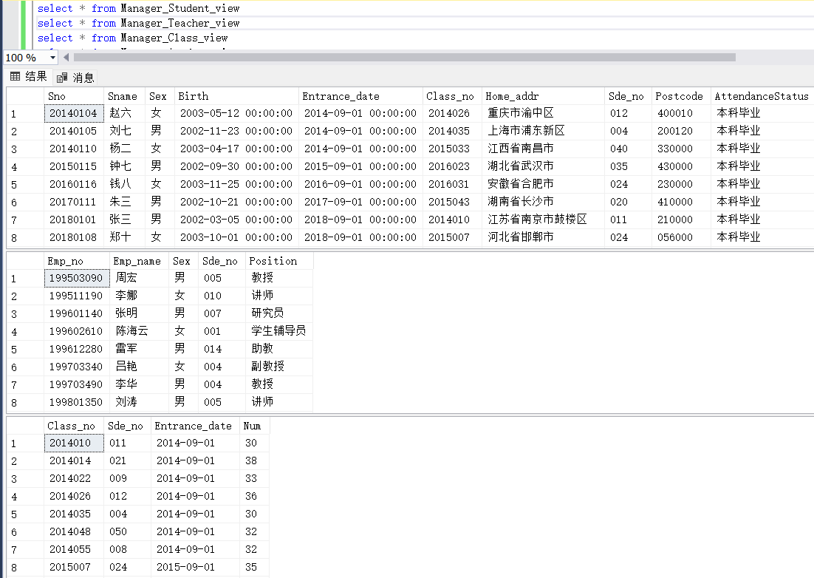

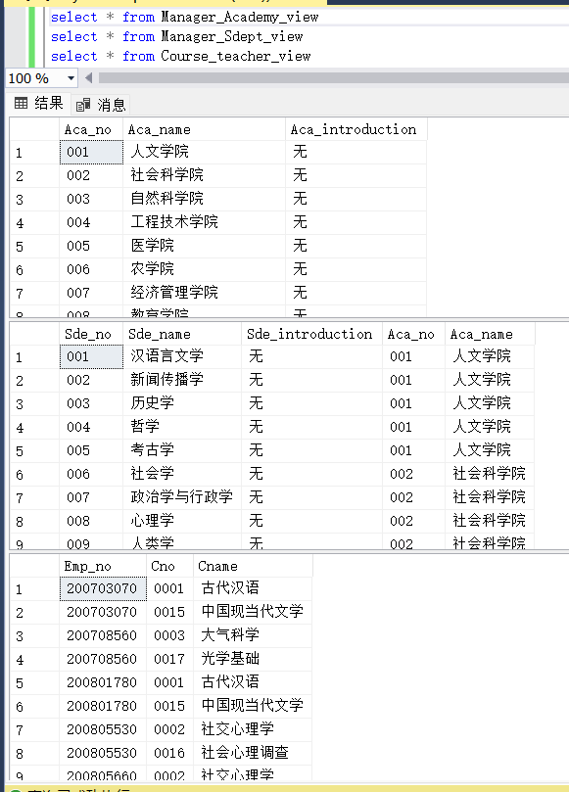

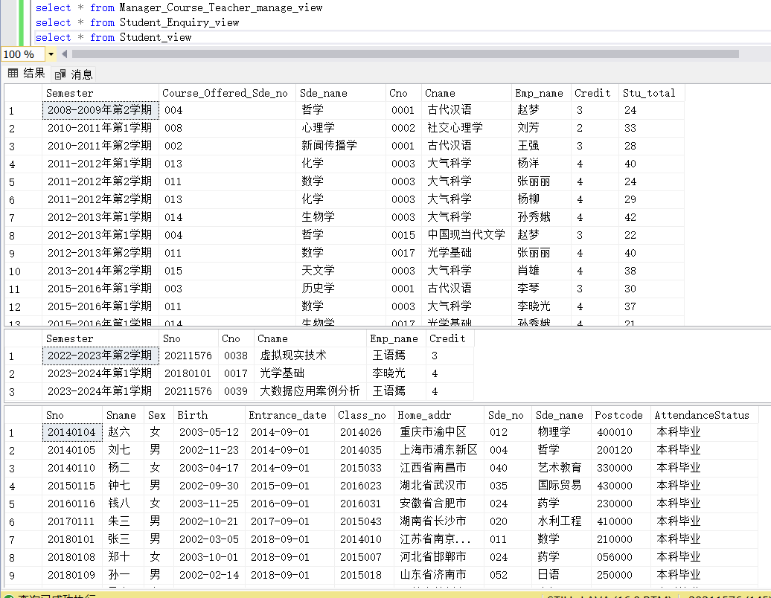

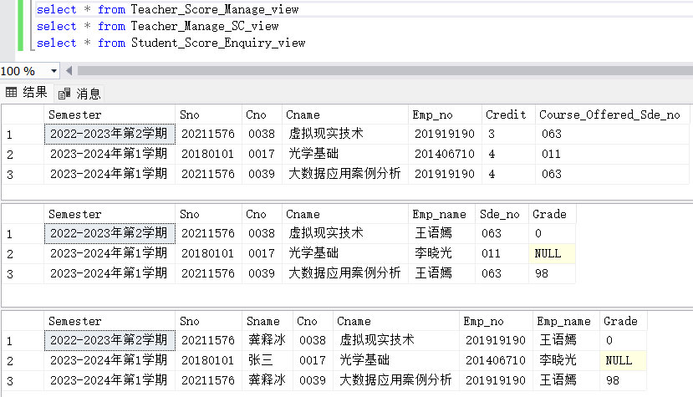

（4）存储过程的定义实现

（一）GetStudentCourseSummary（查询汇总出某学生某学期所选修的全部课程的学分、学时以及成绩、已经获得的学分统计等）

T-SQL语句：

CREATE PROCEDURE GetStudentCourseSummary

@semester char(20),

@sno char(9)

AS

BEGIN

SELECT

@sno AS '学号',

@semester AS '所在学期',

SUM(c.Credit) AS '总学分',

SUM(c.Total_perior) AS '总学时',

SUM(CASE WHEN sc.Grade IS NOT NULL THEN c.Credit ELSE 0 END) AS '已获得学分',

SUM(sc.Grade * c.Credit) / NULLIF(SUM(c.Credit), 0) AS '平均成绩'

FROM Course_20211576 c

INNER JOIN SC_20211576 sc ON c.Cno = sc.Cno

WHERE sc.Semester = @semester AND sc.Sno = @sno

END

在宿主语言中调用存储过程代码段（粘贴）：

if(e.getSource() == btnGetStudentCourseSummary){  
 String Driver2 = "com.microsoft.sqlserver.jdbc.SQLServerDriver";  
 String url = "jdbc:sqlserver://localhost:1433;DatabaseName=Academic_Affairs_Management_System_20211576;encrypt=false";  
 String userName = "s20211576"; *// 默认用户名* String userPwd = "s20211576"; *// 密码* Connection dbConn = null;  
 try {  
 Class.*forName*(Driver2);  
 dbConn = DriverManager.*getConnection*(url, userName, userPwd);  
 } catch (ClassNotFoundException e0) {  
 throw new RuntimeException(e0);  
 } catch (SQLException e1) {  
 throw new RuntimeException(e1);  
 }  
 int columnCount;  
 try {  
 Statement stmt = dbConn.createStatement();  
 ResultSet rs = stmt.executeQuery("EXEC GetStudentCourseSummary '" + comboSemester.getSelectedItem() + "', '" + textFieldStudentID.getText() + "'");  
 ResultSetMetaData rsmd = rs.getMetaData();  
 while (rs.next()) {  
 data[0][0] = rs.getString(1);  
 data[0][1] = rs.getString(2);  
 data[0][2] = rs.getString(3);  
 data[0][3] = rs.getString(4);  
 data[0][4] = rs.getString(5);  
 data[0][5] = rs.getString(6);  
 }  
  
 } catch (SQLException e2) {  
 throw new RuntimeException(e2);  
 } finally {  
 try {  
 dbConn.close();  
 } catch (SQLException e3) {  
 throw new RuntimeException(e3);  
 }  
 }  
 DefaultTableModel model = new DefaultTableModel(data, tableTitle);  
 table.setModel(model);

}

测试结果粘贴：

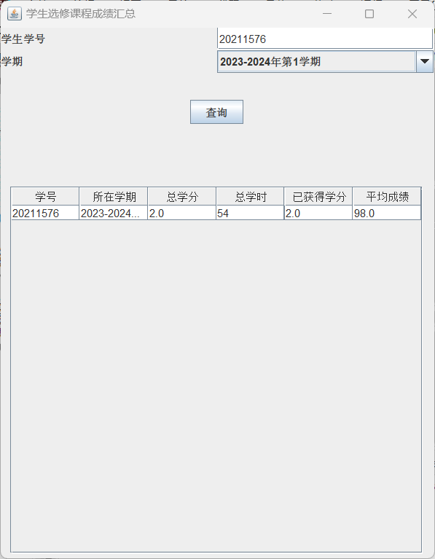

（二）GetClassSummary（查询汇总出某班某学期所有学生按学号排序、按平均绩点排序的学号、姓名以及平均绩点。）

T-SQL语句：

CREATE PROCEDURE GetClassSummary

@semester char(20),

@class_no char(7)

AS

BEGIN

SELECT

s.Sno,

s.Sname,

AVG(sc.Ji_Store) AS AverageGPA

FROM Student_20211576 s

INNER JOIN SC_20211576 sc ON s.Sno = sc.Sno

INNER JOIN Course_20211576 c ON sc.Cno = c.Cno

WHERE sc.Semester = @semester AND s.Class_no = @class_no

GROUP BY s.Sno, s.Sname

ORDER BY s.Sno ASC, AverageGPA DESC

END

在宿主语言中调用存储过程代码段（粘贴）：

if(e.getSource() == btnGetClassSummary){  
 String Driver2 = "com.microsoft.sqlserver.jdbc.SQLServerDriver";  
 String url = "jdbc:sqlserver://localhost:1433;DatabaseName=Academic_Affairs_Management_System_20211576;encrypt=false";  
 String userName = "s20211576"; *// 默认用户名* String userPwd = "s20211576"; *// 密码* Connection dbConn = null;  
 String sql = "EXEC GetClassSummary '"+comboSemester.getSelectedItem()+"','"+textClassno.getText()+"'";  
 try {  
 Class.*forName*(Driver2);  
 dbConn = DriverManager.*getConnection*(url, userName, userPwd);  
 } catch (ClassNotFoundException e0) {  
 throw new RuntimeException(e0);  
 } catch (SQLException e1) {  
 throw new RuntimeException(e1);  
 }  
 int columnCount;  
 try {  
 Statement stmt = dbConn.createStatement();  
 ResultSet rs = stmt.executeQuery(sql);  
 ResultSetMetaData rsmd = rs.getMetaData();  
 int count = 0;  
 while (rs.next()) {  
 data[count][0] = rs.getString("Sno");  
 data[count][1] = rs.getString("Sname");  
 data[count][2] = rs.getString("AverageGPA");  
 }  
 } catch (SQLException e2) {  
 throw new RuntimeException(e2);  
 } finally {  
 try {  
 dbConn.close();  
 } catch (SQLException e3) {  
 throw new RuntimeException(e3);  
 }  
 }  
 DefaultTableModel model = new DefaultTableModel(data, tableTitle);  
 table.setModel(model);  
}

测试结果粘贴：

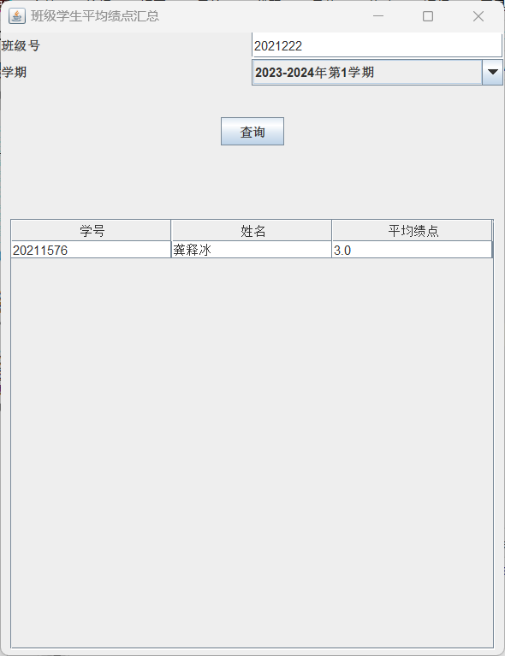

（5）触发器的定义实现

T-SQL语句：

1）trg_UpdateEntranceDate_Class：

CREATE TRIGGER trg_UpdateEntranceDate_Class

ON Class_20211576

AFTER INSERT, UPDATE

AS

BEGIN

UPDATE S

SET Entrance_date = SUBSTRING(S.Class_no, 1, 4) + '/09/01'

FROM Class_20211576 AS S

INNER JOIN (

SELECT DISTINCT Class_no FROM inserted

) AS T ON S.Class_no = T.Class_no

END

2)check_records_CourseAvail_Course_CourseTea

CREATE TRIGGER check_records_CourseAvail_Course_CourseTea

ON Course_Available_20211576

AFTER INSERT

AS

BEGIN

IF NOT EXISTS (

SELECT *

FROM inserted AS i

WHERE NOT EXISTS (

SELECT *

FROM Course_20211576

WHERE Cno = i.Cno AND Credit = i.Credit

) OR NOT EXISTS (

SELECT *

FROM Course_Teacher_20211576

WHERE Cno = i.Cno AND Emp_no = i.Emp_no

)

)

BEGIN

RAISERROR ('插入失败！Course_20211576或Course_Teacher_20211576不存在相同数据！', 16, 1);

ROLLBACK TRANSACTION;

RETURN;

END

END

3)trg_insert_from_course_chosen_to_SC：

CREATE TRIGGER trg_insert_from_course_chosen_to_SC

ON Course_chosen_20211576

AFTER INSERT

AS

BEGIN

INSERT INTO SC_20211576(Semester, Sno, Cno, Emp_no, Sde_no, Grade)

SELECT i.Semester, i.Sno, i.Cno, i.Emp_no, i.Course_Offered_Sde_no,0

FROM inserted i;

END

1. update_stu_chosen：

CREATE TRIGGER update_stu_chosen

ON Course_Chosen_20211576

AFTER INSERT

AS

BEGIN

UPDATE Course_Available_20211576

SET Stu_chosen = Stu_chosen + 1

WHERE Semester IN (SELECT Semester FROM inserted)

AND Emp_no IN (SELECT Emp_no FROM inserted)

AND Cno IN (SELECT Cno FROM inserted);

END

4)add_teacher_password：

CREATE TRIGGER add_teacher_password

ON Teacher_20211576

AFTER INSERT

AS

BEGIN

INSERT INTO Password_20211576 (id, name, position, password)

SELECT i.Emp_no, i.Emp_name, i.Position, '123456'

FROM inserted i

WHERE NOT EXISTS (

SELECT * FROM Password_20211576 WHERE id = i.Emp_no AND position = i.Position

);

END

5)delete_Teacher_Password：

CREATE TRIGGER delete_Teacher_Password

ON Teacher_20211576

INSTEAD OF DELETE

AS

BEGIN

DECLARE @DeletedEmp_no TABLE (Emp_no char(9));

INSERT INTO @DeletedEmp_no (Emp_no)

SELECT Emp_no FROM DELETED;

DELETE FROM Course_chosen_20211576 WHERE Cno IN (SELECT Cno FROM Course_Available_20211576 WHERE Emp_no IN (SELECT Emp_no FROM @DeletedEmp_no));

DELETE FROM Password_20211576 WHERE id IN (SELECT Emp_no FROM @DeletedEmp_no);

DELETE FROM Course_Available_20211576 WHERE Emp_no IN (SELECT Emp_no FROM @DeletedEmp_no);

DELETE FROM Course_Teacher_20211576 WHERE Emp_no IN (SELECT Emp_no FROM @DeletedEmp_no);

DELETE FROM Teacher_20211576 WHERE Emp_no IN (SELECT Emp_no FROM @DeletedEmp_no);

END

6)trg_NewStudent：

CREATE TRIGGER trg_NewStudent

ON Student_20211576

AFTER INSERT

AS

BEGIN

INSERT INTO Password_20211576 (id, name, position, password)

SELECT i.Sno, i.Sname, '学生', '123456'

FROM inserted i

END

7)delete_Student_Password：

CREATE TRIGGER delete_Student_Password

ON Student_20211576

AFTER DELETE

AS

BEGIN

DELETE FROM Course_chosen_20211576 WHERE Sno IN (

SELECT Sno FROM deleted

);

DELETE FROM Password_20211576 WHERE id IN (

SELECT Sno FROM deleted

);

DELETE FROM SC_20211576 WHERE Sno IN (

SELECT Sno FROM deleted

);

UPDATE Course_Available_20211576 SET Stu_chosen = Stu_chosen - 1 WHERE Cno IN (

SELECT DISTINCT Cno FROM SC_20211576 WHERE Sno IN (

SELECT Sno FROM deleted

)

);

END;

8)trg_delete_info：

CREATE TRIGGER trg_delete_info

ON Academy_20211576

INSTEAD OF DELETE

AS

BEGIN

DELETE FROM Password_20211576 WHERE id IN (SELECT Sno FROM Student_20211576 WHERE Sde_no IN (SELECT Sde_no FROM Sdept_20211576 JOIN deleted d ON Sdept_20211576.Aca_no = d.Aca_no));

DELETE FROM Password_20211576 WHERE id IN (SELECT Emp_no FROM Teacher_20211576 WHERE Sde_no IN (SELECT Sde_no FROM Sdept_20211576 JOIN deleted d ON Sdept_20211576.Aca_no = d.Aca_no));

DELETE c FROM Class_20211576 c JOIN deleted d ON c.Sde_no IN (SELECT s.Sde_no FROM Sdept_20211576 s WHERE s.Aca_no = d.Aca_no);

DELETE sc FROM SC_20211576 sc WHERE sc.Cno IN (SELECT co.Cno FROM Course_20211576 co JOIN deleted d ON co.Aca_no = d.Aca_no);

DELETE ccs FROM Course_chosen_20211576 ccs WHERE ccs.Cno IN (SELECT co.Cno FROM Course_20211576 co JOIN deleted d ON co.Aca_no = d.Aca_no);

DELETE st FROM Student_20211576 st JOIN deleted d ON st.Sde_no IN (SELECT s.Sde_no FROM Sdept_20211576 s WHERE s.Aca_no = d.Aca_no);

DELETE t FROM Teacher_20211576 t JOIN deleted d ON t.Sde_no IN (SELECT s.Sde_no FROM Sdept_20211576 s WHERE s.Aca_no = d.Aca_no);

DELETE s FROM Sdept_20211576 s JOIN deleted d ON s.Aca_no = d.Aca_no;

DELETE cas FROM Course_Available_20211576 cas WHERE cas.Cno IN (SELECT co.Cno FROM Course_20211576 co JOIN deleted d ON co.Aca_no = d.Aca_no);

DELETE cts FROM Course_Teacher_20211576 cts WHERE cts.Cno IN (SELECT co.Cno FROM Course_20211576 co JOIN deleted d ON co.Aca_no = d.Aca_no);

DELETE co FROM Course_20211576 co JOIN deleted d ON co.Aca_no = d.Aca_no;

END

9)delete_course_trigger：

CREATE TRIGGER delete_course_trigger

ON Course_20211576

INSTEAD OF DELETE

AS

BEGIN

BEGIN TRANSACTION;

DELETE FROM SC_20211576 WHERE Cno IN (SELECT Cno FROM deleted);

DELETE FROM Course_chosen_20211576 WHERE Cno IN (SELECT Cno FROM deleted);

DELETE FROM Course_Available_20211576 WHERE Cno IN (SELECT Cno FROM deleted);

DELETE FROM Course_Teacher_20211576 WHERE Cno IN (SELECT Cno FROM deleted);

DELETE FROM Course_20211576 WHERE Cno IN (SELECT Cno FROM deleted);

COMMIT TRANSACTION;

END

10)delete_course_teacher_trigger：

CREATE TRIGGER delete_course_teacher_trigger

ON Course_Teacher_20211576

INSTEAD OF DELETE AS

BEGIN

DELETE FROM SC_20211576 WHERE Cno IN (SELECT Cno FROM deleted);

DELETE FROM Course_chosen_20211576 WHERE Cno IN (SELECT Cno FROM deleted);

DELETE FROM Course_Available_20211576 WHERE Cno IN (SELECT Cno FROM deleted);

DELETE FROM Course_Teacher_20211576 WHERE Cno IN (SELECT Cno FROM deleted);

END;

11)delete_course_available_trigger：

CREATE TRIGGER delete_course_available_trigger

ON Course_Available_20211576

INSTEAD OF DELETE AS

BEGIN

DELETE FROM SC_20211576 WHERE Cno IN (SELECT Cno FROM deleted);

DELETE FROM Course_chosen_20211576 WHERE Cno IN (SELECT Cno FROM deleted);

DELETE FROM Course_Available_20211576 WHERE Cno IN (SELECT Cno FROM deleted);

END;

12)delete_course_chosen_trigger：

CREATE TRIGGER delete_course_chosen_trigger

ON Course_chosen_20211576

INSTEAD OF DELETE AS

BEGIN

DELETE FROM SC_20211576 WHERE Cno IN (SELECT Cno FROM deleted);

DELETE FROM Course_chosen_20211576 WHERE Cno IN (SELECT Cno FROM deleted);

END;

测试结果粘贴：

（6）自行设计各模块中所涉及的操作语句

1）插入数据操作

功能模块1：教务管理系统学生界面-学生选课界面选课

功能界面：

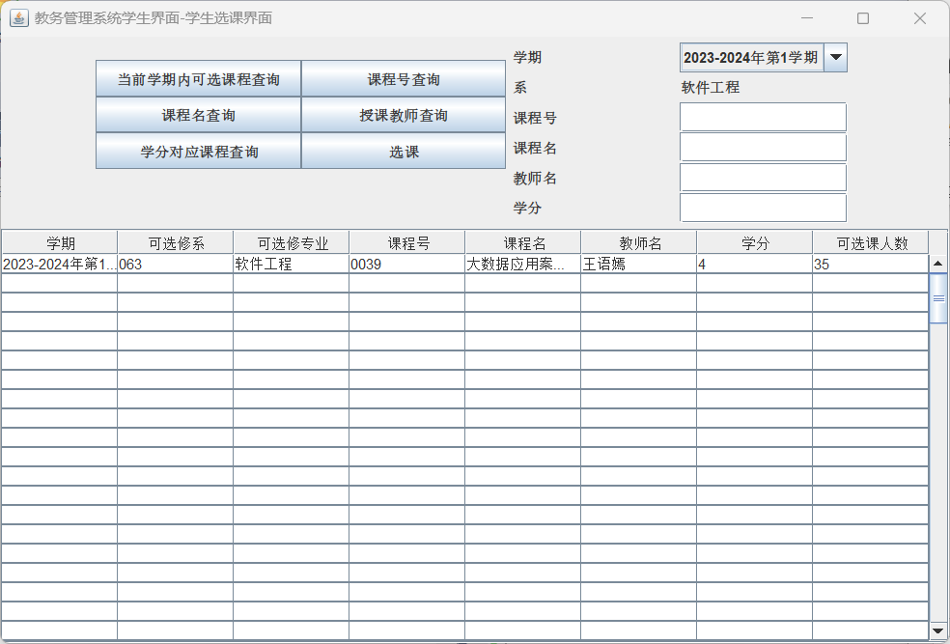

描述：点击选课按钮前需要先选中表格中一项，若未选会弹出报错窗口，点击选课后，若该课已经被该同学选过，则会弹窗提示该课程已选，若未选过，则会弹窗提示选课成功。

T-SQL语句与宿主语言嵌套使用代码段（粘贴）；

@Override  
public void actionPerformed(ActionEvent e) {  
 if (e.getSource() == btnChoose) {  
 if(sqlInsert.equals("")) {  
 JOptionPane.*showMessageDialog*(null, "请先选择课程！", "提示", JOptionPane.*ERROR_MESSAGE*);  
 }else {  
 String Driver2 = "com.microsoft.sqlserver.jdbc.SQLServerDriver";  
 String url = "jdbc:sqlserver://localhost:1433;DatabaseName=Academic_Affairs_Management_System_20211576;encrypt=false";  
 String userName = "s20211576"; *// 默认用户名* String userPwd = "s20211576"; *// 密码* Connection dbConn = null;  
 try {  
 Class.*forName*(Driver2);  
 dbConn = DriverManager.*getConnection*(url, userName, userPwd);  
 } catch (ClassNotFoundException ec) {  
 throw new RuntimeException(ec);  
 } catch (SQLException ex) {  
 throw new RuntimeException(ex);  
 }  
 try {  
 Statement stmt = dbConn.createStatement();  
 System.*out*.println("sqlInsert:"+sqlInsert);  
 if(checkInsert(sqlCheck) == true){*//checkInsert:检查该生是否已选过这门课* JOptionPane.*showMessageDialog*(null, "该课程已选！", "提示", JOptionPane.*ERROR_MESSAGE*);  
 dbConn.close();  
 return;  
 }  
 else{  
 JOptionPane.*showMessageDialog*(null, "选课成功！", "提示", JOptionPane.*INFORMATION_MESSAGE*);  
 }  
 ResultSet rs = stmt.executeQuery(sqlInsert);  
  
 } catch (SQLException ee) {  
 throw new RuntimeException(ee);  
 } finally {  
 try {  
 dbConn.close();  
 } catch (SQLException exc) {  
 throw new RuntimeException(exc);  
 }  
 }  
 DefaultTableModel model = new DefaultTableModel(data, columnNames);  
 table.setModel(model);  
 }  
 }  
 if (e.getSource() == btnEnquiry){  
 for (int i = 0; i < getColumns(); i++) {  
 for (int j = 0; j < 8; j++) {  
 data[i][j] = "";  
 }  
 }  
 String Driver2 = "com.microsoft.sqlserver.jdbc.SQLServerDriver";  
 String url = "jdbc:sqlserver://localhost:1433;DatabaseName=Academic_Affairs_Management_System_20211576;encrypt=false";  
 String userName = "s20211576"; *// 默认用户名* String userPwd = "s20211576"; *// 密码* String sql = "use Academic_Affairs_Management_System_20211576 select * from Manager_Course_Teacher_manage_view where 1=1 ";  
 if (txtCourseNo.getText().trim().length() != 0) {  
 sql += " and Cno='" + txtCourseNo.getText().trim() + "'";  
 }  
 if (txtCourseName.getText().trim().length() != 0) {  
 sql += " and Cname='" + txtCourseName.getText().trim() + "'";  
 }  
 if (txtTeacherName.getText().trim().length() != 0) {  
 sql += " and Emp_name='" + txtTeacherName.getText().trim() + "'";  
 }  
 if (txtCredit.getText().trim().length() != 0) {  
 sql += " and Credit='" + txtCredit.getText().trim() + "'";  
 }  
 if (txtCourseNum.getText().trim().length() != 0) {  
 sql += " and Stu_total='" + txtCourseNum.getText().trim() + "'";  
 }  
 if (comSemester.getSelectedItem().toString().trim().length() != 0) {  
 sql += " and Semester='" + comSemester.getSelectedItem().toString().trim() + "'";  
 }  
 Connection dbConn = null;  
 try {  
 Class.*forName*(Driver2);  
 dbConn = DriverManager.*getConnection*(url, userName, userPwd);  
 } catch (ClassNotFoundException ea) {  
 throw new RuntimeException(ea);  
 } catch (SQLException eb) {  
 throw new RuntimeException(eb);  
 }  
 try {  
 Statement stmt = dbConn.createStatement();  
 ResultSet rs = stmt.executeQuery(sql);  
 int count = 0;  
 while (rs.next()) {  
 data[count][0] = rs.getString("Semester");  
 data[count][1] = rs.getString("Course_Offered_Sde_no");  
 data[count][2] = rs.getString("Sde_name");  
 data[count][3] = rs.getString("Cno");  
 data[count][4] = rs.getString("Cname");  
 data[count][5] = rs.getString("Emp_name");  
 data[count][6] = rs.getString("Credit");  
 data[count][7] = rs.getString("Stu_total");  
 count++;  
 }  
 } catch (SQLException ex) {  
 throw new RuntimeException(ex);  
 } finally {  
 try {  
 dbConn.close();  
 } catch (SQLException exc) {  
 throw new RuntimeException(exc);  
 }  
 }  
 DefaultTableModel model = new DefaultTableModel(data, columnNames);  
 table.setModel(model);  
 }  
 *// 添加监听器，监听表格的行选中事件* table.getSelectionModel().addListSelectionListener(new ListSelectionListener() {  
 public void valueChanged(ListSelectionEvent event) {  
 *// 获取当前选中行的索引* int row = table.getSelectedRow();  
 if (row >= 0) {  
 *// 获取选中行的各列的数据* String insertSemester = table.getValueAt(row, 0).toString();  
 String insertSno = loginID.toString();  
 String insertCourseOfferedSdeNo = table.getValueAt(row, 1).toString();  
 String insertCno = table.getValueAt(row, 3).toString();  
 String insertCname = table.getValueAt(row, 4).toString();  
 *//中间变量insertEmpName* String insertEmpName = table.getValueAt(row, 5).toString();  
 String insertEmpNo = getEmpNo(insertEmpName);  
 String insertCredit = table.getValueAt(row, 6).toString();  
 String insertStuTotal = table.getValueAt(row, 7).toString();  
 sqlInsert = "INSERT INTO Course_chosen_20211576(Semester,Sno,Cno,Cname,Emp_no,Credit,Course_Offered_Sde_no) VALUES ('" + insertSemester.trim() + "','" + insertSno.trim() + "','" + insertCno.trim() + "','" + insertCname.trim() + "','" + insertEmpNo.trim() + "'," + insertCredit + ",'" + insertCourseOfferedSdeNo.trim() + "')";  
 sqlCheck = "SELECT * FROM Course_chosen_20211576 where Sno='" + insertSno.trim() + "' and Cno='" + insertCno.trim() + "' and Semester='" + insertSemester.trim() + "' and Course_Offered_Sde_no='" + insertCourseOfferedSdeNo.trim() + "' and Emp_no='" + insertEmpNo.trim() + "'";  
 }  
 }  
 });  
}

测试结果粘贴：

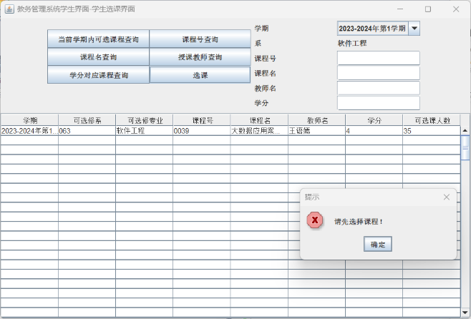

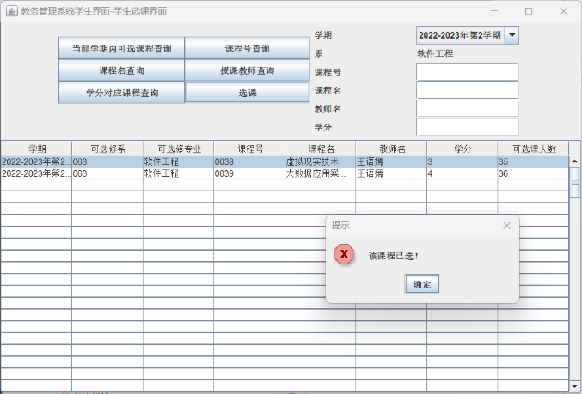 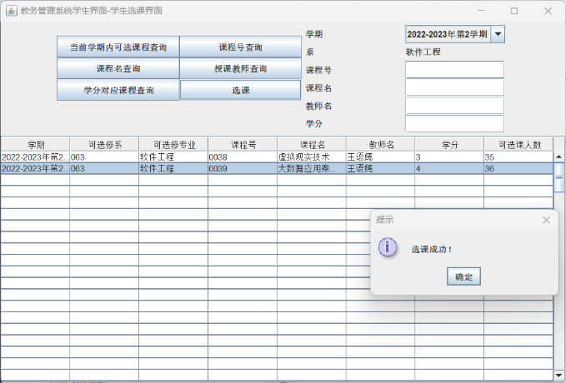

功能模块2：教务管理系统管理员界面-添加学院信息

功能界面：

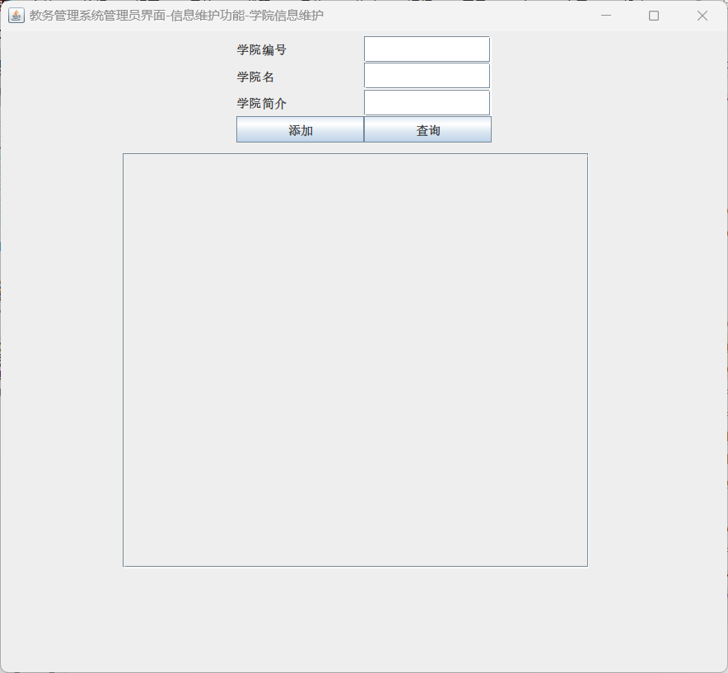

描述：点击教务管理系统管理员界面，打开如图界面，点击查询按钮，会从Manager_Academy_view中查询学院的相关信息，若为空，查询所有学院信息，若不为空，从上到下，按照没空的顺序依序查询（单项查询）。

T-SQL语句与宿主语言嵌套使用代码段（粘贴）：

@Override  
public void actionPerformed(ActionEvent e) {  
 if (e.getSource() == btnAdd){  
 if(textAcaNo.getText().trim().equals("") == false  
 && textAcaName.getText().trim().equals("") == false  
 && textAcaIntroduction.getText().trim().equals("") == false){  
 String Driver = "com.microsoft.sqlserver.jdbc.SQLServerDriver";  
 String url = "jdbc:sqlserver://localhost:1433;DatabaseName=Academic_Affairs_Management_System_20211576;encrypt=false";  
 String userName = "s20211576"; *// 默认用户名* String userPwd = "s20211576"; *// 密码* String sql0 = "use Academic_Affairs_Management_System_20211576 select * from Manager_Academy_view where Aca_no ='"+textAcaNo.getText()+"'";  
 String sql = "insert into Academic_Affairs_Management_System_20211576.dbo.Academy_20211576(Aca_no,Aca_name,Aca_introduction) " +  
 "values('"+textAcaNo.getText()+"','"+textAcaName.getText()+"','"+textAcaIntroduction.getText()+"')";  
 Connection dbConn = null;  
 try {  
 Class.*forName*(Driver);  
 dbConn = DriverManager.*getConnection*(url, userName, userPwd);  
 System.*out*.println(sql0); *// 如果连接成功 控制台输出* System.*out*.println(sql);  
 Statement stmt = dbConn.createStatement();  
 ResultSet rs0 = stmt.executeQuery(sql0);  
 String Aca_no = "";  
 while(rs0.next()){  
 Aca_no += rs0.getString("Aca_no");  
 }  
 if(Aca_no.equals("") == false){  
 JOptionPane.*showMessageDialog*(null, "名字为"+textAcaName.getText()+"的学院信息已存在！", "提示", JOptionPane.*INFORMATION_MESSAGE*);  
 }  
 else{  
 JOptionPane.*showMessageDialog*(null, "名字为"+textAcaName.getText()+"的学院信息添加成功！", "提示", JOptionPane.*INFORMATION_MESSAGE*);  
 ResultSet rs = stmt.executeQuery(sql);  
 rs.close();  
 }  
 rs0.close();  
 stmt.close();  
 dbConn.close();  
 } catch (Exception em) {  
 em.printStackTrace();  
 } finally {  
 try {  
 } catch (Exception ec) {  
 ec.printStackTrace();  
 }  
 }  
 }  
 else{  
 JOptionPane.*showMessageDialog*(null,"请填写完整信息!");  
 }  
 }  
 if (e.getSource() == btnSearch){  
 for (int i = 0; i < getColumns(); i++) {  
 for (int j = 0; j < 10; j++) {  
 data[i][j] = "";  
 }  
 }  
 if (textAcaNo.getText().toString().equals("") == true  
 && textAcaName.getText().toString().equals("") == true  
 && textAcaIntroduction.getText().toString().equals("") == true){  
 String Driver = "com.microsoft.sqlserver.jdbc.SQLServerDriver";  
 String url = "jdbc:sqlserver://localhost:1433;DatabaseName=Academic_Affairs_Management_System_20211576;encrypt=false";  
 String userName = "s20211576"; *// 默认用户名* String userPwd = "s20211576"; *// 密码* String sql = "use Academic_Affairs_Management_System_20211576 select * from Manager_Academy_view";  
 Connection dbConn = null;  
 try {  
 Class.*forName*(Driver);  
 dbConn = DriverManager.*getConnection*(url, userName, userPwd);  
 Statement stmt = dbConn.createStatement();  
 ResultSet rs = stmt.executeQuery(sql);  
 ResultSetMetaData rsmd = rs.getMetaData();  
 int numColumns = rsmd.getColumnCount();  
 int row = 0;  
 while (rs.next()) {  
 for (int col = 0; col < numColumns; col++) {  
 data[row][col] = rs.getString(col + 1);  
 }  
 row++;  
 }  
 rs.close();  
 stmt.close();  
 dbConn.close();  
 } catch (Exception em) {  
 em.printStackTrace();  
 } finally {  
 try {  
 } catch (Exception ec) {  
 ec.printStackTrace();  
 }  
 }  
 }  
 else {  
 for (int i = 0; i < getColumns(); i++) {  
 for (int j = 0; j < 8; j++) {  
 data[i][j] = "";  
 }  
 }  
 String input = null;  
 String sql = null;  
 if (!textAcaNo.getText().isEmpty()) {  
 input = textAcaNo.getText();  
 sql = "SELECT * FROM Manager_Academy_view WHERE Aca_no = ?";  
 } else if (!textAcaName.getText().isEmpty()) {  
 input = textAcaName.getText();  
 sql = "SELECT * FROM Manager_Academy_view WHERE Aca_name = ?";  
 } else if (!textAcaIntroduction.getText().isEmpty()) {  
 input = textAcaIntroduction.getText();  
 sql = "SELECT * FROM Manager_Academy_view WHERE Aca_introduction = ?";  
 }  
 String driver = "com.microsoft.sqlserver.jdbc.SQLServerDriver";  
 String url = "jdbc:sqlserver://localhost:1433;DatabaseName=Academic_Affairs_Management_System_20211576;encrypt=false";  
 String username = "s20211576";  
 String password = "s20211576";  
 try (Connection conn = DriverManager.*getConnection*(url, username, password);  
 PreparedStatement pstmt = conn.prepareStatement(sql)) {  
 pstmt.setString(1, input);  
 ResultSet rs = pstmt.executeQuery();  
 int count = 0;  
 while (rs.next()) {  
 data[count][0] = rs.getString("Aca_no");  
 data[count][1] = rs.getString("Aca_name");  
 data[count][2] = rs.getString("Aca_introduction");  
 count++;  
 }  
 rs.close();  
 } catch (Exception e1) {  
 e1.printStackTrace();  
 }  
 }  
 DefaultTableModel model = new DefaultTableModel(data, columnNames);  
 table.setModel(model);  
 }  
}

测试结果：

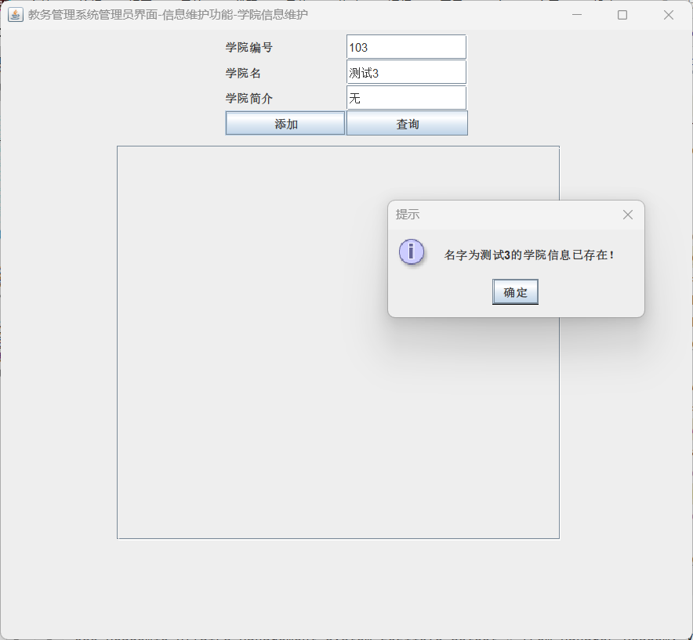

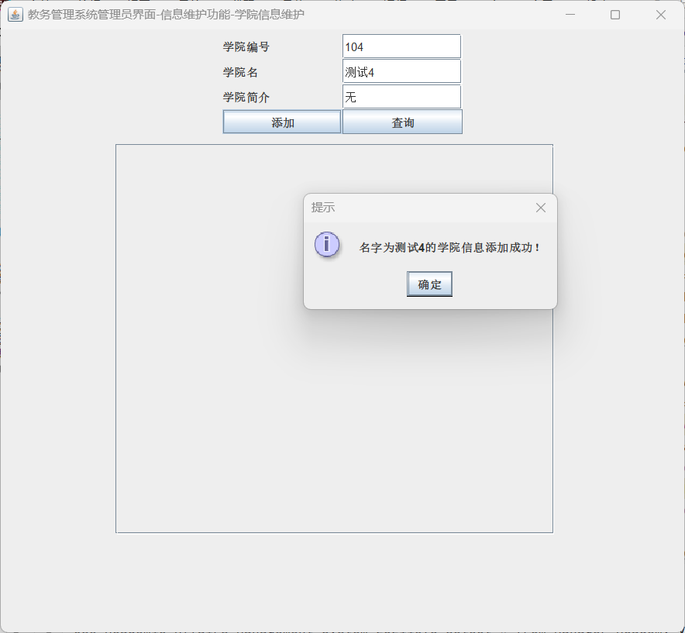

功能模块3：教务管理系统管理员界面-增加班级信息

功能界面：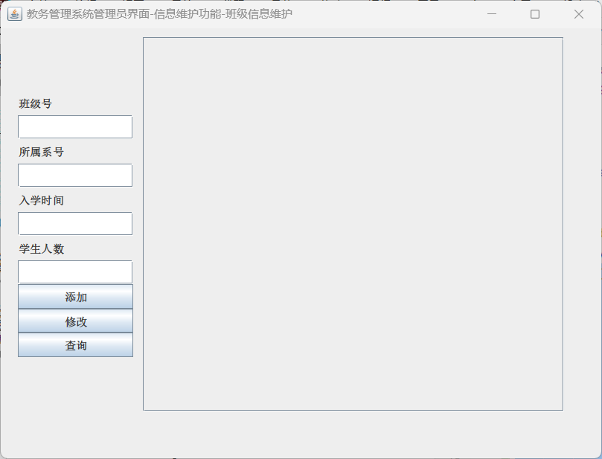

描述：点击教务管理系统管理员界面，打开如图界面，点击查询按钮，会从Manager_Class_view中查询班级的相关信息，若为空，查询所有班级信息，若不为空，从上到下，按照没空的顺序依序查询（单项查询）。

T-SQL语句与宿主语言嵌套使用代码段（粘贴）：

@Override  
public void actionPerformed(ActionEvent e) {  
 if (e.getSource() == btnAdd) {  
 if (textClassNo.getText().trim().equals("") == false  
 && textSdeNo.getText().trim().equals("") == false  
 && textEntranceDate.getText().trim().equals("") == false  
 && textNum.getText().trim().equals("") == false) {  
 String Driver = "com.microsoft.sqlserver.jdbc.SQLServerDriver";  
 String url = "jdbc:sqlserver://localhost:1433;DatabaseName=Academic_Affairs_Management_System_20211576;encrypt=false";  
 String userName = "s20211576"; *// 默认用户名* String userPwd = "s20211576"; *// 密码* String sql0 = "use Academic_Affairs_Management_System_20211576 select * from Manager_Class_view where Class_no ='" + textClassNo.getText() + "'";  
 String sql = "insert into Academic_Affairs_Management_System_20211576.dbo.Class_20211576(Class_no,Sde_no,Entrance_date,Num) values('" + textClassNo.getText() + "','" + textSdeNo.getText() + "','" + textEntranceDate.getText() + "'," + textNum.getText() + ")";  
 Connection dbConn = null;  
 try {  
 Class.*forName*(Driver);  
 dbConn = DriverManager.*getConnection*(url, userName, userPwd);  
 System.*out*.println(sql0); *// 如果连接成功 控制台输出* System.*out*.println(sql);  
 Statement stmt = dbConn.createStatement();  
 ResultSet rs0 = stmt.executeQuery(sql0);  
 String Class_no = "";  
 while (rs0.next()) {  
 Class_no += rs0.getString("Class_no");  
 }  
 if (Class_no.equals("") == false) {  
 JOptionPane.*showMessageDialog*(null, "班级号为" + textClassNo.getText() + "的班级信息已存在！", "提示", JOptionPane.*INFORMATION_MESSAGE*);  
 } else {  
 JOptionPane.*showMessageDialog*(null, "班级号为" + textClassNo.getText() + "的班级信息添加成功！", "提示", JOptionPane.*INFORMATION_MESSAGE*);  
 ResultSet rs = stmt.executeQuery(sql);  
 rs.close();  
 }  
 rs0.close();  
 stmt.close();  
 dbConn.close();  
 } catch (Exception em) {  
 em.printStackTrace();  
 } finally {  
 try {  
 } catch (Exception ec) {  
 ec.printStackTrace();  
 }  
 }  
 } else {  
 JOptionPane.*showMessageDialog*(null, "请填写完整信息!");  
 }  
 }

运行结果：

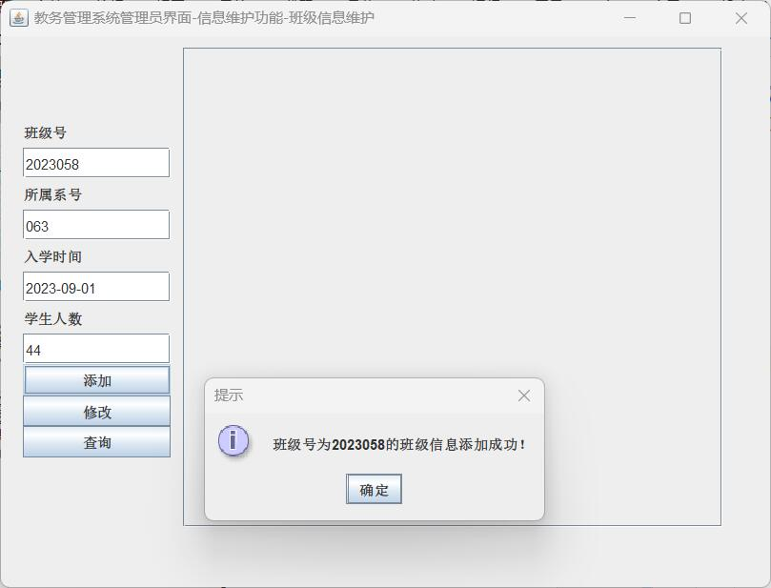

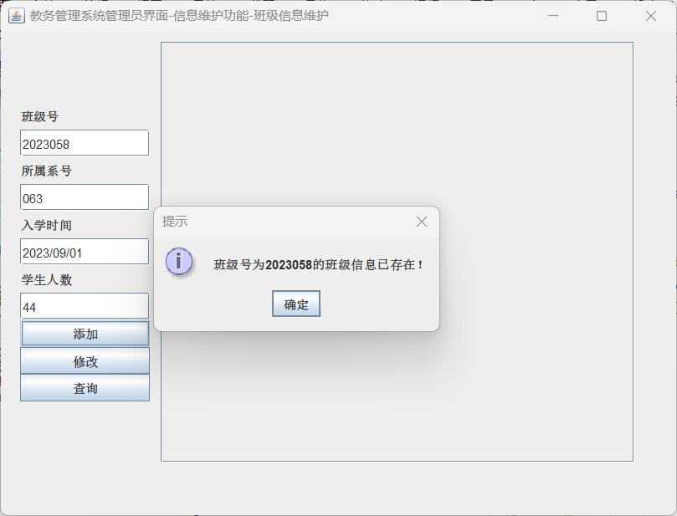

数据模块4：教务管理系统管理员界面-增加专业信息

功能界面：

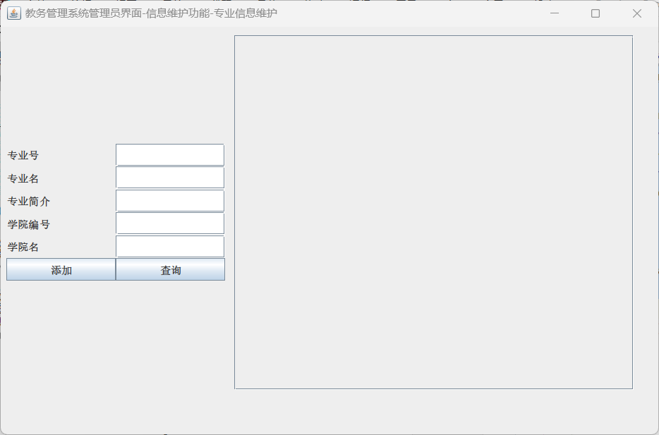

描述：点击教务管理系统管理员界面，打开如图界面，点击查询按钮，会从Manager_Sdept_view中查询专业的相关信息，若为空，查询所有专业信息，若不为空，从上到下，按照没空的顺序依序查询（单项查询）。

T-SQL语句与宿主语言嵌套使用代码段（粘贴）：

if (e.getSource() == btnAdd) {  
 if (textSdeNo.getText().trim().equals("") == false  
 && textSdeName.getText().trim().equals("") == false  
 && textSdeIntroduction.getText().trim().equals("") == false  
 && textAcaNo.getText().trim().equals("") == false  
 && textAcaName.getText().trim().equals("") == false) {  
 String Driver = "com.microsoft.sqlserver.jdbc.SQLServerDriver";  
 String url = "jdbc:sqlserver://localhost:1433;DatabaseName=Academic_Affairs_Management_System_20211576;encrypt=false";  
 String userName = "s20211576"; *// 默认用户名* String userPwd = "s20211576"; *// 密码* String sql0 = "use Academic_Affairs_Management_System_20211576 select * from Manager_Sdept_view where Sde_no ='" + textSdeNo.getText() + "'";  
 String sql = "insert into Academic_Affairs_Management_System_20211576.dbo.Sdept_20211576(Sde_no,Sde_name,Sde_introduction,Aca_no,Aca_name) values('" + textSdeNo.getText() + "','" + textSdeName.getText() + "','" + textSdeIntroduction.getText() + "','" + textAcaNo.getText() + "','" + textAcaName.getText() + "')";  
 Connection dbConn = null;  
 try {  
 Class.*forName*(Driver);  
 dbConn = DriverManager.*getConnection*(url, userName, userPwd);  
 System.*out*.println(sql0); *// 如果连接成功 控制台输出* System.*out*.println(sql);  
 Statement stmt = dbConn.createStatement();  
 ResultSet rs0 = stmt.executeQuery(sql0);  
 String Class_no = "";  
 while (rs0.next()) {  
 Class_no += rs0.getString("Sde_no");  
 }  
 if (Class_no.equals("") == false) {  
 JOptionPane.*showMessageDialog*(null, "专业号为" + textSdeNo.getText() + "的专业信息已存在！", "提示", JOptionPane.*INFORMATION_MESSAGE*);  
 } else {  
 JOptionPane.*showMessageDialog*(null, "专业号为" + textSdeNo.getText() + "的专业信息添加成功！", "提示", JOptionPane.*INFORMATION_MESSAGE*);  
 ResultSet rs = stmt.executeQuery(sql);  
 rs.close();  
 }  
 rs0.close();  
 stmt.close();  
 dbConn.close();  
 } catch (Exception em) {  
 em.printStackTrace();  
 } finally {  
 try {  
 } catch (Exception ec) {  
 ec.printStackTrace();  
 }  
 }  
 } else {  
 JOptionPane.*showMessageDialog*(null, "请填写完整信息!");  
 }  
}

运行结果：

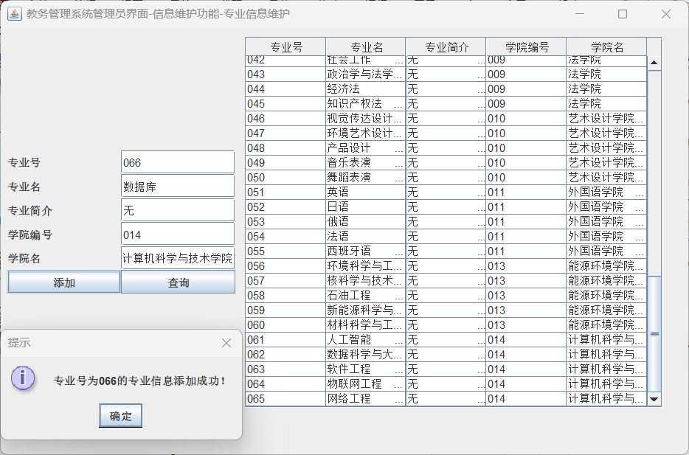

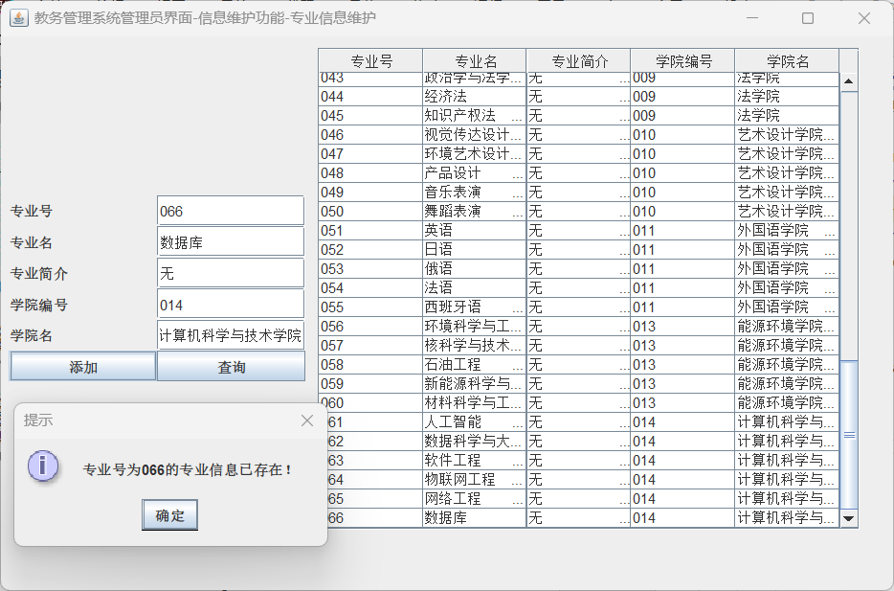

数据模块5：教务管理系统管理员界面-增加学生信息

功能界面：

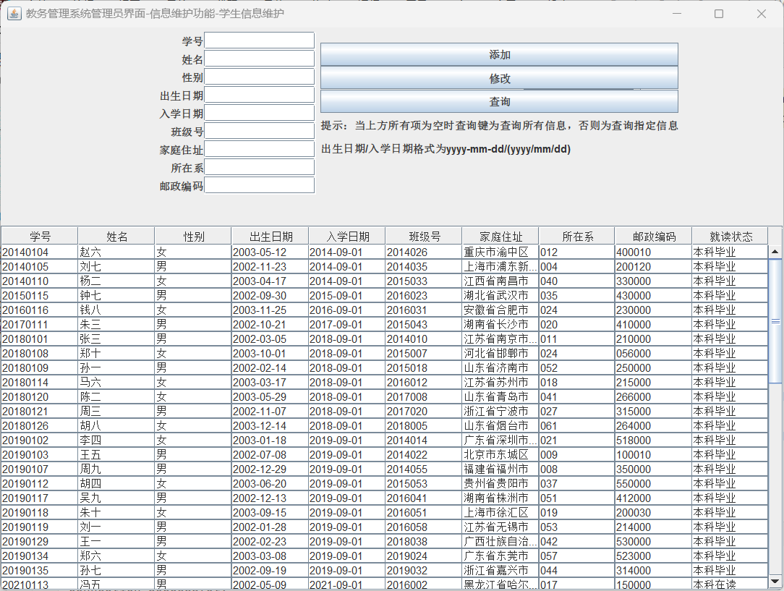

描述：点击教务管理系统管理员界面，打开如图界面，点击查询按钮，会从Manager_Sdept_view中查询相关学生的信息，若为空，查询所有学生信息，若不为空，从上到下，按照没空的顺序依序查询（单项查询）。

T-SQL语句与宿主语言嵌套使用代码段（粘贴）：

if (e.getSource() == btnAdd) {  
 if(textNo.getText().trim().equals("") == false  
 && textName.getText().trim().equals("") == false  
 && textSex.getText().trim().equals("") == false  
 && textBirth.getText().trim().equals("") == false  
 && textEntrancedate.getText().trim().equals("") == false  
 && textClassno.getText().trim().equals("") == false  
 && textHomeaddress.getText().trim().equals("") == false  
 && textSdept.getText().trim().equals("") == false) {  
 String Driver = "com.microsoft.sqlserver.jdbc.SQLServerDriver";  
 String url = "jdbc:sqlserver://localhost:1433;DatabaseName=Academic_Affairs_Management_System_20211576;encrypt=false";  
 String userName = "s20211576"; *// 默认用户名* String userPwd = "s20211576"; *// 密码* String sql0 = "use Academic_Affairs_Management_System_20211576 select * from Manager_Student_view where Sde_no ='" + textNo.getText() + "'";  
 String sql = "insert into Academic_Affairs_Management_System_20211576.dbo.Student_20211576(Sno,Sname,Sex,Birth,Entrance_date,Class_no,Home_addr,Sde_no,Postcode) values('"+textNo.getText()+"','"+textName.getText()+"','"+textSex.getText()+"',"+textBirth.getText()+","+textEntrancedate.getText()+",'"+textClassno.getText()+"','"+textHomeaddress.getText()+"','"+textSdept.getText()+"','"+textPostcode.getText()+"')";  
 Connection dbConn = null;  
 try {  
 Class.*forName*(Driver);  
 dbConn = DriverManager.*getConnection*(url, userName, userPwd);  
 System.*out*.println(sql0); *// 如果连接成功 控制台输出* System.*out*.println(sql);  
 Statement stmt = dbConn.createStatement();  
 ResultSet rs0 = stmt.executeQuery(sql0);  
 String Class_no = "";  
 while (rs0.next()) {  
 Class_no += rs0.getString("Sno");  
 }  
 if (Class_no.equals("") == false) {  
 JOptionPane.*showMessageDialog*(null, "学号为"+textNo.getText()+"的同学信息已存在!", "提示", JOptionPane.*INFORMATION_MESSAGE*);  
 } else {  
 JOptionPane.*showMessageDialog*(null, "学号为"+textNo.getText()+"的同学信息添加成功!", "提示", JOptionPane.*INFORMATION_MESSAGE*);  
 ResultSet rs = stmt.executeQuery(sql);  
 rs.close();  
 }  
 rs0.close();  
 stmt.close();  
 dbConn.close();  
 } catch (Exception em) {  
 em.printStackTrace();  
 } finally {  
 try {  
 } catch (Exception ec) {  
 ec.printStackTrace();  
 }  
 }  
 } else {  
 JOptionPane.*showMessageDialog*(null, "请填写完整信息!");  
 }  
}

运行结果：

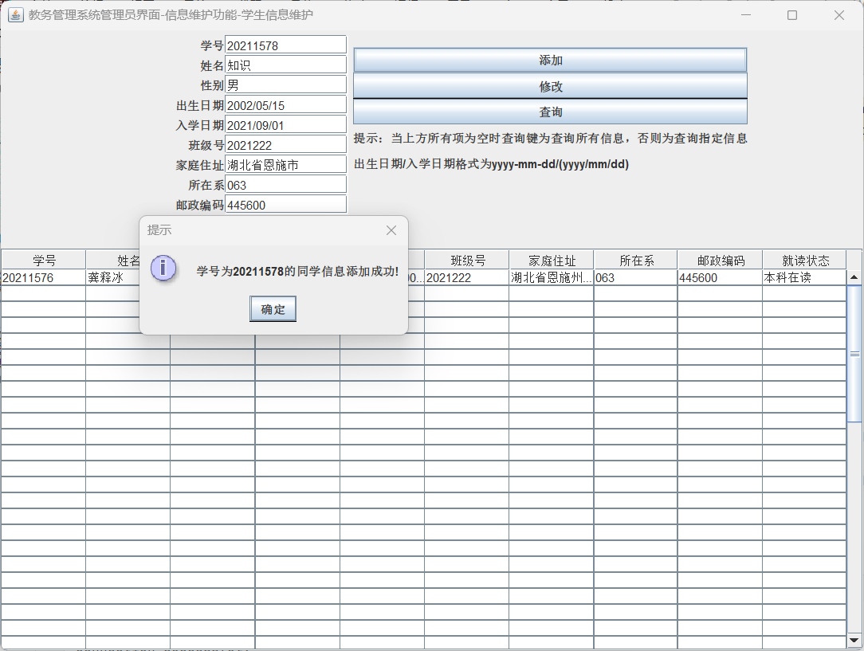

数据模块6：教务管理系统管理员界面-增加教师信息

功能界面：

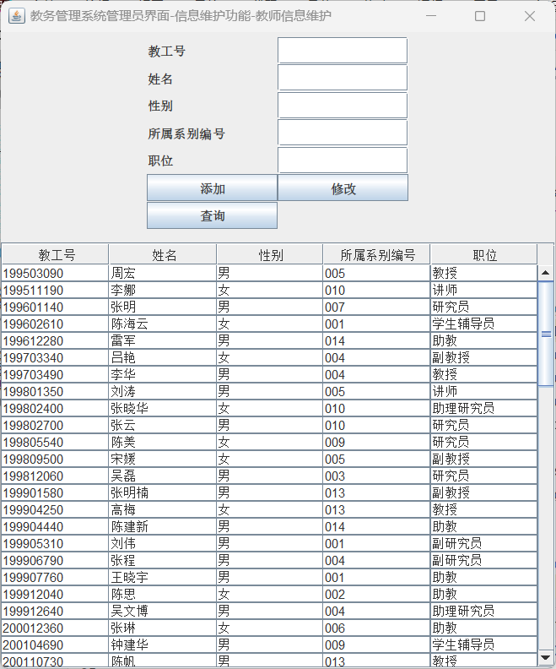

描述：点击教务管理系统管理员信息维护界面，打开如图界面，点击查询按钮，会从Manager_Teacher_view中查询教师的相关信息，若为空，查询所有教师信息，若不为空，从上到下，按照没空的顺序依序查询（单项查询）。

T-SQL语句与宿主语言嵌套使用代码段（粘贴）：

if (e.getSource() == btnAdd) {  
 if(textNo.getText().trim().equals("") == false  
 && textName.getText().trim().equals("") == false  
 && textSex.getText().trim().equals("") == false  
 && textSdept.getText().trim().equals("") == false  
 && textPosition.getText().trim().equals("") == false) {  
 String Driver = "com.microsoft.sqlserver.jdbc.SQLServerDriver";  
 String url = "jdbc:sqlserver://localhost:1433;DatabaseName=Academic_Affairs_Management_System_20211576;encrypt=false";  
 String userName = "s20211576"; *// 默认用户名* String userPwd = "s20211576"; *// 密码* String sql0 = "use Academic_Affairs_Management_System_20211576 select * from Manager_Teacher_view where Emp_no ='" + textNo.getText() + "'";  
 String sql = "insert into Academic_Affairs_Management_System_20211576.dbo.Teacher_20211576(Emp_no,Emp_name,Sex,Sde_no,Position) values('"+textNo.getText()+"','"+textName.getText()+"','"+textSex.getText()+"','"+textSdept.getText()+"','"+textPosition.getText()+"')";  
 Connection dbConn = null;  
 try {  
 Class.*forName*(Driver);  
 dbConn = DriverManager.*getConnection*(url, userName, userPwd);  
 System.*out*.println(sql0); *// 如果连接成功 控制台输出* System.*out*.println(sql);  
 Statement stmt = dbConn.createStatement();  
 ResultSet rs0 = stmt.executeQuery(sql0);  
 String Class_no = "";  
 while (rs0.next()) {  
 Class_no += rs0.getString("Emp_no");  
 }  
 if (Class_no.equals("") == false) {  
 JOptionPane.*showMessageDialog*(null, "工号为"+textNo.getText()+"的教师信息已存在!", "提示", JOptionPane.*INFORMATION_MESSAGE*);  
 } else {  
 JOptionPane.*showMessageDialog*(null, "工号为"+textNo.getText()+"的教师信息添加成功!", "提示", JOptionPane.*INFORMATION_MESSAGE*);  
 ResultSet rs = stmt.executeQuery(sql);  
 rs.close();  
 }  
 rs0.close();  
 stmt.close();  
 dbConn.close();  
 } catch (Exception em) {  
 em.printStackTrace();  
 } finally {  
 try {  
 } catch (Exception ec) {  
 ec.printStackTrace();  
 }  
 }  
 } else {  
 JOptionPane.*showMessageDialog*(null, "请填写完整信息!");  
 }  
}

运行结果：

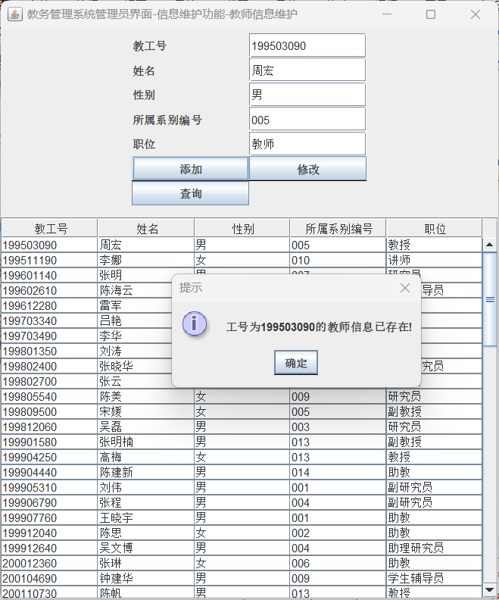

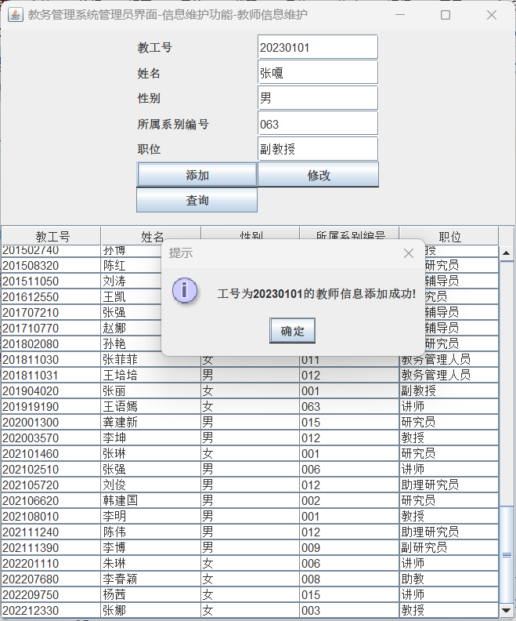

数据模块7：教务管理系统管理员界面-增加管理员账号

功能界面：

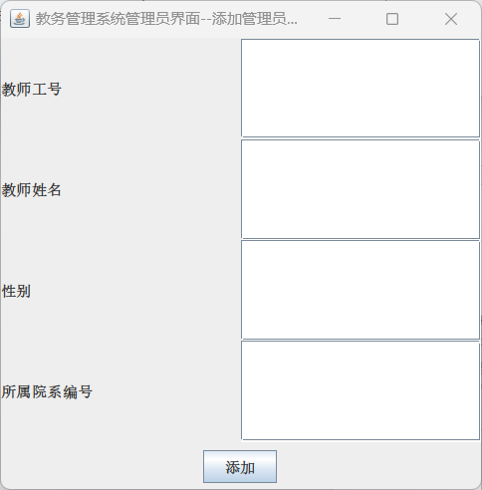

描述：点击教务管理系统管理员界面，点击添加教务系统管理员按钮，打开如图界面，会向Teacher_20211576插入对应的信息，若其中有一项为空，弹窗提示，若无，弹窗提示添加成功。

T-SQL语句与宿主语言嵌套使用代码段（粘贴）：

@Override  
public void actionPerformed(ActionEvent e) {  
 if (e.getSource() == btnAdd) {  
 if (txtEmp_No.getText().equals("") || txtEmp_name.getText().equals("") || txtSex.getText().equals("") || txtEmp_SdeptNo.getText().equals("")) {  
 JOptionPane.*showMessageDialog*(null, "请填写完整信息", "提示", JOptionPane.*ERROR_MESSAGE*);  
 return;  
 }  
 else{  
 frame1.dispose();  
 String Driver = "com.microsoft.sqlserver.jdbc.SQLServerDriver";  
 String url = "jdbc:sqlserver://localhost:1433;DatabaseName=Academic_Affairs_Management_System_20211576;encrypt=false";  
 String userName = "s20211576"; *// 默认用户名* String userPwd = "s20211576"; *// 密码* String sql1 = "use Academic_Affairs_Management_System_20211576 insert into Teacher_20211576 values ('" + txtEmp_No.getText().toString() + "','" + txtEmp_name.getText().toString() + "','" + txtSex.getText().toString() + "','" + txtEmp_SdeptNo.getText().toString() + "','教务管理人员')"; *// SQL语句* Connection dbConn = null;  
 try {  
 Class.*forName*(Driver);  
 dbConn = DriverManager.*getConnection*(url, userName, userPwd);  
 Statement stmt = dbConn.createStatement();  
 JOptionPane.*showMessageDialog*(null, "教师表添加成功！密码表添加成功！", "提示", JOptionPane.*INFORMATION_MESSAGE*);  
 ResultSet rs = stmt.executeQuery(sql1);  
 rs.close();  
 stmt.close();  
 dbConn.close();  
 } catch (Exception em) {  
 em.printStackTrace();  
 } finally {  
 try {  
 } catch (Exception ec) {  
 ec.printStackTrace();  
 }  
 }  
 }  
 }  
}

运行结果：

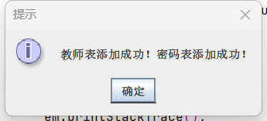

2）删除数据操作

在界面上无删除数据操作，删除只能由管理员在数据库中删除。

3）修改数据操作

功能模块1：教务系统登陆界面-修改密码

功能界面（粘贴）；

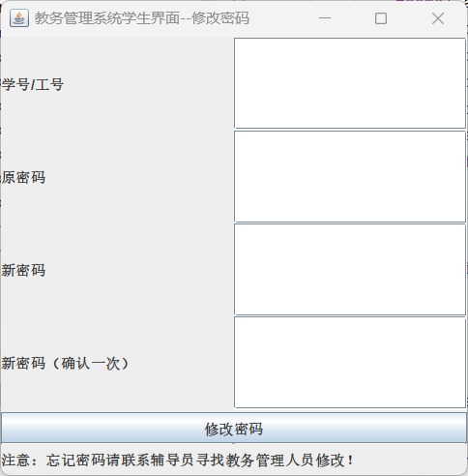

功能界面简单描述；可以对密码进行修改（修改作用于Password_20211576表中），新密码两栏必须保持一致，否则按修改密码按钮时弹窗报错，所有项均需要填，否则按修改密码按钮时弹窗报错。

T-SQL语句与宿主语言嵌套使用代码段（粘贴）；

if (e.getSource() == btnUpdate) {  
 if(txtNo.getText().trim().equals("") || txtOldPassword.getText().trim().equals("") || txtNewPassword.getText().trim().equals("") || txtNewPasswordTwice.getText().trim().equals("")){  
 JOptionPane.*showMessageDialog*(null, "学号/学工号，原密码，新密码等四项均需输入!", "提示", JOptionPane.*ERROR_MESSAGE*);  
 }  
 else{  
 if(txtNewPassword.getText().equals(txtNewPasswordTwice.getText()) == false) {  
 JOptionPane.*showMessageDialog*(null, "两次输入的新密码不一致！");  
 txtNewPassword.setText("");  
 txtNewPasswordTwice.setText("");  
 return;  
 }  
 frame1.dispose();  
 String Driver = "com.microsoft.sqlserver.jdbc.SQLServerDriver";  
 String url = "jdbc:sqlserver://localhost:1433;DatabaseName=Academic_Affairs_Management_System_20211576;encrypt=false";  
 String userName = "s20211576"; *// 默认用户名* String userPwd = "s20211576"; *// 密码* String sql = "use Academic_Affairs_Management_System_20211576 select Position from Password_20211576 where id='" + txtNo.getText() + "'";  
 String sql1 = "use Academic_Affairs_Management_System_20211576 select Password from Password_20211576 where id='" + txtNo.getText() + "'";  
 Connection dbConn = null;  
 try {  
 Class.*forName*(Driver);  
 dbConn = DriverManager.*getConnection*(url, userName, userPwd);  
 System.*out*.println("Connection Successful!"); *// 如果连接成功 控制台输出* Statement stmt = dbConn.createStatement();  
 ResultSet rs = stmt.executeQuery(sql);  
 while(rs.next()){  
 String position = rs.getString("Position");  
 if (position.toString().trim().equals("教务管理人员")) {  
 JOptionPane.*showMessageDialog*(null, "教务管理人员无法修改密码！请至数据库内修改！");  
 }  
 else {  
 ResultSet rs1 = stmt.executeQuery(sql1);  
 while(rs1.next()){  
 String passwordcorrect = rs1.getString("password");  
 if (passwordcorrect.toString().trim().equals(txtOldPassword.getText())) {  
 String sql2 = "use Academic_Affairs_Management_System_20211576 update Password_20211576 set Password='" + txtNewPassword.getText() + "' where id='" + txtNo.getText() + "'";  
 System.*out*.println(sql2);  
 stmt.executeUpdate(sql2);  
 JOptionPane.*showMessageDialog*(null, "修改成功！");  
 } else {  
 JOptionPane.*showMessageDialog*(null, "原密码错误！");  
 }  
 }  
 }  
  
 }  
  
 rs.close();  
 stmt.close();  
 dbConn.close();  
 } catch (Exception em) {  
 em.printStackTrace();  
 } finally {  
 try {  
 } catch (Exception ec) {  
 ec.printStackTrace();  
 }  
 }  
 }  
}

测试结果粘贴；

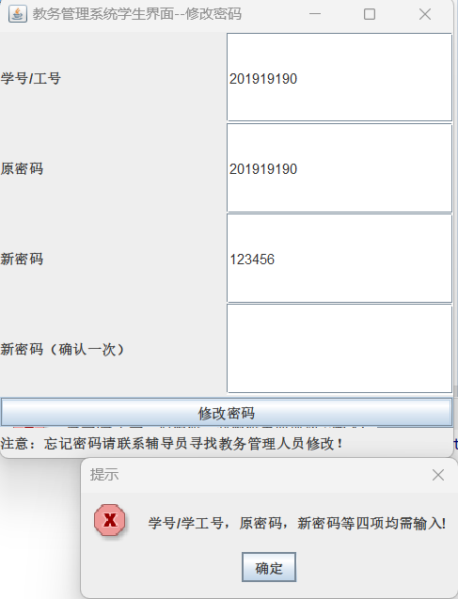

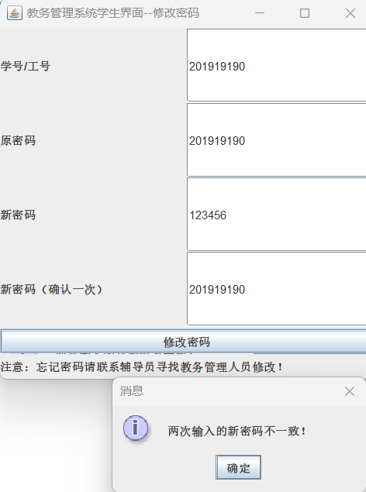

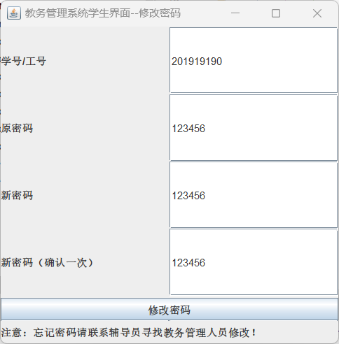

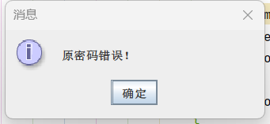

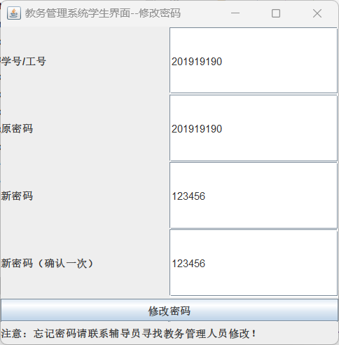

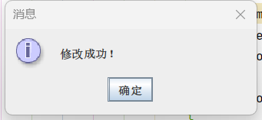

功能模块2：教务管理系统管理员界面-更新班级信息

功能界面：

描述：点击教务管理系统管理员界面，打开如图界面，点击修改按钮，会从Manager_Class_view中修改班级的相关信息，班级号不允许为空，否则弹窗提示。

T-SQL语句与宿主语言嵌套使用代码段（粘贴）：

if (e.getSource() == btnUpdate) {  
 if (textClassNo.getText().trim().equals("") == false) {  
 String Driver = "com.microsoft.sqlserver.jdbc.SQLServerDriver";  
 String url = "jdbc:sqlserver://localhost:1433;DatabaseName=Academic_Affairs_Management_System_20211576;encrypt=false";  
 String userName = "s20211576"; *// 默认用户名* String userPwd = "s20211576"; *// 密码* String sql = null;  
 if (textSdeNo.getText().trim().equals("") == false)  
 sql = "update Academic_Affairs_Management_System_20211576.dbo.Class_20211576 set Sde_no = '" + textSdeNo.getText() + "' where Class_no = '" + textClassNo.getText() + "'";  
 else if (textEntranceDate.getText().trim().equals("") == false)  
 sql = "update Academic_Affairs_Management_System_20211576.dbo.Class_20211576 set Entrance_date = '" + textEntranceDate.getText() + "' where Class_no = '" + textClassNo.getText() + "'";  
 else if (textNum.getText().trim().equals("") == false)  
 sql = "update Academic_Affairs_Management_System_20211576.dbo.Class_20211576 set Num = " + textNum.getText() + " where Class_no = '" + textClassNo.getText() + "'";  
 Connection dbConn = null;  
 try {  
 Class.*forName*(Driver);  
 dbConn = DriverManager.*getConnection*(url, userName, userPwd);  
 System.*out*.println(sql); *// 如果连接成功 控制台输出* JOptionPane.*showMessageDialog*(null, "班级号为" + textClassNo.getText() + "的班级信息修改成功！", "提示", JOptionPane.*INFORMATION_MESSAGE*);  
 Statement stmt = dbConn.createStatement();  
 ResultSet rs = stmt.executeQuery(sql);  
 rs.close();  
 stmt.close();  
 dbConn.close();  
 } catch (Exception em) {  
 em.printStackTrace();  
 } finally {  
 try {  
 } catch (Exception ec) {  
 ec.printStackTrace();  
 }  
 }  
 }  
 else{  
 JOptionPane.*showMessageDialog*(null, "班级号和（所属系号/入学时间/学生人数中至少有一项）不为空!", "提示", JOptionPane.*INFORMATION_MESSAGE*);  
 }  
}

运行结果：

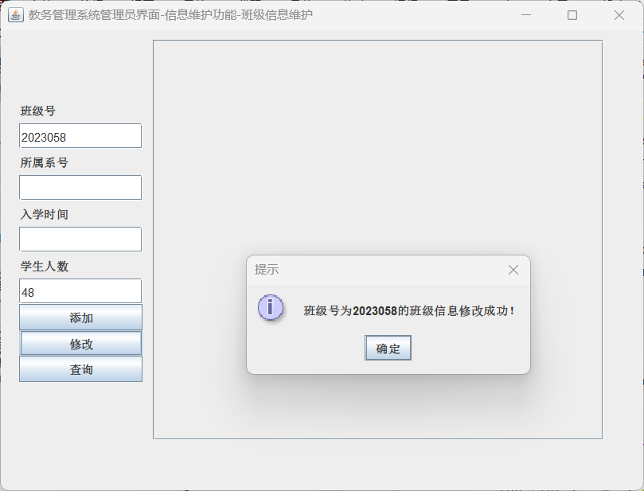

功能模块3：教务管理系统管理员界面-修改学生信息

功能界面：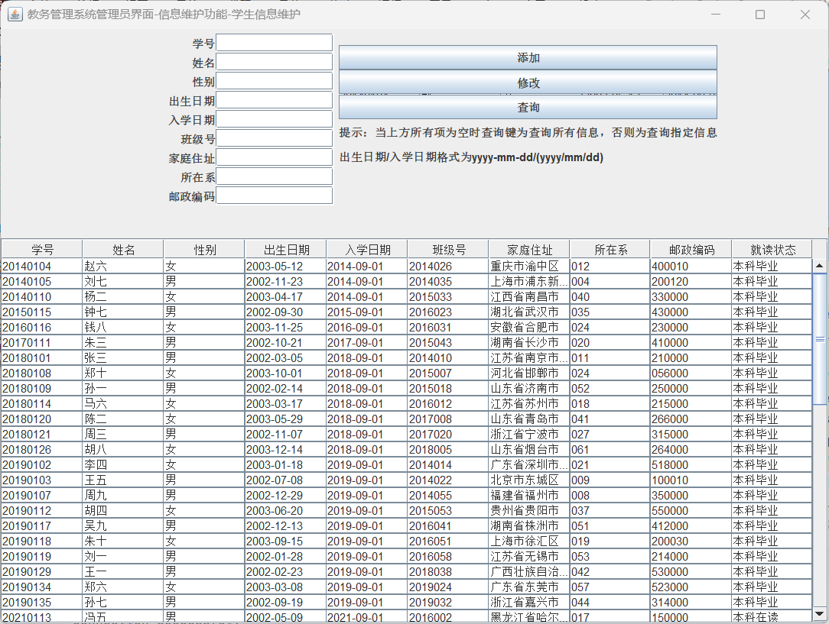

描述：点击教务管理系统管理员界面-信息维护界面，打开如图界面，点击修改按钮，会从Student_20211576中修改学生的相关信息，学号不允许为空，否则弹窗提示。

T-SQL语句与宿主语言嵌套使用代码段（粘贴）：

if (e.getSource() == btnUpdate){  
 if(textNo.getText().trim().equals("") == false  
 &&(textName.getText().trim().equals("") == false  
 || textSex.getText().trim().equals("") == false  
 || textBirth.getText().trim().equals("") == false  
 || textEntrancedate.getText().trim().equals("") == false  
 || textClassno.getText().trim().equals("") == false  
 || textHomeaddress.getText().trim().equals("") == false  
 || textSdept.getText().trim().equals("") == false)){  
 String Driver = "com.microsoft.sqlserver.jdbc.SQLServerDriver";  
 String url = "jdbc:sqlserver://localhost:1433;DatabaseName=Academic_Affairs_Management_System_20211576;encrypt=false";  
 String userName = "s20211576"; *// 默认用户名* String userPwd = "s20211576"; *// 密码* String sql = null;  
 if(textName.getText().trim().equals("") == false)  
 sql = "update Academic_Affairs_Management_System_20211576.dbo.Student_20211576 set Sname = '"+textName.getText()+"' where Sno = '"+textNo.getText()+"'";  
 else if(textSex.getText().trim().equals("") == false)  
 sql = "update Academic_Affairs_Management_System_20211576.dbo.Student_20211576 set Sex = '"+textSex.getText()+"' where Sno = '"+textNo.getText()+"'";  
 else if(textBirth.getText().trim().equals("") == false)  
 sql = "update Academic_Affairs_Management_System_20211576.dbo.Student_20211576 set Birth = "+textBirth.getText()+" where Sno = '"+textNo.getText()+"'";  
 else if(textEntrancedate.getText().trim().equals("") == false)  
 sql = "update Academic_Affairs_Management_System_20211576.dbo.Student_20211576 set Entrance_date = '"+textEntrancedate.getText()+"' where Sno = '"+textNo.getText()+"'";  
 else if(textClassno.getText().trim().equals("") == false)  
 sql = "update Academic_Affairs_Management_System_20211576.dbo.Student_20211576 set Class_no = '"+textClassno.getText()+"' where Sno = '"+textNo.getText()+"'";  
 else if(textHomeaddress.getText().trim().equals("") == false)  
 sql = "update Academic_Affairs_Management_System_20211576.dbo.Student_20211576 set Home_addr = '"+textHomeaddress.getText()+"' where Sno = '"+textNo.getText()+"'";  
 else if(textSdept.getText().trim().equals("") == false)  
 sql = "update Academic_Affairs_Management_System_20211576.dbo.Student_20211576 set Sde_no = '"+textSdept.getText()+"' where Sno = '"+textNo.getText()+"'";  
 else if(textPostcode.getText().trim().equals("") == false)  
 sql = "update Academic_Affairs_Management_System_20211576.dbo.Student_20211576 set Postcode = '"+textPostcode.getText()+"' where Sno = '"+textNo.getText()+"'";  
 Connection dbConn = null;  
 try {  
 Class.*forName*(Driver);  
 dbConn = DriverManager.*getConnection*(url, userName, userPwd);  
 System.*out*.println(sql); *// 如果连接成功 控制台输出* JOptionPane.*showMessageDialog*(null, "学号为"+textNo.getText()+"的同学信息修改成功！", "提示", JOptionPane.*INFORMATION_MESSAGE*);  
 Statement stmt = dbConn.createStatement();  
 ResultSet rs = stmt.executeQuery(sql);  
 rs.close();  
 stmt.close();  
 dbConn.close();  
 } catch (Exception em) {  
 em.printStackTrace();  
 } finally {  
 try {  
 } catch (Exception ec) {  
 ec.printStackTrace();  
 }  
 }  
 }  
 else{  
 JOptionPane.*showMessageDialog*(null, "学号和（姓名/性别/出生日期/入学日期/班级号/家庭住址/所在系/邮政编码中至少有一项）不为空!");  
 }  
}

运行结果：

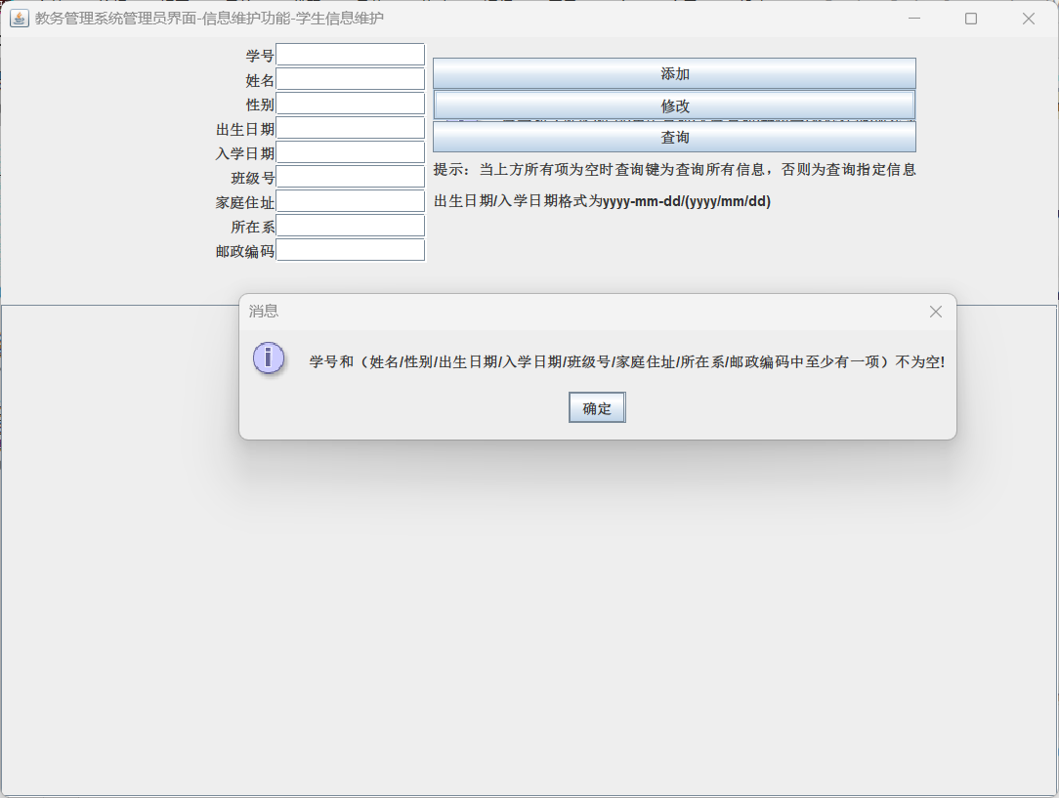

功能模块4：教务管理系统管理员界面-修改教师信息

功能界面：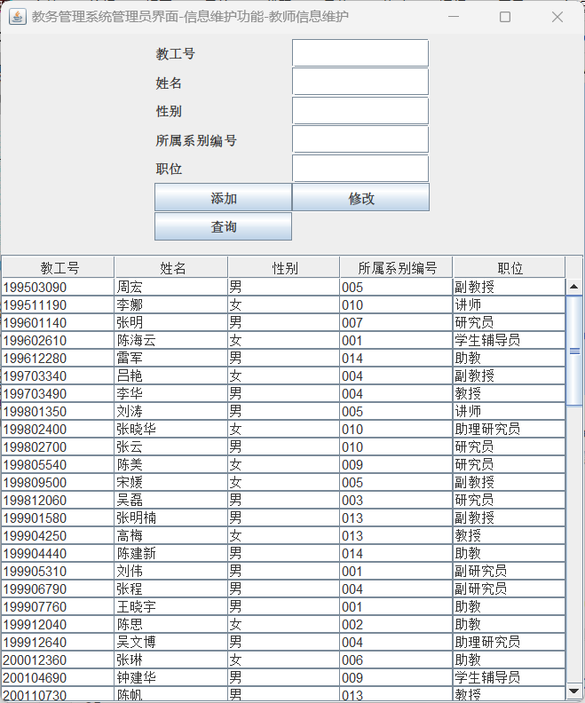

描述：点击教务管理系统管理员界面-信息维护界面，打开如图界面，点击修改按钮，会从Teacher_20211576中修改教师的相关信息，工号不允许为空，否则弹窗提示。

T-SQL语句与宿主语言嵌套使用代码段（粘贴）：

if (e.getSource() == btnUpdate){  
 if(textNo.getText().trim().equals("") == false  
 &&(textName.getText().trim().equals("") == true  
 || textSex.getText().trim().equals("") == true  
 || textSdept.getText().trim().equals("") == true  
 || textPosition.getText().trim().equals("") == true)){  
 String Driver = "com.microsoft.sqlserver.jdbc.SQLServerDriver";  
 String url = "jdbc:sqlserver://localhost:1433;DatabaseName=Academic_Affairs_Management_System_20211576;encrypt=false";  
 String userName = "s20211576"; *// 默认用户名* String userPwd = "s20211576"; *// 密码* String sql = null;  
 if(textName.getText().trim().equals("") == false)  
 sql = "update Academic_Affairs_Management_System_20211576.dbo.Teacher_20211576 set Emp_name = '"+textName.getText()+"' where Emp_no = '"+textNo.getText()+"'";  
 else if(textSex.getText().trim().equals("") == false)  
 sql = "update Academic_Affairs_Management_System_20211576.dbo.Teacher_20211576 set Sex = "+textSex.getText()+" where Emp_no = '"+textNo.getText()+"'";  
 else if(textSdept.getText().trim().equals("") == false)  
 sql = "update Academic_Affairs_Management_System_20211576.dbo.Teacher_20211576 set Sdept = '"+textSdept.getText()+"' where Emp_no = '"+textNo.getText()+"'";  
 else if(textPosition.getText().trim().equals("") == false)  
 sql = "update Academic_Affairs_Management_System_20211576.dbo.Teacher_20211576 set Position = '"+textPosition.getText()+"' where Emp_no = '"+textNo.getText()+"'";  
 Connection dbConn = null;  
 try {  
 Class.*forName*(Driver);  
 dbConn = DriverManager.*getConnection*(url, userName, userPwd);  
 System.*out*.println(sql); *// 如果连接成功 控制台输出* JOptionPane.*showMessageDialog*(null, "工号为"+textNo.getText()+"的教师信息修改成功！", "提示", JOptionPane.*INFORMATION_MESSAGE*);  
 Statement stmt = dbConn.createStatement();  
 ResultSet rs = stmt.executeQuery(sql);  
 rs.close();  
 stmt.close();  
 dbConn.close();  
 } catch (Exception em) {  
 em.printStackTrace();  
 } finally {  
 try {  
 } catch (Exception ec) {  
 ec.printStackTrace();  
 }  
 }  
 }  
 else{  
 JOptionPane.*showMessageDialog*(null, "工号和（姓名，性别，所属系别编号职位中至少有一项）不为空!");  
 }  
}

运行结果：

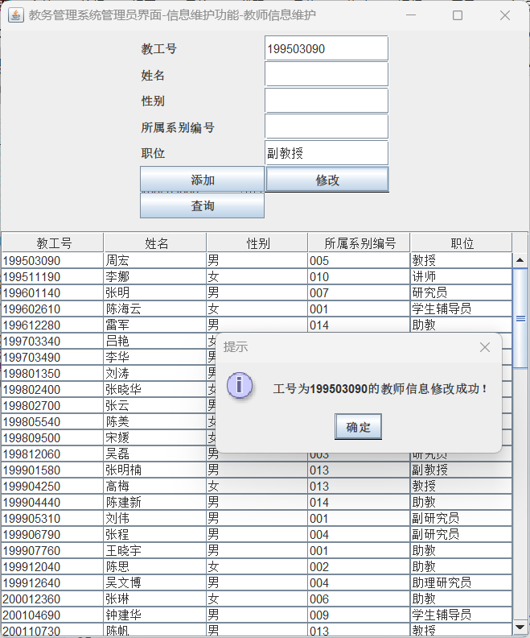

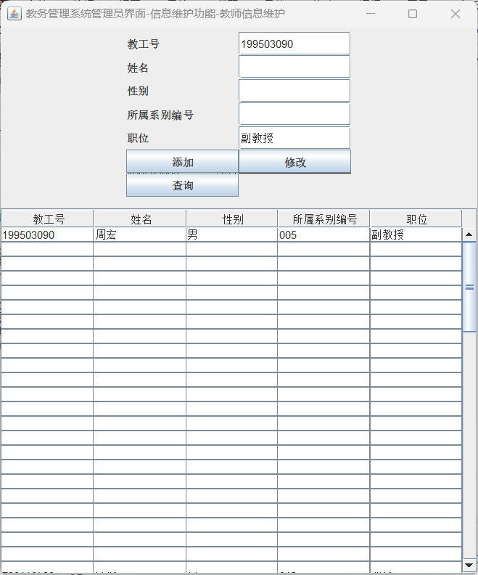

4）查询数据操作：

功能模块1：登陆界面查询操作

功能界面：

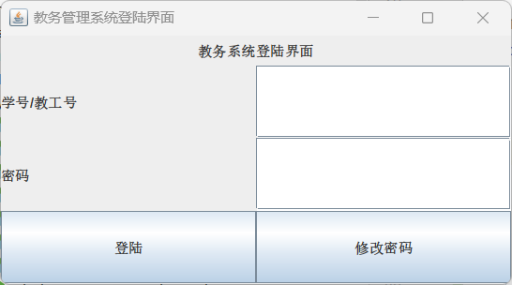

描述：包含用户名和密码输入框、登录按钮和注册按钮，用户输入用户名和密码后，若密码正确，则点击登录按钮即可进入主界面，教务管理人员对应的账号进入管理员界面，学生对应的账号进入学生界面，其余密码与用户名匹配的均进入教师界面。

T-SQL语句与宿主语言嵌套使用代码段（粘贴）：

@Override  
public void actionPerformed(ActionEvent e) {  
 if (e.getSource() == buttonRegister) {  
 if (txtLabelNo.getText().trim().equals("")) {  
 JOptionPane.*showMessageDialog*(null, "请输入学号/教工号", "提示", JOptionPane.*ERROR_MESSAGE*);  
 } else if (txtLabelPassword.getText().trim().equals("")) {  
 JOptionPane.*showMessageDialog*(null, "密码不能为空", "提示", JOptionPane.*ERROR_MESSAGE*);  
 } else {  
 String userInput = null;  
 if(txtLabelNo.getText().length()<7){  
 userInput = "'" + txtLabelNo.getText() + "'";  
 }  
 else{  
 userInput = txtLabelNo.getText();  
 }  
 String passwordInput = txtLabelPassword.getText().toString();  
 String Driver = "com.microsoft.sqlserver.jdbc.SQLServerDriver";  
 String url = "jdbc:sqlserver://localhost:1433;database=Academic_Affairs_Management_System_20211576;encrypt=false";  
 String sql="use Academic_Affairs_Management_System_20211576 select Position from Password_20211576 where id = " + userInput;  
 String sql1="use Academic_Affairs_Management_System_20211576 select password from Password_20211576 where id = " + userInput;  
 String userName = "s20211576"; *// 默认用户名* String userPwd = "s20211576"; *// 密码* Connection dbConn = null;  
 try {  
 Class.*forName*(Driver);  
 dbConn = DriverManager.*getConnection*(url, userName, userPwd);  
 } catch (Exception em) {  
 em.printStackTrace();  
 }  
 Statement stml;  
 ResultSet rs,rs1;  
 try {  
 stml = dbConn.createStatement();  
 rs = stml.executeQuery(sql);*//SQL查询语句* while (rs.next()) {  
 String passwordCorrect;  
 String position = rs.getString("Position");  
 rs1 = stml.executeQuery(sql1);  
 while (rs1.next()) {  
 passwordCorrect = rs1.getString("password");  
 if(passwordInput.equals(passwordCorrect.toString().trim())) {  
 JOptionPane.*showMessageDialog*(null, "登陆成功");  
 *//关闭界面，打开新界面* if (position.toString().trim().equals("学生")){  
 *loginID* = userInput;  
 *loginName* = getStudentName(*loginID*);  
 System.*out*.println(*loginName*);  
 System.*out*.println(*loginID*);  
 WindowStudent student = new WindowStudent();  
 }else if (position.trim().equals("教务管理人员")){  
 WindowManager manager = new WindowManager();  
 }else{  
 *loginID* = userInput;  
 *loginName* = getTeacherName(*loginID*);  
 WindowTeacher teacher = new WindowTeacher();  
 }  
 frame1.dispose();  
 }  
 else{  
 JOptionPane.*showMessageDialog*(null, "密码错误", "提示", JOptionPane.*ERROR_MESSAGE*);  
 }  
 }  
 }  
 dbConn.close();  
  
 } catch (SQLException ex) {  
 System.*out*.println(ex);  
 }  
 }  
 }

}

测试结果粘贴；

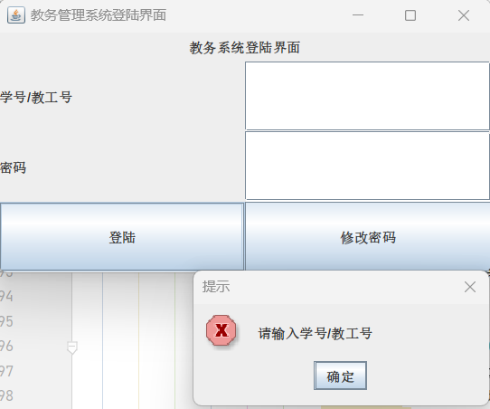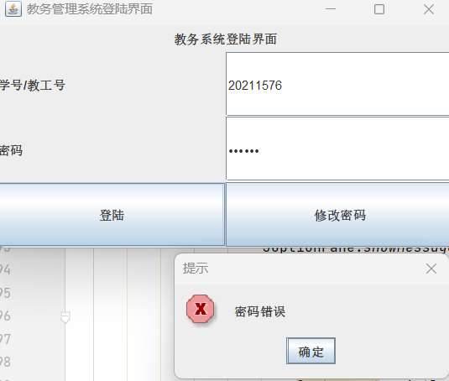

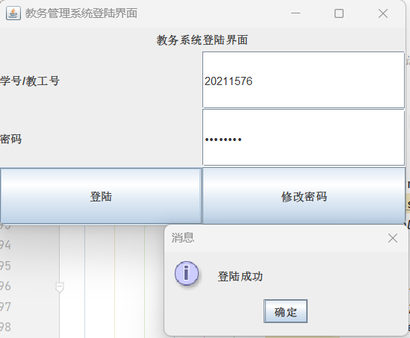 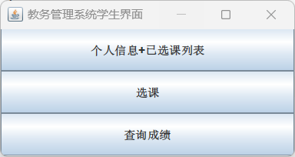

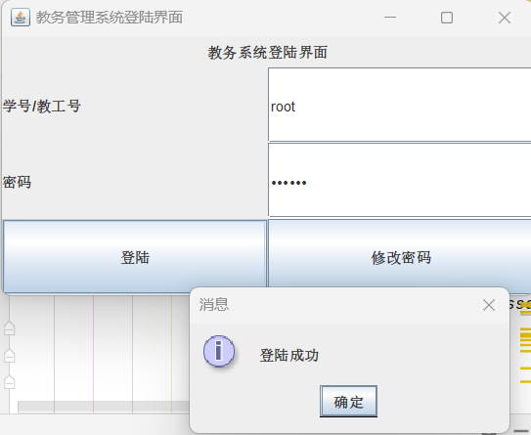

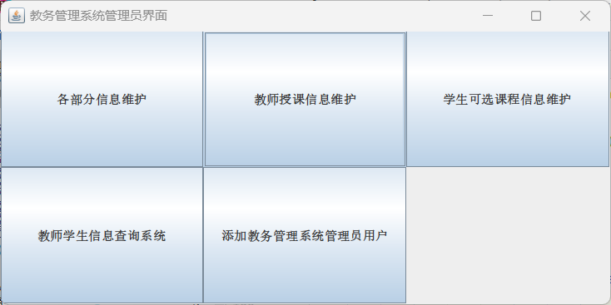

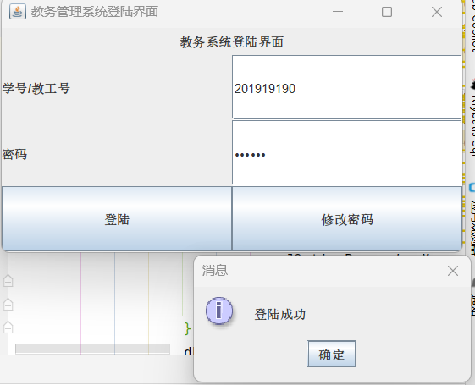

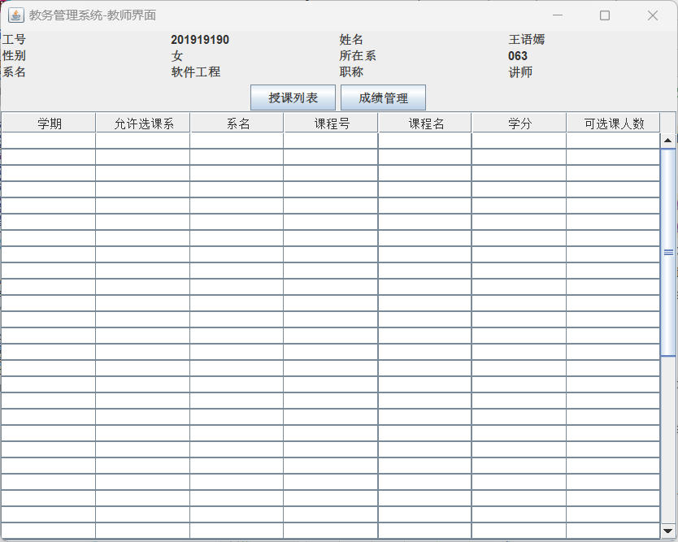

功能模块2：教务管理系统学生界面-个人信息+已选课程展示-

功能界面：

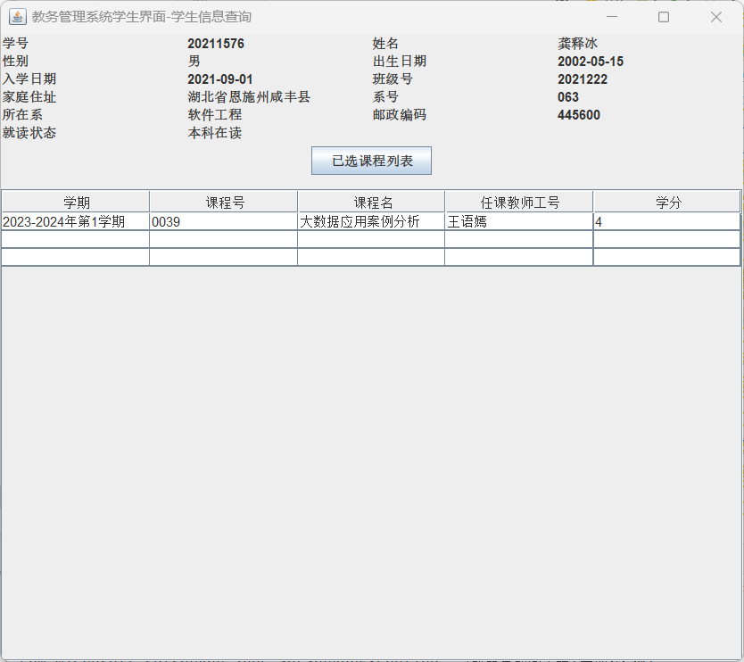

描述：点击学生界面-个人信息+已选课列表按钮，打开如图界面，点击已选课程列表按钮，通过学号查询并输出该学生已选修的所有课程到表中，学号是从登陆界面通过static string变量传过来的。

T-SQL语句与宿主语言嵌套使用代码段（粘贴）：

@Override  
public void actionPerformed(ActionEvent e) {  
 if (e.getSource() == btnEnquiry) {  
 String sqlEnquiryStudent = "use Academic_Affairs_Management_System_20211576 select * from Student_Enquiry_view where Sno = '" + loginID.toString() + "'";  
 btnEnquiry(sqlEnquiryStudent);  
 }  
}  
public void btnEnquiry(String sql){  
 String Driver2 = "com.microsoft.sqlserver.jdbc.SQLServerDriver";  
 String url = "jdbc:sqlserver://localhost:1433;DatabaseName=Academic_Affairs_Management_System_20211576;encrypt=false";  
 String userName = "s20211576"; *// 默认用户名* String userPwd = "s20211576"; *// 密码* Connection dbConn = null;  
 try {  
 Class.*forName*(Driver2);  
 dbConn = DriverManager.*getConnection*(url, userName, userPwd);  
 } catch (ClassNotFoundException ea) {  
 throw new RuntimeException(ea);  
 } catch (SQLException eb) {  
 throw new RuntimeException(eb);  
 }  
 int columnCount = 0;  
 try {  
 Statement stmt = dbConn.createStatement();  
 ResultSet rs = stmt.executeQuery(sql);  
 while (rs.next()) {  
 data[0][0] = rs.getString("Semester");  
 data[0][1] = rs.getString("Cno");  
 data[0][2] = rs.getString("Cname");  
 data[0][3] = rs.getString("Emp_name");  
 data[0][4] = rs.getString("Credit");  
 }  
 } catch (SQLException ex) {  
 throw new RuntimeException(ex);  
 } finally {  
 try {  
 dbConn.close();  
 } catch (SQLException exc) {  
 throw new RuntimeException(exc);  
 }  
 }  
 DefaultTableModel model = new DefaultTableModel(data, columnNames);  
 table.setModel(model);  
}

功能模块3：教务管理系统学生界面-学生选课界面查询

功能界面：

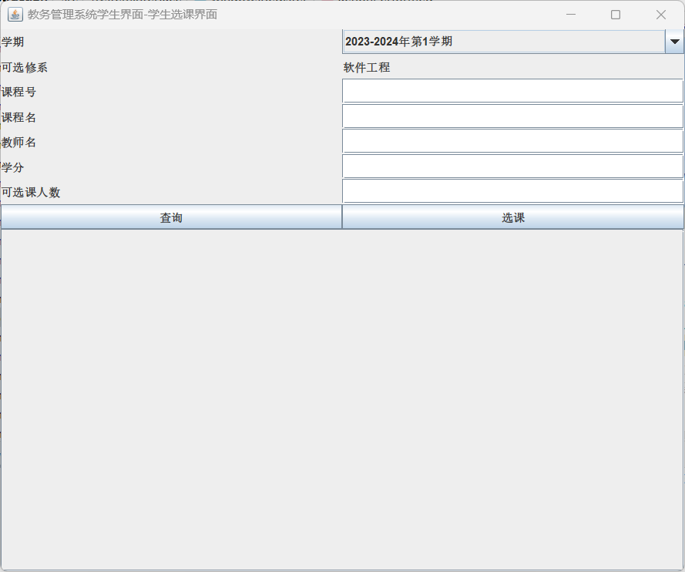

描述：点击学生界面-选课按钮，打开如图界面，点击按钮即可进行多项查询，系名是通过查询Student_view中学好对应的系名，学号是从登陆界面通过static string变量传过来的。

T-SQL语句与宿主语言嵌套使用代码段（粘贴）：

if (e.getSource() == btnEnquiry){  
 for (int i = 0; i < getColumns(); i++) {  
 for (int j = 0; j < 8; j++) {  
 data[i][j] = "";  
 }  
 }  
 String Driver2 = "com.microsoft.sqlserver.jdbc.SQLServerDriver";  
 String url = "jdbc:sqlserver://localhost:1433;DatabaseName=Academic_Affairs_Management_System_20211576;encrypt=false";  
 String userName = "s20211576"; *// 默认用户名* String userPwd = "s20211576"; *// 密码* String sql = "use Academic_Affairs_Management_System_20211576 select * from Manager_Course_Teacher_manage_view where 1=1 ";  
 if (txtCourseNo.getText().trim().length() != 0) {  
 sql += " and Cno='" + txtCourseNo.getText().trim() + "'";  
 }  
 if (txtCourseName.getText().trim().length() != 0) {  
 sql += " and Cname='" + txtCourseName.getText().trim() + "'";  
 }  
 if (txtTeacherName.getText().trim().length() != 0) {  
 sql += " and Emp_name='" + txtTeacherName.getText().trim() + "'";  
 }  
 if (txtCredit.getText().trim().length() != 0) {  
 sql += " and Credit='" + txtCredit.getText().trim() + "'";  
 }  
 if (txtCourseNum.getText().trim().length() != 0) {  
 sql += " and Stu_total='" + txtCourseNum.getText().trim() + "'";  
 }  
 if (comSemester.getSelectedItem().toString().trim().length() != 0) {  
 sql += " and Semester='" + comSemester.getSelectedItem().toString().trim() + "'";  
 }  
 Connection dbConn = null;  
 try {  
 Class.*forName*(Driver2);  
 dbConn = DriverManager.*getConnection*(url, userName, userPwd);  
 } catch (ClassNotFoundException ea) {  
 throw new RuntimeException(ea);  
 } catch (SQLException eb) {  
 throw new RuntimeException(eb);  
 }  
 try {  
 Statement stmt = dbConn.createStatement();  
 ResultSet rs = stmt.executeQuery(sql);  
 int count = 0;  
 while (rs.next()) {  
 data[count][0] = rs.getString("Semester");  
 data[count][1] = rs.getString("Course_Offered_Sde_no");  
 data[count][2] = rs.getString("Sde_name");  
 data[count][3] = rs.getString("Cno");  
 data[count][4] = rs.getString("Cname");  
 data[count][5] = rs.getString("Emp_name");  
 data[count][6] = rs.getString("Credit");  
 data[count][7] = rs.getString("Stu_total");  
 count++;  
 }  
 } catch (SQLException ex) {  
 throw new RuntimeException(ex);  
 } finally {  
 try {  
 dbConn.close();  
 } catch (SQLException exc) {  
 throw new RuntimeException(exc);  
 }  
 }  
 DefaultTableModel model = new DefaultTableModel(data, columnNames);  
 table.setModel(model);  
}

测试结果粘贴：

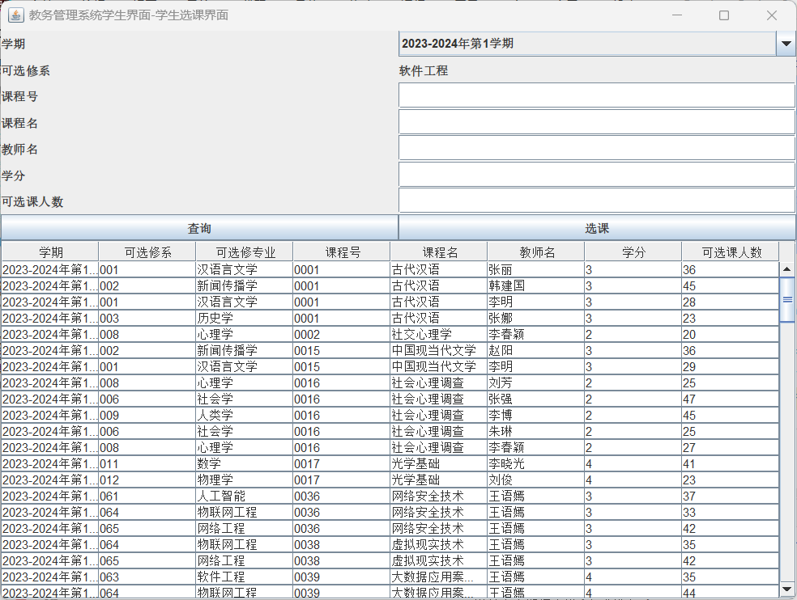

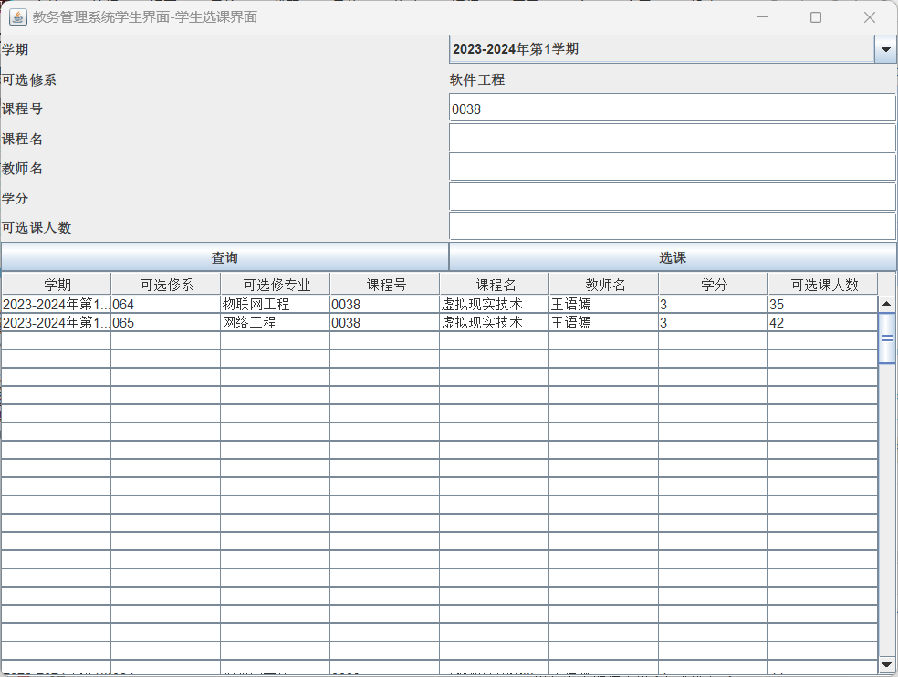

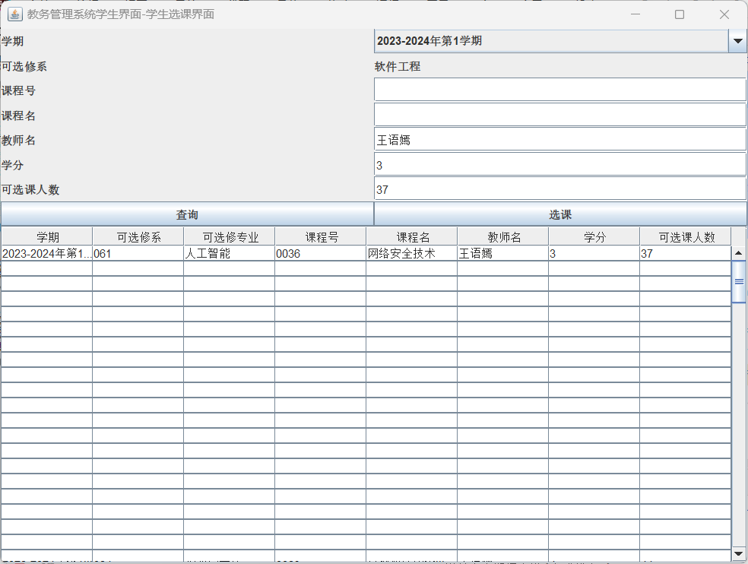

功能模块4：教务管理系统学生界面-学生成绩查询界面

功能界面：

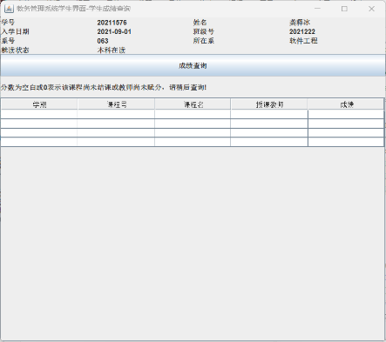

描述：点击学生界面-成绩查询按钮，打开如图界面，点击成绩查询按钮，查找该生选修的所有课程的成绩（通过Sno在Student_Score_Enquiry_view中查询），学号是从登陆界面通过static string变量传过来的。

T-SQL语句与宿主语言嵌套使用代码段（粘贴）：

@Override  
public void actionPerformed(ActionEvent e) {  
 if (e.getSource() == btnEnquiry) {  
 String Driver2 = "com.microsoft.sqlserver.jdbc.SQLServerDriver";  
 String url = "jdbc:sqlserver://localhost:1433;DatabaseName=Academic_Affairs_Management_System_20211576;encrypt=false";  
 String userName = "s20211576"; *// 默认用户名* String userPwd = "s20211576"; *// 密码* String sqlCourseEnquiry = "select * from Student_Score_Enquiry_view where Sno = '" + loginID + "' and Sname = '" + loginName + "' order by Semester asc";  
 System.*out*.println(sqlCourseEnquiry);  
 Connection dbConn = null;  
 try {  
 Class.*forName*(Driver2);  
 dbConn = DriverManager.*getConnection*(url, userName, userPwd);  
 } catch (ClassNotFoundException e1) {  
 throw new RuntimeException(e1);  
 } catch (SQLException e2) {  
 throw new RuntimeException(e2);  
 }  
 try {  
 Statement stmt = dbConn.createStatement();  
 ResultSet rs = stmt.executeQuery(sqlCourseEnquiry);  
 ResultSetMetaData rsmd = rs.getMetaData();  
 int count = 0;  
 while (rs.next()&&count<getColumns()) {  
 data[count][0] = rs.getString("Semester");  
 data[count][1] = rs.getString("Cno");  
 data[count][2] = rs.getString("Cname");  
 data[count][3] = rs.getString("Emp_name");  
 data[count][4] = rs.getString("Grade");  
 count++;  
 }  
 } catch (SQLException e3) {  
 throw new RuntimeException(e3);  
 } finally {  
 try {  
 dbConn.close();  
 } catch (SQLException e4) {  
 throw new RuntimeException(e4);  
 }  
 }  
 DefaultTableModel model = new DefaultTableModel(data, columnNames);  
 table.setModel(model);  
 }  
}  
}

测试结果粘贴：

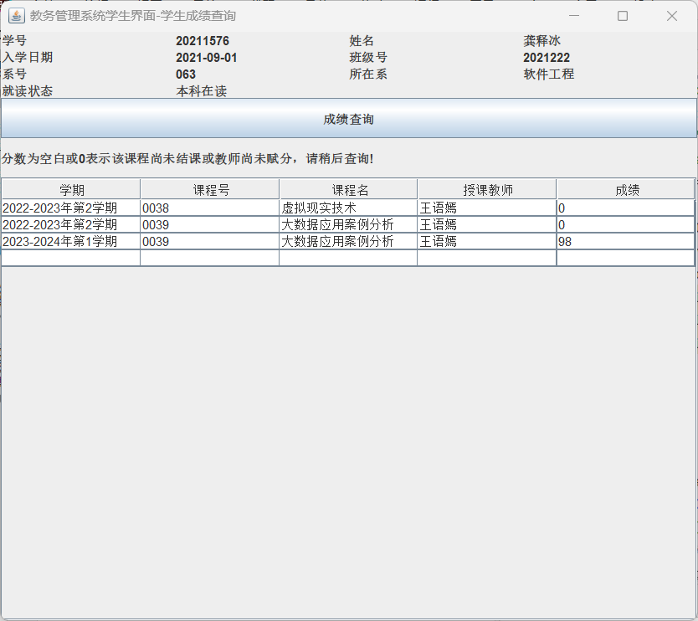

功能模块5：教务管理系统教师界面授课列表查询

功能界面：

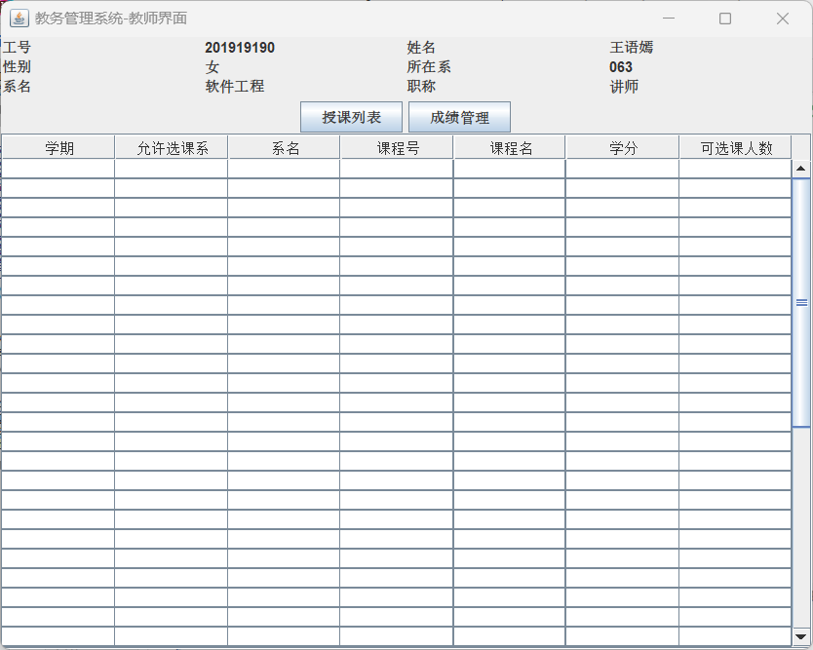

描述：点击教务管理系统登陆界面，打开如图界面，点击授课列表按钮，查找该教师所授的所有课程的信息（通过Emp_name在Manager_Course_Teacher_manage_view中查询），教师姓名是从登陆界面通过static string变量loginName传过来的。

T-SQL语句与宿主语言嵌套使用代码段（粘贴）：

@Override  
public void actionPerformed(ActionEvent e) {  
 if (e.getSource() == btnEnquiry) {  
 Enquiry();  
 }

}

public void Enquiry(){  
 String Driver = "com.microsoft.sqlserver.jdbc.SQLServerDriver";  
 String url = "jdbc:sqlserver://localhost:1433;DatabaseName=Academic_Affairs_Management_System_20211576;encrypt=false";  
 String sql = "use Academic_Affairs_Management_System_20211576 select * from Manager_Course_Teacher_manage_view where Emp_name = '" + loginName.trim() + "'";  
 System.*out*.println(sql);  
 String userName = "s20211576"; *// 默认用户名* String userPwd = "s20211576"; *// 密码* Connection dbConn = null;  
 try {  
 Class.*forName*(Driver);  
 dbConn = DriverManager.*getConnection*(url, userName, userPwd);  
 } catch (ClassNotFoundException ea) {  
 throw new RuntimeException(ea);  
 } catch (SQLException eb) {  
 throw new RuntimeException(eb);  
 }  
 int columnCount = 0;  
 try {  
 Statement stmt = dbConn.createStatement();  
 ResultSet rs = stmt.executeQuery(sql);  
 int i=0;  
 while (rs.next()) {  
 data[i][0] = rs.getString("Semester");  
 data[i][1] = rs.getString("Course_Offered_Sde_no");  
 data[i][2] = rs.getString("Sde_name");  
 data[i][3] = rs.getString("Cno");  
 data[i][4] = rs.getString("Cname");  
 data[i][5] = rs.getString("Credit");  
 data[i][6] = rs.getString("Stu_total");  
 i++;  
 }  
 } catch (SQLException ex) {  
 throw new RuntimeException(ex);  
 } finally {  
 try {  
 dbConn.close();  
 } catch (SQLException exc) {  
 throw new RuntimeException(exc);  
 }  
 }  
 DefaultTableModel model = new DefaultTableModel(data, columnNames);  
 table.setModel(model);  
}

测试结果粘贴：

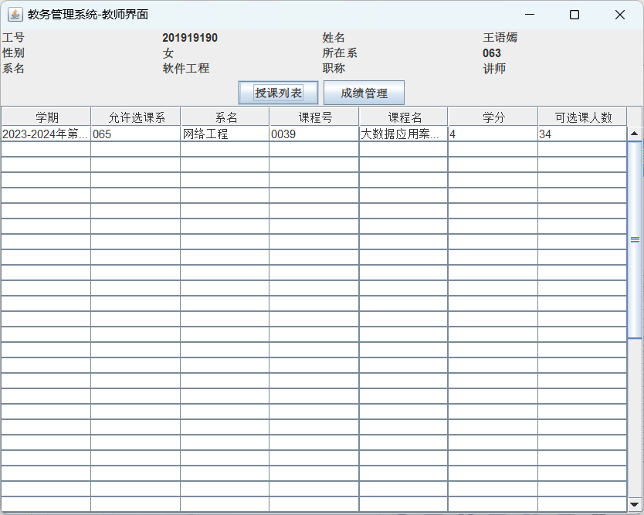

功能模块6：教务管理系统教师界面-对应课程成绩管理界面

功能界面：

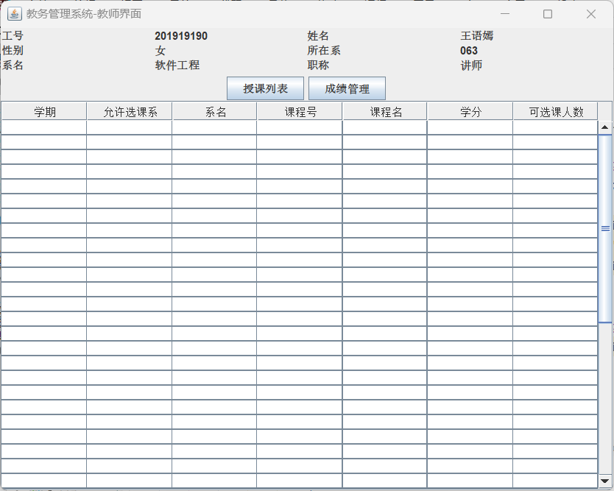

描述：点击教务管理系统登陆界面，打开如图界面，选中一列后，点击成绩管理按钮，查找该教师所授的所有课程的成绩（通过Emp_name在Manager_Course_Teacher_manage_view中查询）并打开新界面，教师姓名是从登陆界面通过static string变量loginName传过来的，当在教务管理系统教师界面未选中课程直接点击成绩管理时，会弹窗报错，当选中课程没有学生选修，会关闭新界面，并弹窗提示。

T-SQL语句与宿主语言嵌套使用代码段（粘贴）：

public void actionPerformed(ActionEvent e) {  
 if (e.getSource() == btnEnquiry) {  
 Enquiry();  
 }  
 if (e.getSource() == btnScoreManage){  
 *//如果没有选中行，则弹出提示框* if (table.getSelectedRow() == -1) {  
 JOptionPane.*showMessageDialog*(null, "请先选中课程再进行此操作！", "提示", JOptionPane.*ERROR_MESSAGE*);  
 return;  
 }  
  
 if(getInformationSC(TeacherRelated,*sqlScore*) == true){  
 JOptionPane.*showMessageDialog*(null, "该课程无人选择，无法进行赋分操作!", "提示", JOptionPane.*ERROR_MESSAGE*);  
 return;  
 }  
 else{  
 WindowTeacherScoreManage windowTeacherScoreManage = new WindowTeacherScoreManage();  
 }  
 }  
}

}

public boolean getInformationSC(Object[] TeacherRelated, String sql){  
 String Driver4 = "com.microsoft.sqlserver.jdbc.SQLServerDriver";  
 String url = "jdbc:sqlserver://localhost:1433;DatabaseName=Academic_Affairs_Management_System_20211576;encrypt=false";  
 String userName = "s20211576"; *// 默认用户名* String userPwd = "s20211576"; *// 密码* sql = *sqlScore*;  
 Connection dbConn = null;  
 try {  
 Class.*forName*(Driver4);  
 dbConn = DriverManager.*getConnection*(url, userName, userPwd);  
 } catch (ClassNotFoundException ea) {  
 throw new RuntimeException(ea);  
 } catch (SQLException eb) {  
 throw new RuntimeException(eb);  
 }  
 try {  
 Statement stmt = dbConn.createStatement();  
 ResultSet rs = stmt.executeQuery(sql);  
 while (rs.next()) {  
 TeacherRelated[0] = rs.getString("Semester");  
 TeacherRelated[1] = rs.getString("Cno");  
 TeacherRelated[2] = rs.getString("Cname");  
 }  
 } catch (SQLException ex) {  
 throw new RuntimeException(ex);  
 } finally {  
 try {  
 dbConn.close();  
 } catch (SQLException exc) {  
 throw new RuntimeException(exc);  
 }  
 }  
 int flag = 0;  
 for(int i=0;i<3;i++){  
 if(TeacherRelated[i].equals("")){  
 flag++;  
 }  
 }  
 if(flag==3){  
 return true;  
 }  
 else{  
 return false;  
 }  
}

测试结果截图：

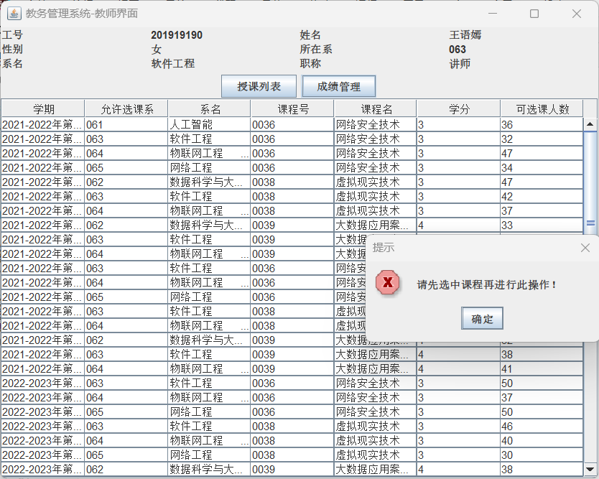

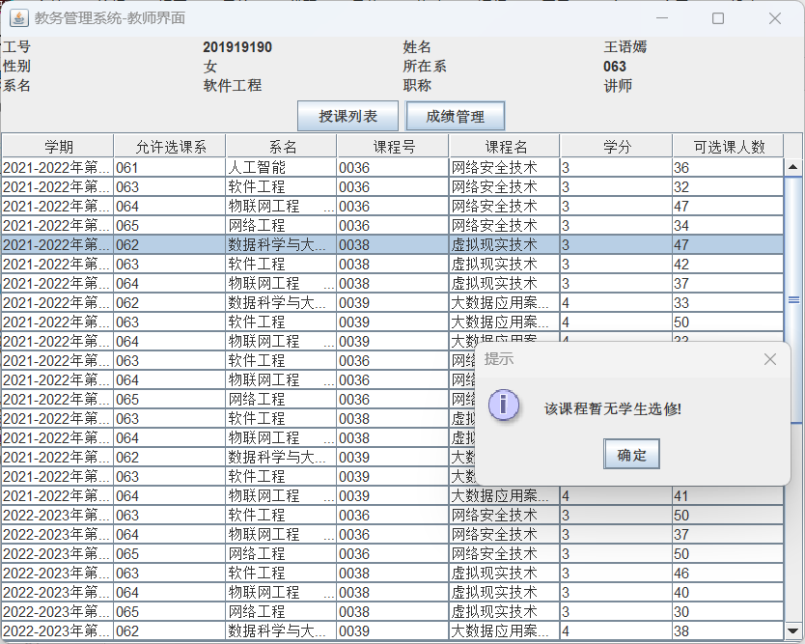

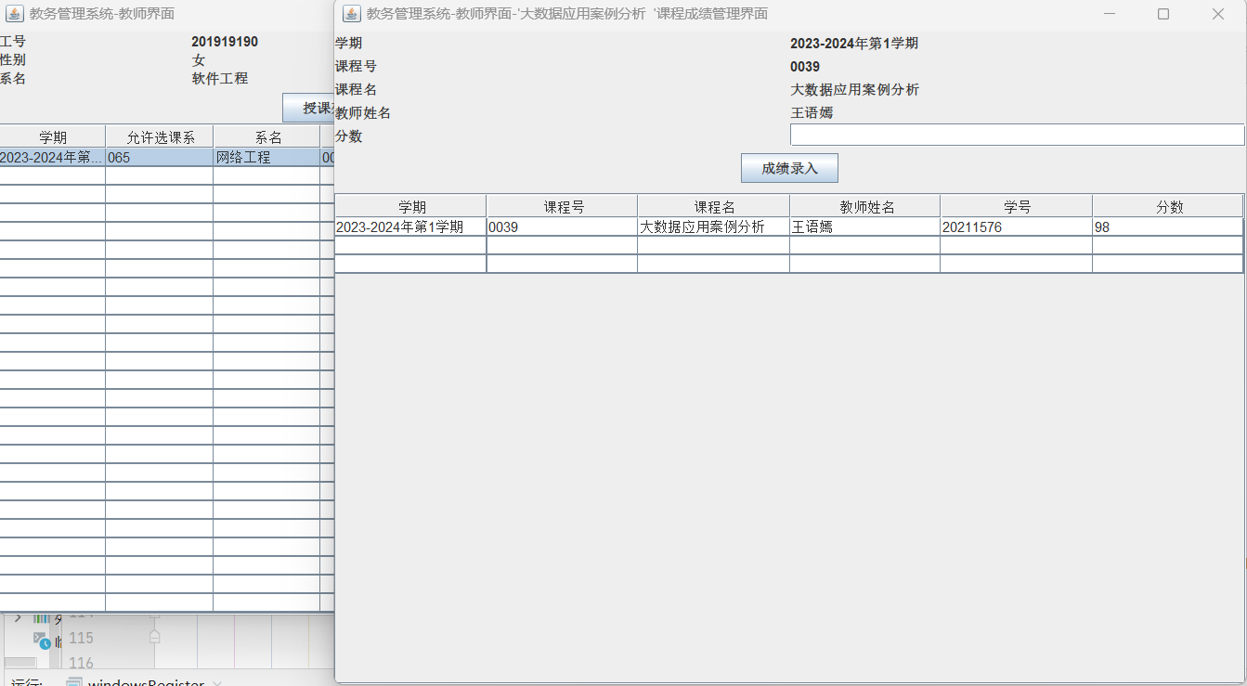

功能模块7：教务管理系统管理员界面-教师授课管理界面

功能界面：

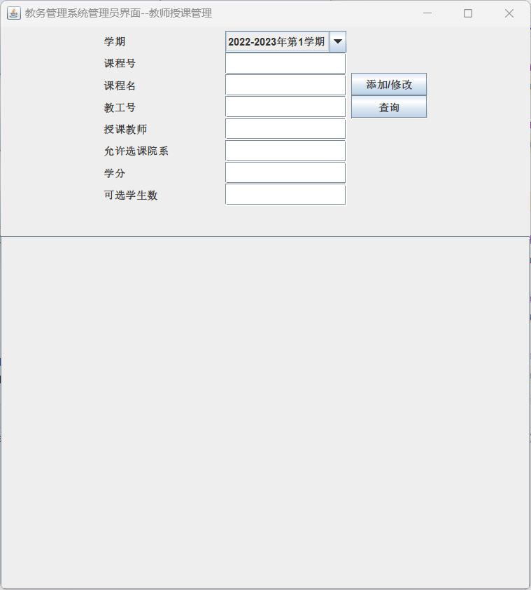

描述：点击教务管理系统管理员界面，点击教师授课信息维护按钮，打开如图界面，查询按钮进行多项查询，从Manager_Course_Teacher_manage_view获取相关信息。

T-SQL语句与宿主语言嵌套使用代码段（粘贴）：

if (e.getSource() == btnEnquiry){  
 for (int i = 0; i < getColumns(); i++) {  
 for (int j = 0; j < 8; j++) {  
 data[i][j] = "";  
 }  
 }  
 String sql = "use Academic_Affairs_Management_System_20211576 select * from Manager_Course_Teacher_manage_view where Semester='" + comSearchSemester.getSelectedItem().toString() + "'";  
 if (!txtSearchCname.getText().trim().equals("")) {  
 sql += " and Cname ='" + txtSearchCname.getText().trim() + "'";  
 }  
 if (!txtSearchName.getText().trim().equals("")) {  
 sql += " and Emp_name ='" + txtSearchName.getText().trim() + "'";  
 }  
 if (!txtEmp_no.getText().trim().equals("")) {  
 sql += " and Emp_no ='" + txtEmp_no.getText().trim() + "'";  
 }  
 if (!txtCourseOfferedSdeNo.getText().trim().equals("")) {  
 sql += " and Course_Offered_Sde_no ='" + txtCourseOfferedSdeNo.getText().trim() + "'";  
 }  
 if(!txtCno.getText().trim().equals("")){  
 sql += " and Cno ='" + txtCno.getText().trim() + "'";  
 }  
 if(!txtCredit.getText().trim().equals("")){  
 sql += " and Credit ='" + txtCredit.getText().trim() + "'";  
 }  
 if(!txtStu_total.getText().trim().equals("")){  
 sql += " and Stu_total ='" + txtStu_total.getText().trim() + "'";  
 }  
 Connect(sql);  
}

测试结果截图：

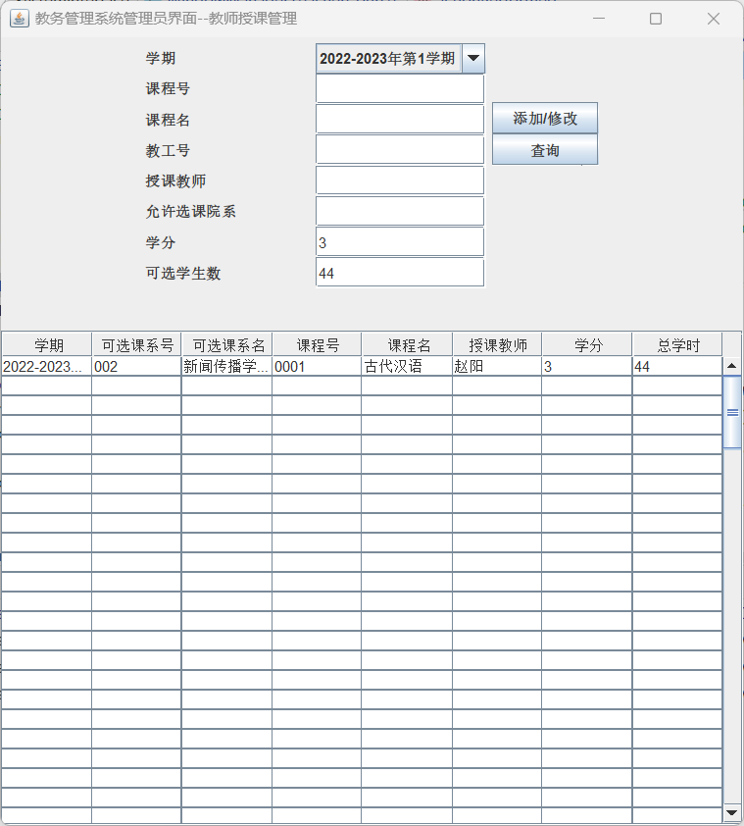

功能模块7：教务管理系统管理员界面-学生可选课程管理界面

功能界面：

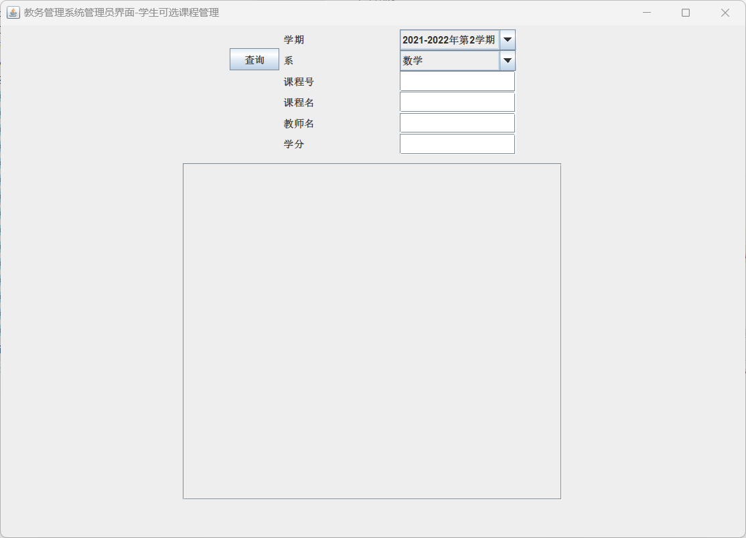

描述：点击教务管理系统管理员界面，点击学生可选课程信息维护按钮，打开如图界面，查询按钮进行多项查询，从Manager_Course_Teacher_manage_view

获取相关信息。

T-SQL语句与宿主语言嵌套使用代码段（粘贴）：

@Override  
public void actionPerformed(ActionEvent e) {  
 if (e.getSource() == btnList) {  
 String sql = "SELECT * FROM Manager_Course_Teacher_manage_view where Semester = '"+comSemester.getSelectedItem()+"' and Sde_name = '"+comSdept.getSelectedItem()+"'";  
 if(txtCno.getText().length()!=0)  
 sql+=" and Cno = '"+txtCno.getText()+"'";  
 if(txtCname.getText().length()!=0)  
 sql+=" and Cname = '"+txtCname.getText()+"'";  
 if(txtEmp_Name.getText().length()!=0)  
 sql+=" and Emp_Name = '"+txtEmp_Name.getText()+"'";  
 if(txtCredit.getText().length()!=0)  
 sql+=" and Credit = '"+txtCredit.getText()+"'";  
 Connect(sql);  
 }  
}

public void Connect(String sql){  
 for (int i = 0; i < getColumns(); i++) {  
 for (int j = 0; j < 8; j++) {  
 data[i][j] = "";  
 }  
 }  
 String Driver = "com.microsoft.sqlserver.jdbc.SQLServerDriver";  
 String url = "jdbc:sqlserver://localhost:1433;DatabaseName=Academic_Affairs_Management_System_20211576;encrypt=false";  
 String userName = "s20211576"; *// 默认用户名* String userPwd = "s20211576"; *// 密码* Connection dbConn = null;  
 try {  
 Class.*forName*(Driver);  
 dbConn = DriverManager.*getConnection*(url, userName, userPwd);  
 Statement stmt = dbConn.createStatement();  
 System.*out*.println(sql);  
 ResultSet rs = stmt.executeQuery(sql);  
 ResultSetMetaData rsmd = rs.getMetaData();  
 int numColumns = rsmd.getColumnCount();  
 int row = 0;  
 while (rs.next()) {  
 for (int col = 0; col < numColumns; col++) {  
 data[row][col] = rs.getString(col + 1);  
 }  
 row++;  
 }  
 rs.close();  
 stmt.close();  
 dbConn.close();  
 } catch (Exception em) {  
 em.printStackTrace();  
 } finally {  
 try {  
 } catch (Exception ec) {  
 ec.printStackTrace();  
 }  
 }  
 DefaultTableModel model = new DefaultTableModel(data, columnNames);  
 table.setModel(model);  
}

测试结果截图：

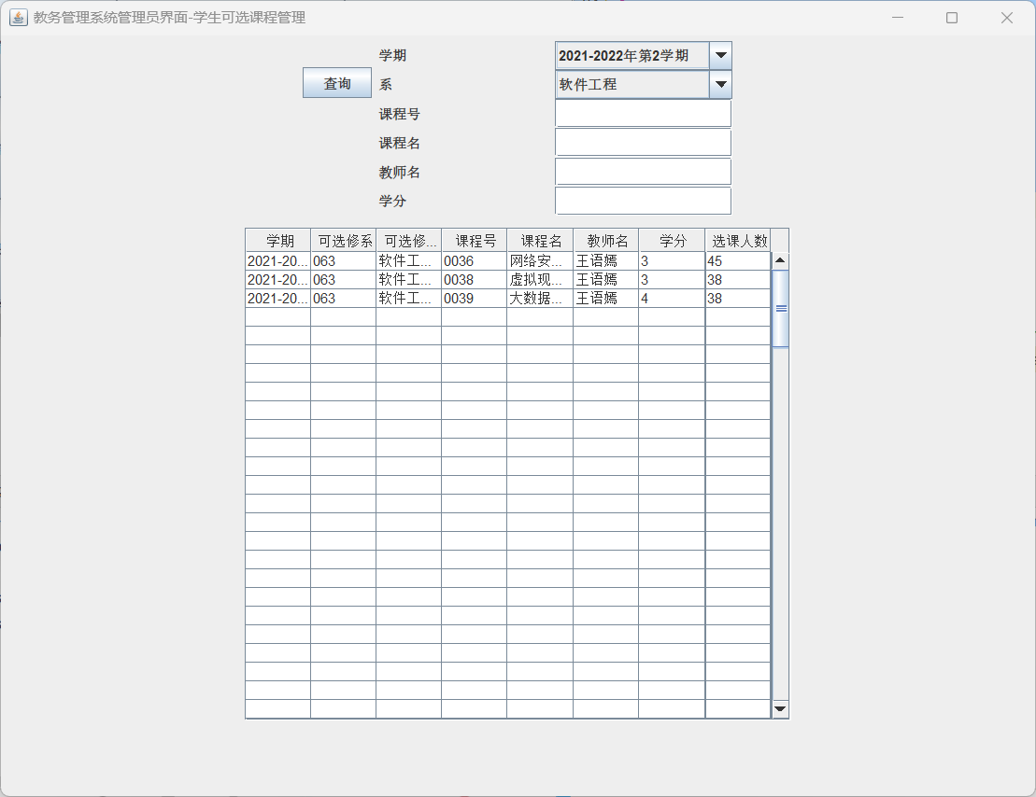

功能模块8：教务管理系统管理员界面-教师学生信息查询界面-教师信息查询

功能界面：

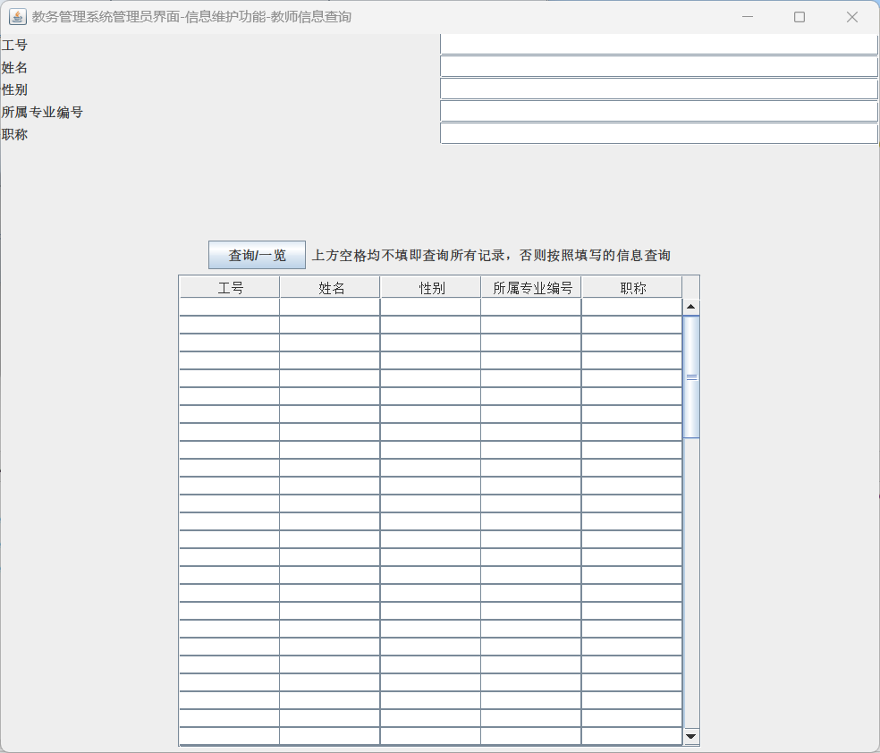

描述：点击教务管理系统管理员界面，点击教师学生信息查询系统按钮，店家教师信息查询按钮，打开如图界面，查询按钮进行多项查询，从

Manager_Course_Teacher_manage_view获取相关信息。

T-SQL语句与宿主语言嵌套使用代码段（粘贴）：

@Override  
public void actionPerformed(ActionEvent e) {  
 if (e.getSource() == btnEnquiry) {  
 *//清空表格* for (int i = 0; i < getColumns(); i++) {  
 for (int j = 0; j < 10; j++) {  
 data[i][j] = "";  
 }  
 }  
 if (textNo.getText().toString().equals("") == true  
 && textName.getText().toString().equals("") == true  
 && textSex.getText().toString().equals("") == true  
 && textSdept.getText().toString().equals("") == true  
 && textPosition.getText().toString().equals("") == true){  
 String Driver = "com.microsoft.sqlserver.jdbc.SQLServerDriver";  
 String url = "jdbc:sqlserver://localhost:1433;DatabaseName=Academic_Affairs_Management_System_20211576;encrypt=false";  
 String userName = "s20211576"; *// 默认用户名* String userPwd = "s20211576"; *// 密码* String sql = "use Academic_Affairs_Management_System_20211576 select * from Manager_Teacher_view";  
 Connection dbConn = null;  
 try {  
 Class.*forName*(Driver);  
 dbConn = DriverManager.*getConnection*(url, userName, userPwd);  
 Statement stmt = dbConn.createStatement();  
 System.*out*.println(sql);  
 ResultSet rs = stmt.executeQuery(sql);  
 ResultSetMetaData rsmd = rs.getMetaData();  
 int numColumns = rsmd.getColumnCount();  
 int row = 0;  
 while (rs.next()) {  
 for (int col = 0; col < numColumns; col++) {  
 data[row][col] = rs.getString(col + 1);  
 }  
 row++;  
 }  
 rs.close();  
 stmt.close();  
 dbConn.close();  
 } catch (Exception em) {  
 em.printStackTrace();  
 } finally {  
 try {  
 } catch (Exception ec) {  
 ec.printStackTrace();  
 }  
 }  
 }  
 else {  
 *//清空表格* for (int i = 0; i < getColumns(); i++) {  
 for (int j = 0; j < 10; j++) {  
 data[i][j] = "";  
 }  
 }  
 int flag = 0;  
 String Input = null;  
 String sql = "use Academic_Affairs_Management_System_20211576 select * from Manager_Teacher_view where 1=1 ";  
 if (textNo.getText().toString().equals("") == false) {  
 sql += "and Emp_no = " + "'" + textNo.getText().toString() + "'";  
 }  
 if (textName.getText().toString().equals("") == false) {  
 sql += "and Emp_name = " + "'" + textName.getText().toString() + "'";  
 }  
 if (textSex.getText().toString().equals("") == false) {  
 sql += "and Sex = " + "'" + textSex.getText().toString() + "'";  
 }  
 if (textSdept.getText().toString().equals("") == false) {  
 sql += "and Sdept_no = " + "'" + textSdept.getText().toString() + "'";  
 }  
 if (textPosition.getText().toString().equals("") == false) {  
 System.*out*.println(textPosition.getText().toString());  
 sql += "and Position = " + "'" + textPosition.getText().toString() + "'";  
 }  
 String Driver = "com.microsoft.sqlserver.jdbc.SQLServerDriver";  
 String url = "jdbc:sqlserver://localhost:1433;DatabaseName=Academic_Affairs_Management_System_20211576;encrypt=false";  
 String userName = "s20211576"; *// 默认用户名* String userPwd = "s20211576"; *// 密码* Connection dbConn = null;  
 try {  
 Class.*forName*(Driver);  
 dbConn = DriverManager.*getConnection*(url, userName, userPwd);  
 Statement stmt = dbConn.createStatement();  
 System.*out*.println(sql);  
 ResultSet rs = stmt.executeQuery(sql);  
 int count = 0;  
 while(rs.next()){  
 data[count][0] = rs.getString("Emp_no");  
 data[count][1] = rs.getString("Emp_name");  
 data[count][2] = rs.getString("Sex");  
 data[count][3] = rs.getString("Sde_no");  
 data[count][4] = rs.getString("Position");  
 count++;  
 }  
 rs.close();  
 stmt.close();  
 dbConn.close();  
 } catch (Exception em) {  
 em.printStackTrace();  
 } finally {  
 try {  
 } catch (Exception ec) {  
 ec.printStackTrace();  
 }  
 }  
 }  
 DefaultTableModel model = new DefaultTableModel(data, columnNames);  
 table.setModel(model);  
 }  
}

运行结果：

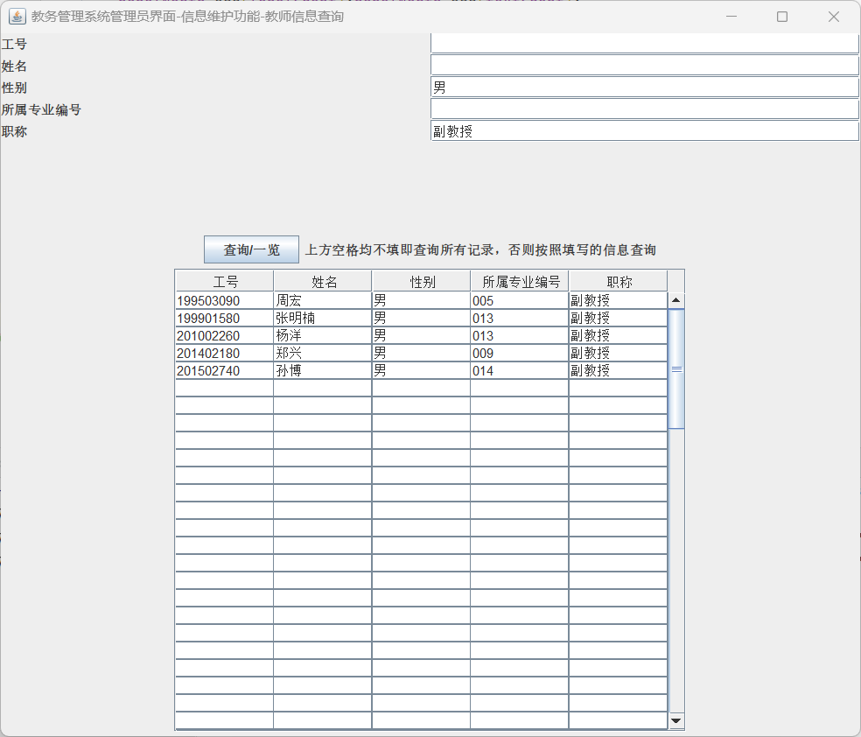

功能模块9：教务管理系统管理员界面-教师学生信息查询界面-学生信息查询

功能界面：

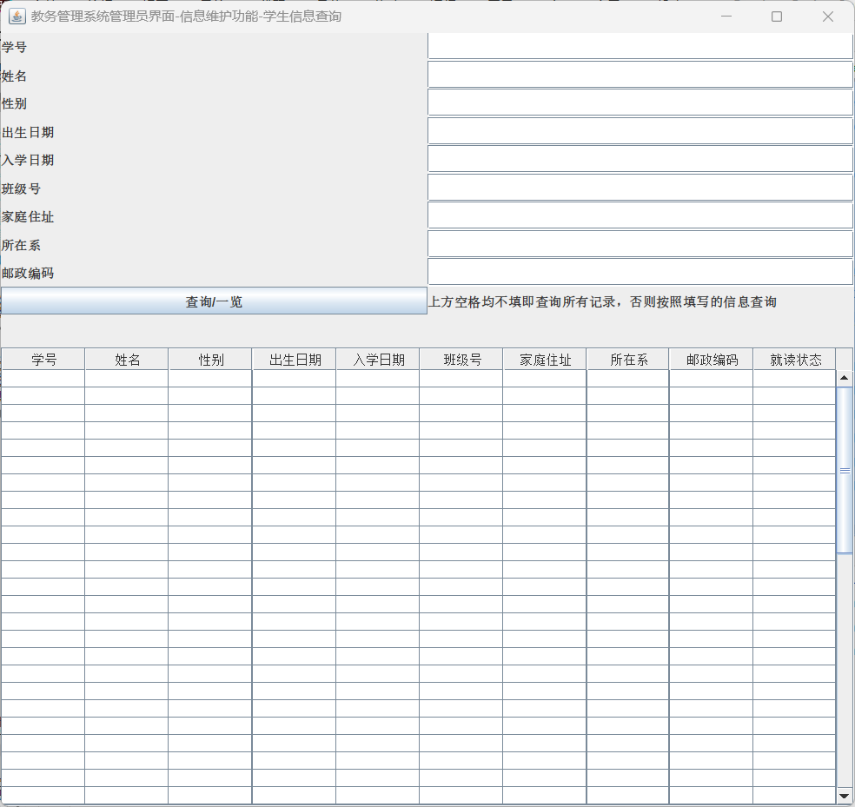

描述：点击教务管理系统管理员界面，点击教师学生信息查询系统按钮，店家学生信息查询按钮，打开如图界面，查询按钮进行多项查询，从Manager_Student_view获取相关信息。

T-SQL语句与宿主语言嵌套使用代码段（粘贴）：

@Override  
public void actionPerformed(ActionEvent e) {  
 if (e.getSource() == btnEnquiry) {  
 *//清空表格* for (int i = 0; i < getColumns(); i++) {  
 for (int j = 0; j < 10; j++) {  
 data[i][j] = "";  
 }  
 }  
 if (textNo.getText().toString().equals("") == true  
 && textName.getText().toString().equals("") == true  
 && textSex.getText().toString().equals("") == true  
 && textBirth.getText().toString().equals("") == true  
 && textEntrancedate.getText().toString().equals("") == true  
 && textClassno.getText().toString().equals("") == true  
 && textHomeaddress.getText().toString().equals("") == true  
 && textSdept.getText().toString().equals("") == true  
 && textPostcode.getText().toString().equals("") == true) {  
 String Driver = "com.microsoft.sqlserver.jdbc.SQLServerDriver";  
 String url = "jdbc:sqlserver://localhost:1433;DatabaseName=Academic_Affairs_Management_System_20211576;encrypt=false";  
 String userName = "s20211576"; *// 默认用户名* String userPwd = "s20211576"; *// 密码* String sql = "use Academic_Affairs_Management_System_20211576 select * from Manager_Student_view";  
 Connection dbConn = null;  
 try {  
 Class.*forName*(Driver);  
 dbConn = DriverManager.*getConnection*(url, userName, userPwd);  
 Statement stmt = dbConn.createStatement();  
 System.*out*.println(sql);  
 ResultSet rs = stmt.executeQuery(sql);  
 *// Get the number of columns in the ResultSet* ResultSetMetaData rsmd = rs.getMetaData();  
 int numColumns = rsmd.getColumnCount();  
 int row = 0;  
 while (rs.next()) {  
 for (int col = 0; col < numColumns; col++) {  
 data[row][col] = rs.getString(col + 1);  
 }  
 row++;  
 }  
 rs.close();  
 stmt.close();  
 dbConn.close();  
 } catch (Exception em) {  
 em.printStackTrace();  
 } finally {  
 try {  
 } catch (Exception ec) {  
 ec.printStackTrace();  
 }  
 }  
 DefaultTableModel model = new DefaultTableModel(data, columnNames);  
 table.setModel(model);  
 } else {  
 *//清空表格* for (int i = 0; i < getColumns(); i++) {  
 for (int j = 0; j < 10; j++) {  
 data[i][j] = "";  
 }  
 }  
 int flag = 0;  
 String Input = null;  
 String sql = "use Academic_Affairs_Management_System_20211576 select * from Manager_Student_view where 1=1 ";  
 if (textNo.getText().toString().equals("") == false)  
 sql += " and Sno = " + "'" + textNo.getText() + "'";  
 if (textName.getText().toString().equals("") == false)  
 sql += " and Sname = " + "'" + textName.getText() + "'";  
 if (textSex.getText().toString().equals("") == false)  
 sql += "and Sex = " + "'" + textSex.getText() + "'";  
 if (textBirth.getText().toString().equals("") == false)  
 sql += "and Birth = " + "'" + textBirth.getText() + "'";  
 if (textEntrancedate.getText().toString().equals("") == false)  
 sql += "and Entrance_date = " + "'" + textEntrancedate.getText() + "'";  
 if (textClassno.getText().toString().equals("") == false)  
 sql += "and Class_no = " + "'" + textClassno.getText() + "'";  
 if (textHomeaddress.getText().toString().equals("") == false)  
 sql += "and Home_address = " + "'" + textHomeaddress.getText() + "'";  
 if (textSdept.getText().toString().equals("") == false)  
 sql += "and Sdept = " + "'" + textSdept.getText() + "'";  
 if (textPostcode.getText().toString().equals("") == false)  
 sql += "and Postcode = " + "'" + textPostcode.getText() + "'";  
 String Driver = "com.microsoft.sqlserver.jdbc.SQLServerDriver";  
 String url = "jdbc:sqlserver://localhost:1433;DatabaseName=Academic_Affairs_Management_System_20211576;encrypt=false";  
 String userName = "s20211576"; *// 默认用户名* String userPwd = "s20211576"; *// 密码* Connection dbConn = null;  
 try {  
 Class.*forName*(Driver);  
 dbConn = DriverManager.*getConnection*(url, userName, userPwd);  
 Statement stmt = dbConn.createStatement();  
 System.*out*.println(sql);  
 ResultSet rs = stmt.executeQuery(sql);  
 int count = 0;  
 while (rs.next()) {  
 data[count][0] = rs.getString("Sno");  
 data[count][1] = rs.getString("Sname");  
 data[count][2] = rs.getString("Sex");  
 data[count][3] = rs.getString("Birth");  
 data[count][4] = rs.getString("Entrance_date");  
 data[count][5] = rs.getString("Class_no");  
 data[count][6] = rs.getString("Home_addr");  
 data[count][7] = rs.getString("Sde_no");  
 data[count][8] = rs.getString("Postcode");  
 data[count][9] = rs.getString("AttendanceStatus");  
 count++;  
 }  
 rs.close();  
 stmt.close();  
 dbConn.close();  
 } catch (Exception em) {  
 em.printStackTrace();  
 } finally {  
 try {  
 } catch (Exception ec) {  
 ec.printStackTrace();  
 }  
 }  
 DefaultTableModel model = new DefaultTableModel(data, columnNames);  
 table.setModel(model);  
 }  
 }  
}

运行结果：

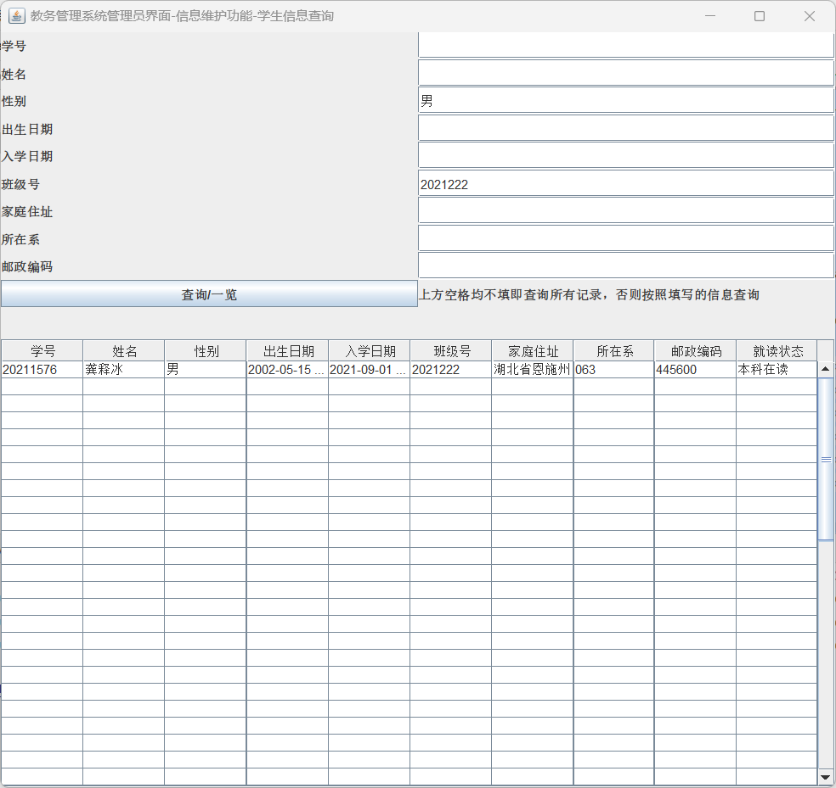

功能模块10：教务管理系统管理员界面-学生选修课程成绩汇总：

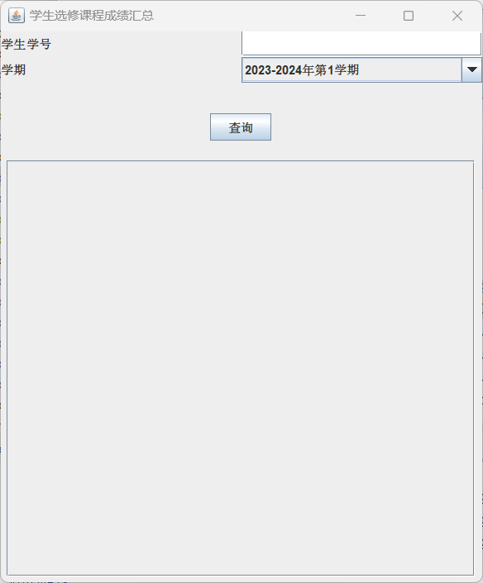

描述：点击教务管理系统管理员界面，点击学生选修课程成绩汇总按钮，打开如图界面，从存储过程GetStudentCourseSummary中获取相关信息。

T-SQL语句与宿主语言嵌套使用代码段（粘贴）：

@Override  
public void actionPerformed(ActionEvent e) {  
 if(e.getSource() == btnGetStudentCourseSummary){  
 String Driver2 = "com.microsoft.sqlserver.jdbc.SQLServerDriver";  
 String url = "jdbc:sqlserver://localhost:1433;DatabaseName=Academic_Affairs_Management_System_20211576;encrypt=false";  
 String userName = "s20211576"; *// 默认用户名* String userPwd = "s20211576"; *// 密码* Connection dbConn = null;  
 try {  
 Class.*forName*(Driver2);  
 dbConn = DriverManager.*getConnection*(url, userName, userPwd);  
 } catch (ClassNotFoundException e0) {  
 throw new RuntimeException(e0);  
 } catch (SQLException e1) {  
 throw new RuntimeException(e1);  
 }  
 int columnCount;  
 try {  
 Statement stmt = dbConn.createStatement();  
 ResultSet rs = stmt.executeQuery("EXEC GetStudentCourseSummary '" + comboSemester.getSelectedItem() + "', '" + textFieldStudentID.getText() + "'");  
 ResultSetMetaData rsmd = rs.getMetaData();  
 while (rs.next()) {  
 data[0][0] = rs.getString(1);  
 data[0][1] = rs.getString(2);  
 data[0][2] = rs.getString(3);  
 data[0][3] = rs.getString(4);  
 data[0][4] = rs.getString(5);  
 data[0][5] = rs.getString(6);  
 }  
  
 } catch (SQLException e2) {  
 throw new RuntimeException(e2);  
 } finally {  
 try {  
 dbConn.close();  
 } catch (SQLException e3) {  
 throw new RuntimeException(e3);  
 }  
 }  
 DefaultTableModel model = new DefaultTableModel(data, tableTitle);  
 table.setModel(model);  
 }  
}

运行结果：

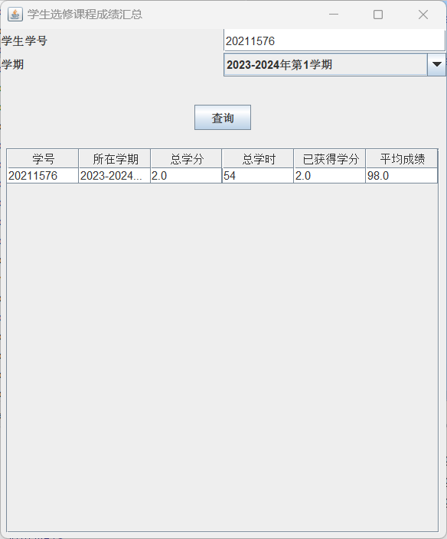

功能模块11：教务管理系统管理员界面-班级选修课程成绩汇总：

功能界面：

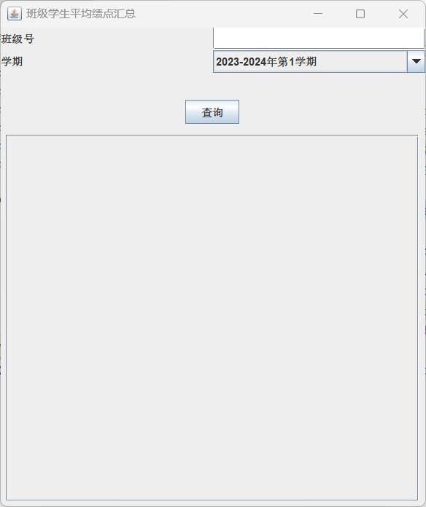

描述：点击教务管理系统管理员界面，点击班级选修课程成绩汇总按钮，打开如图界面，查询按钮进行多项查询，从存储过程GetClassSummary获取相关信息。

T-SQL语句与宿主语言嵌套使用代码段（粘贴）：

@Override  
public void actionPerformed(ActionEvent e) {  
 if(e.getSource() == btnGetClassSummary){  
 String Driver2 = "com.microsoft.sqlserver.jdbc.SQLServerDriver";  
 String url = "jdbc:sqlserver://localhost:1433;DatabaseName=Academic_Affairs_Management_System_20211576;encrypt=false";  
 String userName = "s20211576"; *// 默认用户名* String userPwd = "s20211576"; *// 密码* Connection dbConn = null;  
 String sql = "EXEC GetClassSummary '"+comboSemester.getSelectedItem()+"','"+textClassno.getText()+"'";  
 try {  
 Class.*forName*(Driver2);  
 dbConn = DriverManager.*getConnection*(url, userName, userPwd);  
 } catch (ClassNotFoundException e0) {  
 throw new RuntimeException(e0);  
 } catch (SQLException e1) {  
 throw new RuntimeException(e1);  
 }  
 int columnCount;  
 try {  
 Statement stmt = dbConn.createStatement();  
 ResultSet rs = stmt.executeQuery(sql);  
 ResultSetMetaData rsmd = rs.getMetaData();  
 int count = 0;  
 while (rs.next()) {  
 data[count][0] = rs.getString("Sno");  
 data[count][1] = rs.getString("Sname");  
 data[count][2] = rs.getString("AverageGPA");  
 }  
 } catch (SQLException e2) {  
 throw new RuntimeException(e2);  
 } finally {  
 try {  
 dbConn.close();  
 } catch (SQLException e3) {  
 throw new RuntimeException(e3);  
 }  
 }  
 DefaultTableModel model = new DefaultTableModel(data, tableTitle);  
 table.setModel(model);  
 }  
}

运行结果：

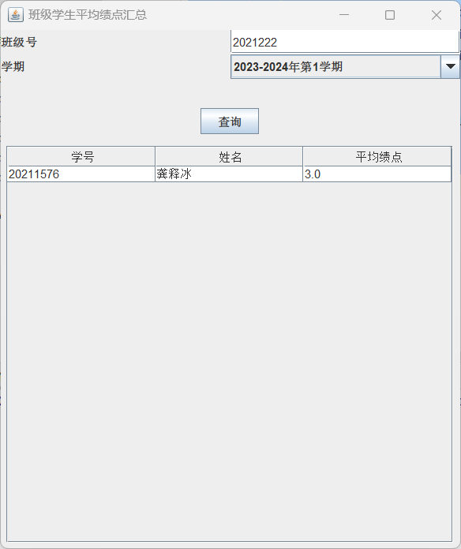

功能模块12：教务管理系统管理员界面-教师授课学时统计：

功能界面：

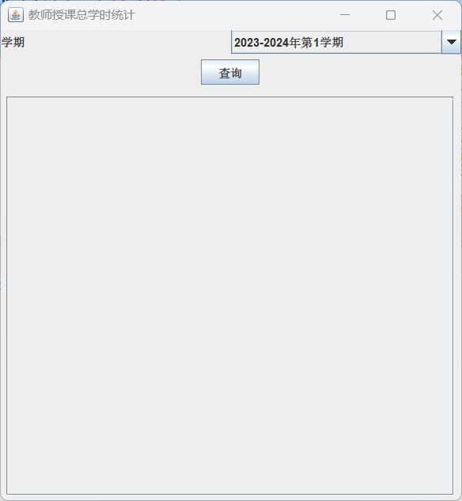

描述：点击教务管理系统管理员界面，点击教师授课学时统计按钮，打开如图界面，从存储过程sp_CountTeachingHours获取相关信息。

T-SQL语句与宿主语言嵌套使用代码段（粘贴）：

@Override  
public void actionPerformed(ActionEvent e) {  
 if(e.getSource() == btnGetClassSummary){  
 String Driver2 = "com.microsoft.sqlserver.jdbc.SQLServerDriver";  
 String url = "jdbc:sqlserver://localhost:1433;DatabaseName=Academic_Affairs_Management_System_20211576;encrypt=false";  
 String userName = "s20211576"; *// 默认用户名* String userPwd = "s20211576"; *// 密码* Connection dbConn = null;  
 String sql = "EXEC sp_CountTeachingHours '" + comboSemester.getSelectedItem() + "'";  
 try {  
 Class.*forName*(Driver2);  
 dbConn = DriverManager.*getConnection*(url, userName, userPwd);  
 } catch (ClassNotFoundException e0) {  
 throw new RuntimeException(e0);  
 } catch (SQLException e1) {  
 throw new RuntimeException(e1);  
 }  
 try {  
 Statement stmt = dbConn.createStatement();  
 ResultSet rs = stmt.executeQuery(sql);  
 ResultSetMetaData rsmd = rs.getMetaData();  
 int i = 0;  
 while (rs.next()) {  
 data[i][0] = rs.getString(1);  
 data[i][1] = comboSemester.getSelectedItem();  
 data[i][2] = rs.getString(2);  
 data[i][3] = rs.getString(3);  
 i++;  
 }  
 } catch (SQLException e2) {  
 throw new RuntimeException(e2);  
 } finally {  
 try {  
 dbConn.close();  
 } catch (SQLException e3) {  
 throw new RuntimeException(e3);  
 }  
 }  
 DefaultTableModel model = new DefaultTableModel(data, tableTitle);  
 table.setModel(model);  
 }  
}

运行结果：

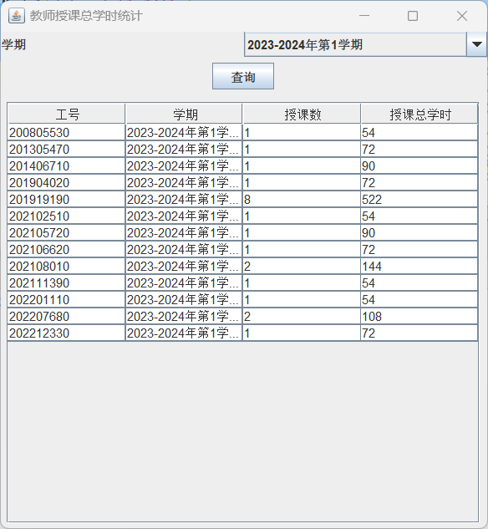

功能模块12：教务管理系统管理员界面-各部分信息维护-添加学院信息-查询：

功能界面：

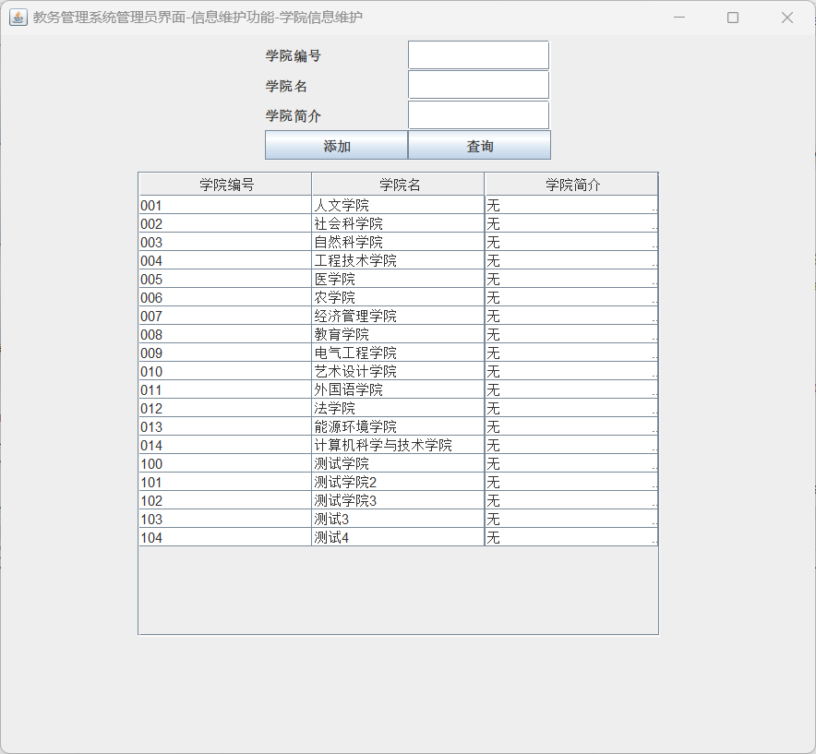

描述：点击教务管理系统管理员界面，点击各部分信息维护按钮，打开如图界面，点击查询按钮可进行多项查询，从Manager_Academy_view中获取相关信息。

T-SQL语句与宿主语言嵌套使用代码段（粘贴）：

@Override  
public void actionPerformed(ActionEvent e) {  
 if (e.getSource() == btnSearch){  
 for (int i = 0; i < getColumns(); i++) {  
 for (int j = 0; j < 10; j++) {  
 data[i][j] = "";  
 }  
 }  
 if (textAcaNo.getText().toString().equals("") == true  
 && textAcaName.getText().toString().equals("") == true  
 && textAcaIntroduction.getText().toString().equals("") == true){  
 String Driver = "com.microsoft.sqlserver.jdbc.SQLServerDriver";  
 String url = "jdbc:sqlserver://localhost:1433;DatabaseName=Academic_Affairs_Management_System_20211576;encrypt=false";  
 String userName = "s20211576"; *// 默认用户名* String userPwd = "s20211576"; *// 密码* String sql = "use Academic_Affairs_Management_System_20211576 select * from Manager_Academy_view";  
 Connection dbConn = null;  
 try {  
 Class.*forName*(Driver);  
 dbConn = DriverManager.*getConnection*(url, userName, userPwd);  
 Statement stmt = dbConn.createStatement();  
 ResultSet rs = stmt.executeQuery(sql);  
 ResultSetMetaData rsmd = rs.getMetaData();  
 int numColumns = rsmd.getColumnCount();  
 int row = 0;  
 while (rs.next()) {  
 for (int col = 0; col < numColumns; col++) {  
 data[row][col] = rs.getString(col + 1);  
 }  
 row++;  
 }  
 rs.close();  
 stmt.close();  
 dbConn.close();  
 } catch (Exception em) {  
 em.printStackTrace();  
 } finally {  
 try {  
 } catch (Exception ec) {  
 ec.printStackTrace();  
 }  
 }  
 }  
 else {  
 for (int i = 0; i < getColumns(); i++) {  
 for (int j = 0; j < 8; j++) {  
 data[i][j] = "";  
 }  
 }  
 String input = null;  
 String sql = null;  
 if (!textAcaNo.getText().isEmpty()) {  
 input = textAcaNo.getText();  
 sql = "SELECT * FROM Manager_Academy_view WHERE Aca_no = ?";  
 } else if (!textAcaName.getText().isEmpty()) {  
 input = textAcaName.getText();  
 sql = "SELECT * FROM Manager_Academy_view WHERE Aca_name = ?";  
 } else if (!textAcaIntroduction.getText().isEmpty()) {  
 input = textAcaIntroduction.getText();  
 sql = "SELECT * FROM Manager_Academy_view WHERE Aca_introduction = ?";  
 }  
 String driver = "com.microsoft.sqlserver.jdbc.SQLServerDriver";  
 String url = "jdbc:sqlserver://localhost:1433;DatabaseName=Academic_Affairs_Management_System_20211576;encrypt=false";  
 String username = "s20211576";  
 String password = "s20211576";  
 try (Connection conn = DriverManager.*getConnection*(url, username, password);  
 PreparedStatement pstmt = conn.prepareStatement(sql)) {  
 pstmt.setString(1, input);  
 ResultSet rs = pstmt.executeQuery();  
 int count = 0;  
 while (rs.next()) {  
 data[count][0] = rs.getString("Aca_no");  
 data[count][1] = rs.getString("Aca_name");  
 data[count][2] = rs.getString("Aca_introduction");  
 count++;  
 }  
 rs.close();  
 } catch (Exception e1) {  
 e1.printStackTrace();  
 }  
 }  
 DefaultTableModel model = new DefaultTableModel(data, columnNames);  
 table.setModel(model);  
 }  
}

运行结果：

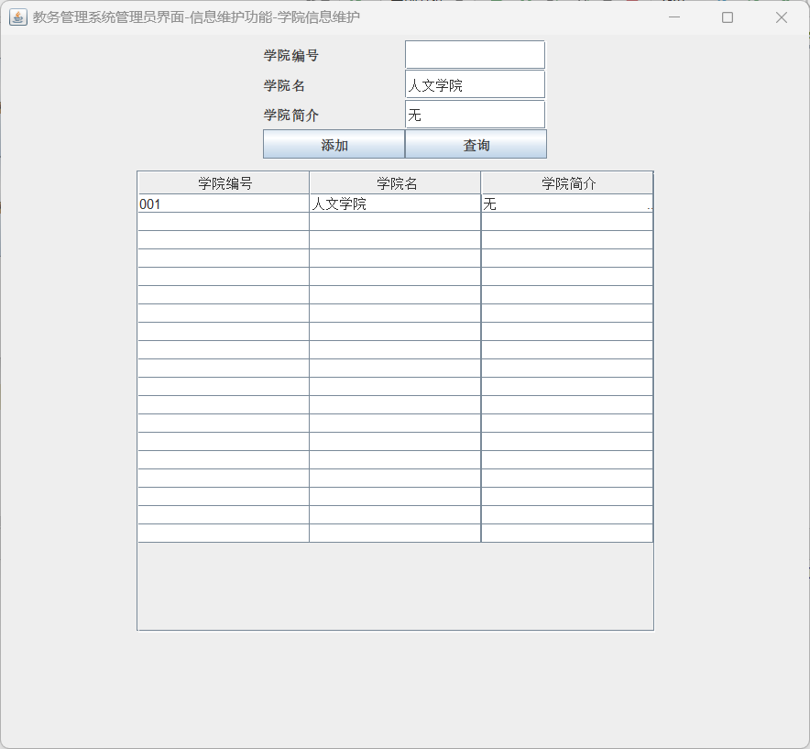

功能模块13：教务管理系统管理员界面-各部分信息维护-专业信息维护-查询：

功能界面：

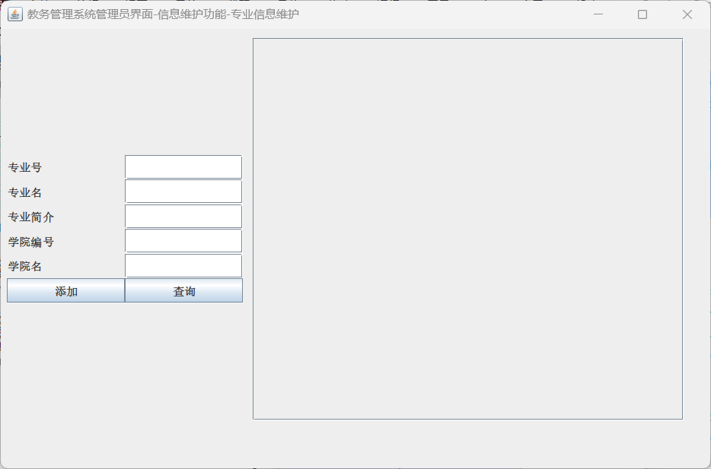

描述：点击教务管理系统管理员界面，点击各部分信息维护按钮，点击专业信息维护按钮，打开如图界面，点击查询按钮可进行多项查询，从Manager_Sdept_view中获取相关信息。

T-SQL语句与宿主语言嵌套使用代码段（粘贴）：

if (e.getSource() == btnSearch) {  
 *//清空表格* for (int i = 0; i < getColumns(); i++) {  
 for (int j = 0; j < 10; j++) {  
 data[i][j] = "";  
 }  
 }  
 if (textSdeNo.getText().toString().equals("") == true  
 && textSdeName.getText().toString().equals("") == true  
 && textSdeIntroduction.getText().toString().equals("") == true  
 && textAcaNo.getText().toString().equals("") == true  
 && textAcaName.getText().toString().equals("") == true) {  
 String Driver = "com.microsoft.sqlserver.jdbc.SQLServerDriver";  
 String url = "jdbc:sqlserver://localhost:1433;DatabaseName=Academic_Affairs_Management_System_20211576;encrypt=false";  
 String userName = "s20211576"; *// 默认用户名* String userPwd = "s20211576"; *// 密码* String sql = "use Academic_Affairs_Management_System_20211576 select * from Manager_Sdept_view";  
 Connection dbConn = null;  
 try {  
 Class.*forName*(Driver);  
 dbConn = DriverManager.*getConnection*(url, userName, userPwd);  
 Statement stmt = dbConn.createStatement();  
 System.*out*.println(sql);  
 ResultSet rs = stmt.executeQuery(sql);  
 *// Get the number of columns in the ResultSet* ResultSetMetaData rsmd = rs.getMetaData();  
 int numColumns = rsmd.getColumnCount();  
 int row = 0;  
 while (rs.next()) {  
 for (int col = 0; col < numColumns; col++) {  
 data[row][col] = rs.getString(col + 1);  
 }  
 row++;  
 }  
 rs.close();  
 stmt.close();  
 dbConn.close();  
 } catch (Exception em) {  
 em.printStackTrace();  
 } finally {  
 try {  
 } catch (Exception ec) {  
 ec.printStackTrace();  
 }  
 }  
 } else {  
 for (int i = 0; i < getColumns(); i++) {  
 for (int j = 0; j < 8; j++) {  
 data[i][j] = "";  
 }  
 }  
 String Input = null;  
 String sql = "use Academic_Affairs_Management_System_20211576 select * from Manager_Sdept_view where 1=1";  
 if (textSdeNo.getText().toString().equals("") == false) {  
 Input = textSdeNo.getText().toString();  
 sql += " and Sde_no = " + "'" + Input + "'";  
 } else if (textSdeName.getText().toString().equals("") == false) {  
 Input = textSdeName.getText().toString();  
 sql += " and Sde_name = " + "'" + Input + "'";  
 } else if (textSdeIntroduction.getText().toString().equals("") == false) {  
 Input = textSdeIntroduction.getText().toString();  
 sql += " and Sde_introduction = " + "'" + Input + "'";  
 } else if (textAcaNo.getText().toString().equals("") == false) {  
 Input = textAcaNo.getText().toString();  
 sql += " and Aca_no = " + "'" + Input + "'";  
 } else if (textAcaName.getText().toString().equals("") == false) {  
 Input = textAcaName.getText().toString();  
 sql += " and Aca_name = " + "'" + Input + "'";  
 }  
 String Driver = "com.microsoft.sqlserver.jdbc.SQLServerDriver";  
 String url = "jdbc:sqlserver://localhost:1433;DatabaseName=Academic_Affairs_Management_System_20211576;encrypt=false";  
 String userName = "s20211576"; *// 默认用户名* String userPwd = "s20211576"; *// 密码* Connection dbConn = null;  
 try {  
 Class.*forName*(Driver);  
 dbConn = DriverManager.*getConnection*(url, userName, userPwd);  
 System.*out*.println("Connection Successful!"); *// 如果连接成功 控制台输出* Statement stmt = dbConn.createStatement();  
 System.*out*.println(sql);  
 ResultSet rs = stmt.executeQuery(sql);  
 int count = 0;  
 while (rs.next()) {  
 data[count][0] = rs.getString("Sde_no");  
 data[count][1] = rs.getString("Sde_name");  
 data[count][2] = rs.getString("Sde_introduction");  
 data[count][3] = rs.getString("Aca_no");  
 data[count][4] = rs.getString("Aca_name");  
 count++;  
 }  
 rs.close();  
 stmt.close();  
 dbConn.close();  
 } catch (Exception em) {  
 em.printStackTrace();  
 } finally {  
 try {  
 } catch (Exception ec) {  
 ec.printStackTrace();  
 }  
 }  
 }  
 DefaultTableModel model = new DefaultTableModel(data, columnNames);  
 table.setModel(model);  
}

运行结果：

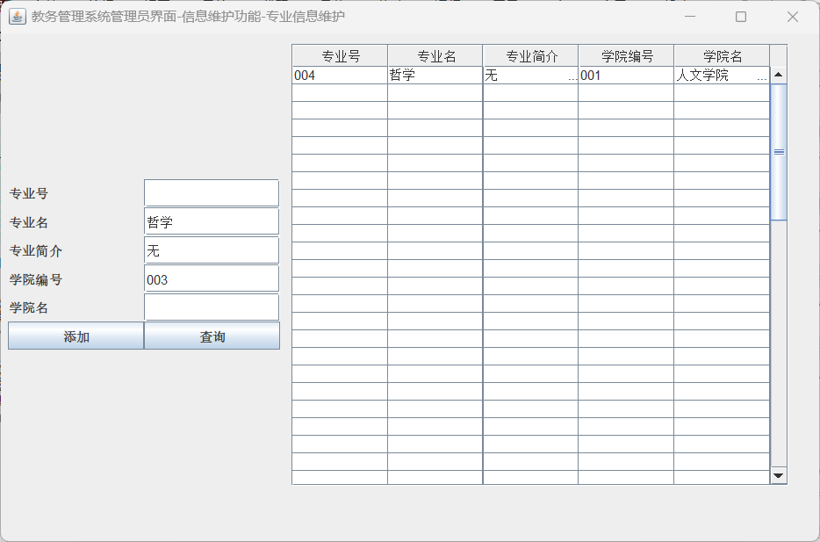

功能模块14：教务管理系统管理员界面-各部分信息维护-班级信息维护-查询：

功能界面：

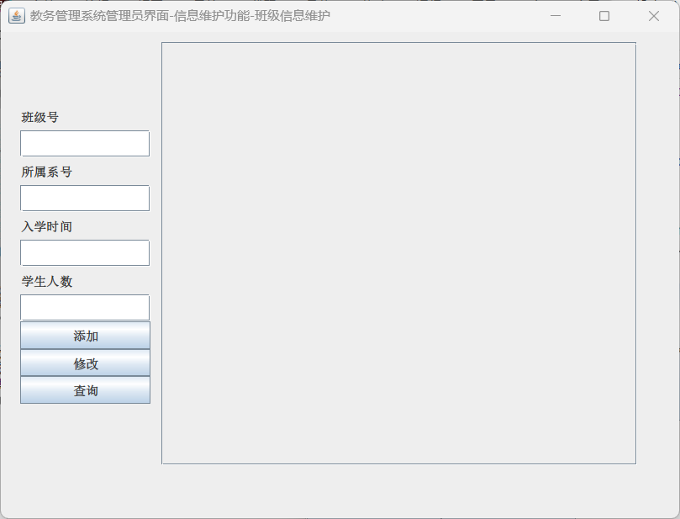

描述：点击教务管理系统管理员界面，点击各部分信息维护按钮，点击班级信息维护按钮，打开如图界面，点击查询按钮可进行多项查询，从Manager_Class_view中获取相关信息。

T-SQL语句与宿主语言嵌套使用代码段（粘贴）：

if (e.getSource() == btnSearch) {  
 *//清空表格* for (int i = 0; i < getColumns(); i++) {  
 for (int j = 0; j < 10; j++) {  
 data[i][j] = "";  
 }  
 }  
 if (textClassNo.getText().equals("") == true  
 && textSdeNo.getText().equals("") == true  
 && textNum.getText().equals("") == true) {  
 String Driver = "com.microsoft.sqlserver.jdbc.SQLServerDriver";  
 String url = "jdbc:sqlserver://localhost:1433;DatabaseName=Academic_Affairs_Management_System_20211576;encrypt=false";  
 String userName = "s20211576"; *// 默认用户名* String userPwd = "s20211576"; *// 密码* String sql = "use Academic_Affairs_Management_System_20211576 select * from Manager_Class_view";  
 Connection dbConn = null;  
 try {  
 Class.*forName*(Driver);  
 dbConn = DriverManager.*getConnection*(url, userName, userPwd);  
 Statement stmt = dbConn.createStatement();  
 System.*out*.println(sql);  
 ResultSet rs = stmt.executeQuery(sql);  
 ResultSetMetaData rsmd = rs.getMetaData();  
 int numColumns = rsmd.getColumnCount();  
 int row = 0;  
 while (rs.next()) {  
 for (int col = 0; col < numColumns; col++) {  
 if (col == 2) {  
 data[row][col] = rs.getString(col + 1).substring(0, 10);  
 } else {  
 data[row][col] = rs.getString(col + 1);  
 }  
 }  
 row++;  
 }  
 rs.close();  
 stmt.close();  
 dbConn.close();  
 } catch (Exception em) {  
 em.printStackTrace();  
 } finally {  
 try {  
 } catch (Exception ec) {  
 ec.printStackTrace();  
 }  
 }  
 } else {  
 *//清空表格* for (int i = 0; i < getColumns(); i++) {  
 for (int j = 0; j < 10; j++) {  
 data[i][j] = "";  
 }  
 }  
 int flag = 0;  
 String input = null;  
 String sql = "SELECT * FROM Manager_Class_view WHERE 1=1 ";  
 if (!textClassNo.getText().isEmpty()) {  
 input = textClassNo.getText();  
 sql += "and Class_no = '"+input+"' ";  
 }  
 if (!textSdeNo.getText().isEmpty()) {  
 input = textSdeNo.getText();  
 sql += "and Sde_no = '"+input+"' ";  
 }  
 if (!textNum.getText().isEmpty()) {  
 input = textNum.getText();  
 sql += "and Num = "+input+" ";  
 }  
 String driver = "com.microsoft.sqlserver.jdbc.SQLServerDriver";  
 String url = "jdbc:sqlserver://localhost:1433;DatabaseName=Academic_Affairs_Management_System_20211576;encrypt=false";  
 String username = "s20211576";  
 String password = "s20211576";  
 try{  
 Class.*forName*(driver);  
 Connection conn = DriverManager.*getConnection*(url, username, password);  
 Statement stmt = conn.createStatement();  
 ResultSet rs = stmt.executeQuery(sql);  
 System.*out*.println(sql);  
 int count = 0;  
 while (rs.next()) {  
 data[count][0] = rs.getString("Class_no");  
 data[count][1] = rs.getString("Sde_no");  
 data[count][2] = rs.getString("Entrance_date");  
 data[count][3] = rs.getString("Num");  
 count++;  
 }  
 rs.close();  
 } catch (Exception e1) {  
 e1.printStackTrace();  
 }  
  
 }  
 DefaultTableModel model = new DefaultTableModel(data, columnNames);  
 table.setModel(model);  
}

运行结果：

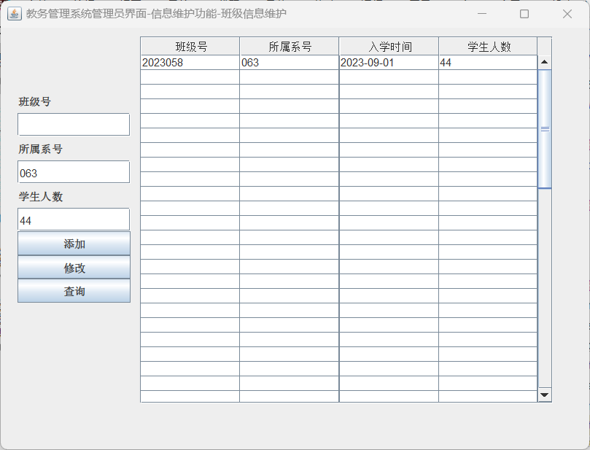

功能模块15：教务管理系统管理员界面-各部分信息维护-教师信息维护-查询：

功能界面：

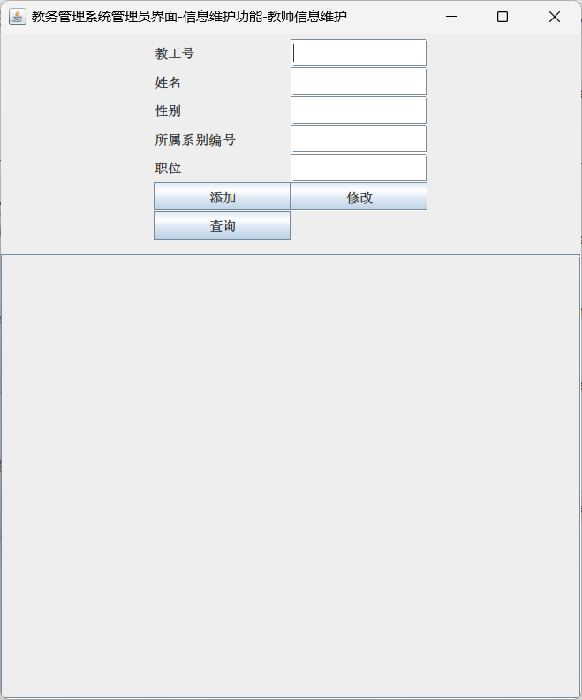

描述：点击教务管理系统管理员界面，点击各部分信息维护按钮，点击教师信息维护按钮，打开如图界面，点击查询按钮可进行多项查询，从Manager_Teacher_view中获取相关信息。

T-SQL语句与宿主语言嵌套使用代码段（粘贴）：

if (e.getSource() == btnSearch){  
 *//清空表格* for (int i = 0; i < getColumns(); i++) {  
 for (int j = 0; j < 10; j++) {  
 data[i][j] = "";  
 }  
 }  
 if (textNo.getText().toString().equals("") == true  
 && textName.getText().toString().equals("") == true  
 && textSex.getText().toString().equals("") == true  
 && textSdept.getText().toString().equals("") == true  
 && textPosition.getText().toString().equals("") == true){  
 String Driver = "com.microsoft.sqlserver.jdbc.SQLServerDriver";  
 String url = "jdbc:sqlserver://localhost:1433;DatabaseName=Academic_Affairs_Management_System_20211576;encrypt=false";  
 String userName = "s20211576"; *// 默认用户名* String userPwd = "s20211576"; *// 密码* String sql = "use Academic_Affairs_Management_System_20211576 select * from Manager_Teacher_view";  
 Connection dbConn = null;  
 try {  
 Class.*forName*(Driver);  
 dbConn = DriverManager.*getConnection*(url, userName, userPwd);  
 Statement stmt = dbConn.createStatement();  
 System.*out*.println(sql);  
 ResultSet rs = stmt.executeQuery(sql);  
 ResultSetMetaData rsmd = rs.getMetaData();  
 int numColumns = rsmd.getColumnCount();  
 int row = 0;  
 while (rs.next()) {  
 for (int col = 0; col < numColumns; col++) {  
 data[row][col] = rs.getString(col + 1);  
 }  
 row++;  
 }  
 rs.close();  
 stmt.close();  
 dbConn.close();  
 } catch (Exception em) {  
 em.printStackTrace();  
 } finally {  
 try {  
 } catch (Exception ec) {  
 ec.printStackTrace();  
 }  
 }  
 }  
 else {  
 String sql = "use Academic_Affairs_Management_System_20211576 select * from Manager_Teacher_view where 1=1 ";  
 String Driver = "com.microsoft.sqlserver.jdbc.SQLServerDriver";  
 String url = "jdbc:sqlserver://localhost:1433;DatabaseName=Academic_Affairs_Management_System_20211576;encrypt=false";  
 String userName = "s20211576"; *// 默认用户名* String userPwd = "s20211576"; *// 密码* Connection dbConn = null;  
 try {  
 Class.*forName*(Driver);  
 dbConn = DriverManager.*getConnection*(url, userName, userPwd);  
 Statement stmt = dbConn.createStatement();  
 if (!textNo.getText().isEmpty()) {  
 String Input = textNo.getText();  
 sql += " and Emp_no='" + Input + "'";  
 }  
 if (!textName.getText().isEmpty()) {  
 String Input = textName.getText();  
 sql += " and Emp_name='" + Input + "'";  
 }  
 if (!textSex.getText().isEmpty()) {  
 String Input = textSex.getText();  
 sql += " and Sex='" + Input + "'";  
 }  
 if (!textSdept.getText().isEmpty()) {  
 String Input = textSdept.getText();  
 sql += " and Sde_no='" + Input + "'";  
 }  
 if (!textPosition.getText().isEmpty()) {  
 String Input = textPosition.getText();  
 sql += " and Position='" + Input + "'";  
 }  
 System.*out*.println(sql);  
 ResultSet rs = stmt.executeQuery(sql);  
 int count = 0;  
 while (rs.next()) {  
 data[count][0] = rs.getString("Emp_no");  
 data[count][1] = rs.getString("Emp_name");  
 data[count][2] = rs.getString("Sex");  
 data[count][3] = rs.getString("Sde_no");  
 data[count][4] = rs.getString("Position");  
 count++;  
 }  
 rs.close();  
 stmt.close();  
 dbConn.close();  
 } catch (Exception em) {  
 em.printStackTrace();  
 } finally {  
 try {  
 dbConn.close();  
 } catch (Exception ec) {  
 ec.printStackTrace();  
 }  
 }  
 }  
 DefaultTableModel model = new DefaultTableModel(data, columnNames);  
 table.setModel(model);  
}

运行结果：

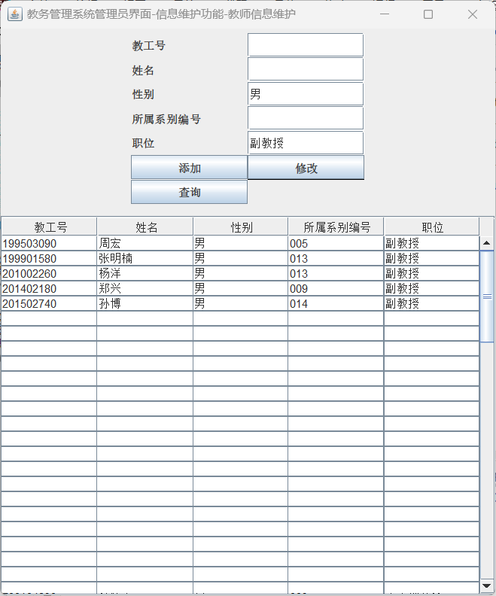

功能模块16：教务管理系统管理员界面-各部分信息维护-学生信息维护-查询：

功能界面：

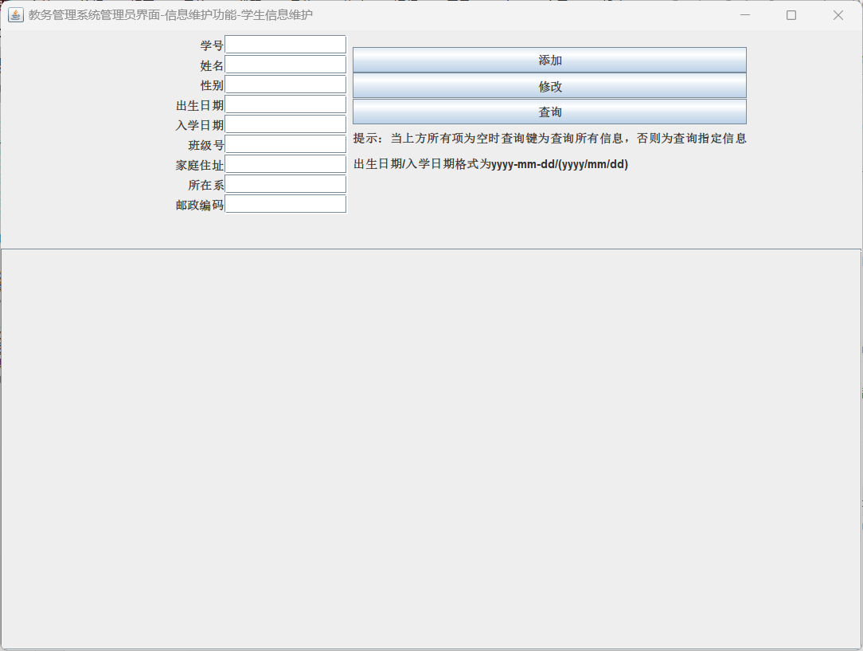

描述：点击教务管理系统管理员界面，点击各部分信息维护按钮，点击教师信息维护按钮，打开如图界面，点击查询按钮可进行多项查询，从Manager_Teacher_view中获取相关信息。

T-SQL语句与宿主语言嵌套使用代码段（粘贴）：

if (e.getSource() == btnSearch){  
 *//清空表格* for (int i = 0; i < getColumns(); i++) {  
 for (int j = 0; j < 10; j++) {  
 data[i][j] = "";  
 }  
 }  
 if (textNo.getText().equals("") == true  
 && textName.getText().equals("") == true  
 && textSex.getText().equals("") == true  
 && textBirth.getText().equals("") == true  
 && textEntrancedate.getText().equals("") == true  
 && textClassno.getText().equals("") == true  
 && textHomeaddress.getText().equals("") == true  
 && textSdept.getText().equals("") == true  
 && textPostcode.getText().equals("") == true){  
 String Driver = "com.microsoft.sqlserver.jdbc.SQLServerDriver";  
 String url = "jdbc:sqlserver://localhost:1433;DatabaseName=Academic_Affairs_Management_System_20211576;encrypt=false";  
 String userName = "s20211576"; *// 默认用户名* String userPwd = "s20211576"; *// 密码* String sql = "use Academic_Affairs_Management_System_20211576 select * from Manager_Student_view";  
 Connection dbConn = null;  
 try {  
 Class.*forName*(Driver);  
 dbConn = DriverManager.*getConnection*(url, userName, userPwd);  
 Statement stmt = dbConn.createStatement();  
 System.*out*.println(sql);  
 ResultSet rs = stmt.executeQuery(sql);  
 ResultSetMetaData rsmd = rs.getMetaData();  
 int numColumns = rsmd.getColumnCount();  
 int row = 0;  
 while (rs.next()) {  
 for (int col = 0; col < numColumns; col++) {  
 if(col == 3||col == 4){  
 data[row][col] = rs.getString(col + 1).substring(0,10);  
 }  
 else{  
 data[row][col] = rs.getString(col + 1);  
 }  
 }  
 row++;  
 }  
 rs.close();  
 stmt.close();  
 dbConn.close();  
 } catch (Exception em) {  
 em.printStackTrace();  
 } finally {  
 try {  
 } catch (Exception ec) {  
 ec.printStackTrace();  
 }  
 }  
 DefaultTableModel model = new DefaultTableModel(data, columnNames);  
 table.setModel(model);  
 }  
 else {  
 *//清空表格* for (int i = 0; i < getColumns(); i++) {  
 for (int j = 0; j < 10; j++) {  
 data[i][j] = "";  
 }  
 }  
 int flag = 0;  
 String Input = null;  
 String driver = "com.microsoft.sqlserver.jdbc.SQLServerDriver";  
 String url = "jdbc:sqlserver://localhost:1433;DatabaseName=Academic_Affairs_Management_System_20211576;encrypt=false";  
 String userName = "s20211576"; *// 默认用户名* String userPwd = "s20211576"; *// 密码* String[][] data = new String[getColumns()][10];  
 String inputNo = textNo.getText();  
 String inputName = textName.getText();  
 String inputSex = textSex.getText();  
 String inputBirth = textBirth.getText();  
 String inputEntrancedate = textEntrancedate.getText();  
 String inputClassno = textClassno.getText();  
 String inputHomeaddress = textHomeaddress.getText();  
 String inputSdept = textSdept.getText();  
 String inputPostcode = textPostcode.getText();  
 String sql = "use Academic_Affairs_Management_System_20211576 select * from Manager_Student_view where 1=1";  
 if (!inputNo.equals("")) {  
 sql += " and Sno='" + inputNo + "'";  
 }  
 if (!inputName.equals("")) {  
 sql += " and Sname='" + inputName + "'";  
 }  
 if (!inputSex.equals("")) {  
 sql += " and Sex='" + inputSex + "'";  
 }  
 if (!inputBirth.equals("")) {  
 sql += " and Birth BETWEEN '" + inputBirth + "' AND dateadd(second,-1,dateadd(day,1,'" + inputBirth + "'))";  
 }  
 if (!inputEntrancedate.equals("")) {  
 sql += " and Entrance_date BETWEEN '" + inputEntrancedate + "' AND dateadd(second,-1,dateadd(day,1,'" + inputEntrancedate + "'))";  
 }  
 if (!inputClassno.equals("")) {  
 sql += " and Class_no='" + inputClassno + "'";  
 }  
 if (!inputHomeaddress.equals("")) {  
 sql += " and Home_addr='" + inputHomeaddress + "'";  
 }  
 if (!inputSdept.equals("")) {  
 sql += " and Sde_no='" + inputSdept + "'";  
 }  
 if (!inputPostcode.equals("")) {  
 sql += " and Postcode='" + inputPostcode + "'";  
 }  
 System.*out*.println(sql); *// 打印完整的SQL查询语句* Connection dbConn = null;  
 try {  
 Class.*forName*(driver);  
 dbConn = DriverManager.*getConnection*(url, userName, userPwd);  
 } catch (ClassNotFoundException e1) {  
 e1.printStackTrace();  
 } catch (SQLException e2) {  
 e2.printStackTrace();  
 }  
 try{  
 Statement stmt = dbConn.createStatement();  
 ResultSet rs = stmt.executeQuery(sql);  
 int count = 0;  
 while (rs.next()) {  
 data[count][0] = rs.getString("Sno");  
 data[count][1] = rs.getString("Sname");  
 data[count][2] = rs.getString("Sex");  
 data[count][3] = rs.getString("Birth");  
 data[count][4] = rs.getString("Entrance_date");  
 data[count][5] = rs.getString("Class_no");  
 data[count][6] = rs.getString("Home_addr");  
 data[count][7] = rs.getString("Sde_no");  
 data[count][8] = rs.getString("Postcode");  
 data[count][9] = rs.getString("AttendanceStatus");  
 count++;  
 }  
 rs.close();  
 stmt.close();  
 dbConn.close();  
 } catch (SQLException e2) {  
 e2.printStackTrace();  
 } finally {  
 try {  
 if (dbConn != null) {  
 dbConn.close();  
 }  
 } catch (SQLException e1) {  
 e1.printStackTrace();  
 }  
 }  
 DefaultTableModel model = new DefaultTableModel(data, columnNames);  
 table.setModel(model);  
 }  
}

运行结果：

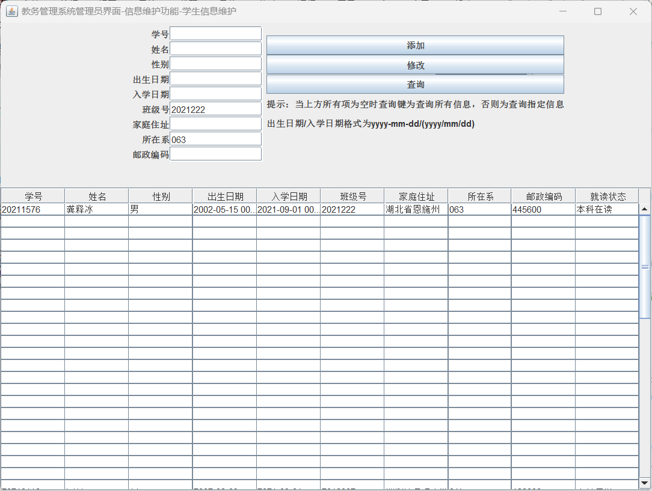

（7）原子性事务显示定义：无

六、系统详细设计及实现

（1）系统功能模块说明

（一）教务管理系统登录功能模块

1、登录

2、修改密码：

（二）教务管理系统管理员功能模块

1、维护学院、专业、班级、教师、学生信息；

2、维护教师授课信息；

3、维护学生可选课程的信息；

4、查询教师、学生的各项信息；

5、添加教务管理系统管理员用户；

（三）教务管理系统学生功能模块

1、查看个人信息

2、查看已选课程

3、选课

4、查看课程成绩

（四）教务管理系统教师功能模块

1、查询所授课程

2、给有学生选修的课程进行赋分

（2）每个模块的关键语句及关键技术说明

（一）教务管理系统登录功能模块

1、登录：关键技术：数据验证、数据库查询。

（1）声明各类组件：

JPanel panel = new JPanel();  
JPanel panelNorth = new JPanel();  
JFrame frame1 = new JFrame();  
public static String *loginID* = "";  
public static String *loginName* = "";  
JLabel labelName = new JLabel("教务系统登陆界面");  
JLabel labelNo = new JLabel("学号/教工号");  
JTextField txtLabelNo = new JTextField(12);  
JLabel labelPassword = new JLabel("密码");  
JPasswordField txtLabelPassword = new JPasswordField(12);  
JButton buttonRegister = new JButton("登陆");  
JButton buttonForget = new JButton("修改密码");

（2）登陆界面的创建：

public windowsRegister() {  
 *//创建界面* frame1.setTitle("教务管理系统登陆界面");  
 frame1.setVisible(true);  
 frame1.setSize(450, 250);  
 frame1.setLocation(300, 249);  
 frame1.setDefaultCloseOperation(JFrame.*EXIT_ON_CLOSE*);  
 frame1.add(panelNorth,BorderLayout.*NORTH*);  
 frame1.add(panel, BorderLayout.*CENTER*);  
 panelNorth.add(labelName);  
 panel.setLayout(new GridLayout(3, 2));  
 panel.add(labelNo);panel.add(txtLabelNo);  
 panel.add(labelPassword);panel.add(txtLabelPassword);  
 panel.add(buttonRegister);  
 panel.add(buttonForget);  
 buttonRegister.addActionListener(this);  
 buttonForget.addActionListener(this);  
}

（3）登陆按钮的事件：

@Override  
public void actionPerformed(ActionEvent e) {  
 if (e.getSource() == buttonRegister) {  
 if (txtLabelNo.getText().trim().equals("")) {  
 JOptionPane.*showMessageDialog*(null, "请输入学号/教工号", "提示", JOptionPane.*ERROR_MESSAGE*);  
 } else if (txtLabelPassword.getText().trim().equals("")) {  
 JOptionPane.*showMessageDialog*(null, "密码不能为空", "提示", JOptionPane.*ERROR_MESSAGE*);  
 } else {  
 String userInput = null;  
 if(txtLabelNo.getText().length()<7){  
 userInput = "'" + txtLabelNo.getText() + "'";  
 }  
 else{  
 userInput = txtLabelNo.getText();  
 }  
 String passwordInput = txtLabelPassword.getText().toString();  
 String Driver = "com.microsoft.sqlserver.jdbc.SQLServerDriver";  
 String url = "jdbc:sqlserver://localhost:1433;database=Academic_Affairs_Management_System_20211576;encrypt=false";  
 String sql="use Academic_Affairs_Management_System_20211576 select Position from Password_20211576 where id = " + userInput;  
 String sql1="use Academic_Affairs_Management_System_20211576 select password from Password_20211576 where id = " + userInput;  
 String userName = "s20211576"; *// 默认用户名* String userPwd = "s20211576"; *// 密码* Connection dbConn = null;  
 try {  
 Class.*forName*(Driver);  
 dbConn = DriverManager.*getConnection*(url, userName, userPwd);  
 } catch (Exception em) {  
 em.printStackTrace();  
 }  
 Statement stml;  
 ResultSet rs,rs1;  
 try {  
 stml = dbConn.createStatement();  
 rs = stml.executeQuery(sql);*//SQL查询语句* while (rs.next()) {  
 String passwordCorrect;  
 String position = rs.getString("Position");  
 rs1 = stml.executeQuery(sql1);  
 while (rs1.next()) {  
 passwordCorrect = rs1.getString("password");  
 if(passwordInput.equals(passwordCorrect.toString().trim())) {  
 JOptionPane.*showMessageDialog*(null, "登陆成功");  
 *//关闭界面，打开新界面* if (position.toString().trim().equals("学生")){  
 *loginID* = userInput;  
 *loginName* = getStudentName(*loginID*);  
 System.*out*.println(*loginName*);  
 System.*out*.println(*loginID*);  
 WindowStudent student = new WindowStudent();  
 }else if (position.trim().equals("教务管理人员")){  
 WindowManager manager = new WindowManager();  
 }else{  
 *loginID* = userInput;  
 *loginName* = getTeacherName(*loginID*);  
 WindowTeacher teacher = new WindowTeacher();  
 }  
 frame1.dispose();  
 }  
 else{  
 JOptionPane.*showMessageDialog*(null, "密码错误", "提示", JOptionPane.*ERROR_MESSAGE*);  
 }  
 }  
 }  
 dbConn.close();  
  
 } catch (SQLException ex) {  
 System.*out*.println(ex);  
 }  
 }  
 }  
 else if (e.getSource() == buttonForget) {  
 WindowForget forget = new WindowForget();  
 }  
}

**2、修改密码：关键技术：数据验证、数据库更新。**

（1）声明各类组件：

JPanel panel = new JPanel();  
JPanel panel1 = new JPanel();  
JFrame frame1 = new JFrame();  
JLabel labelWarning = new JLabel("注意：忘记密码请联系辅导员寻找教务管理人员修改！");  
JLabel labelNo = new JLabel("学号/工号");  
JTextField txtNo = new JTextField(10);  
JLabel labelOldPassword = new JLabel("原密码");  
JTextField txtOldPassword = new JTextField(10);  
JLabel labelNewPassword = new JLabel("新密码");  
JTextField txtNewPassword = new JTextField(10);  
JLabel labelNewPasswordTwice = new JLabel("新密码（确认一次）");  
JTextField txtNewPasswordTwice = new JTextField(10);  
JButton btnUpdate = new JButton("修改密码");

（2）登陆界面的创建：

public WindowForget() {  
 frame1.setTitle("教务管理系统学生界面--修改密码");  
 frame1.setVisible(true);  
 frame1.setSize(400, 400);  
 frame1.setLocation(300, 249);  
 frame1.setDefaultCloseOperation(JFrame.*DISPOSE_ON_CLOSE*);  
 frame1.add(panel, BorderLayout.*CENTER*);  
 panel.setLayout(new GridLayout(4,2));  
 panel1.setLayout(new GridLayout(2,1));  
 frame1.add(panel1, BorderLayout.*SOUTH*);  
 panel.add(labelNo);panel.add(txtNo);  
 panel.add(labelOldPassword);panel.add(txtOldPassword);  
 panel.add(labelNewPassword);panel.add(txtNewPassword);  
 panel.add(labelNewPasswordTwice);panel.add(txtNewPasswordTwice);  
 panel1.add(btnUpdate);panel1.add(labelWarning);  
 btnUpdate.addActionListener(this);  
}

（3）登陆按钮的事件：

@Override  
public void actionPerformed(ActionEvent e) {  
 if (e.getSource() == btnUpdate) {  
 if(txtNo.getText().trim().equals("") || txtOldPassword.getText().trim().equals("") || txtNewPassword.getText().trim().equals("") || txtNewPasswordTwice.getText().trim().equals("")){  
 JOptionPane.*showMessageDialog*(null, "学号/学工号，原密码，新密码等四项均需输入!", "提示", JOptionPane.*ERROR_MESSAGE*);  
 }  
 else{  
 if(txtNewPassword.getText().equals(txtNewPasswordTwice.getText()) == false) {  
 JOptionPane.*showMessageDialog*(null, "两次输入的新密码不一致！");  
 txtNewPassword.setText("");  
 txtNewPasswordTwice.setText("");  
 return;  
 }  
 frame1.dispose();  
 String Driver = "com.microsoft.sqlserver.jdbc.SQLServerDriver";  
 String url = "jdbc:sqlserver://localhost:1433;DatabaseName=Academic_Affairs_Management_System_20211576;encrypt=false";  
 String userName = "s20211576"; *// 默认用户名* String userPwd = "s20211576"; *// 密码* String sql = "use Academic_Affairs_Management_System_20211576 select Position from Password_20211576 where id='" + txtNo.getText() + "'";  
 String sql1 = "use Academic_Affairs_Management_System_20211576 select Password from Password_20211576 where id='" + txtNo.getText() + "'";  
 Connection dbConn = null;  
 try {  
 Class.*forName*(Driver);  
 dbConn = DriverManager.*getConnection*(url, userName, userPwd);  
 System.*out*.println("Connection Successful!"); *// 如果连接成功 控制台输出* Statement stmt = dbConn.createStatement();  
 ResultSet rs = stmt.executeQuery(sql);  
 while(rs.next()){  
 String position = rs.getString("Position");  
 if (position.toString().trim().equals("教务管理人员")) {  
 JOptionPane.*showMessageDialog*(null, "教务管理人员无法修改密码！请至数据库内修改！");  
 }  
 else {  
 ResultSet rs1 = stmt.executeQuery(sql1);  
 while(rs1.next()){  
 String passwordcorrect = rs1.getString("password");  
 if (passwordcorrect.toString().trim().equals(txtOldPassword.getText())) {  
 String sql2 = "use Academic_Affairs_Management_System_20211576 update Password_20211576 set Password='" + txtNewPassword.getText() + "' where id='" + txtNo.getText() + "'";  
 System.*out*.println(sql2);  
 stmt.executeUpdate(sql2);  
 JOptionPane.*showMessageDialog*(null, "修改成功！");  
 } else {  
 JOptionPane.*showMessageDialog*(null, "原密码错误！");  
 }  
 }  
 }  
  
 }  
  
 rs.close();  
 stmt.close();  
 dbConn.close();  
 } catch (Exception em) {  
 em.printStackTrace();  
 } finally {  
 try {  
 } catch (Exception ec) {  
 ec.printStackTrace();  
 }  
 }  
 }  
 }  
}

（二）教务管理系统管理员功能模块

1、维护学院、专业、班级、教师、学生信息：关键技术：数据库操作、表单验证。

学院：

1. 声明各类组件：
2. JPanel panel = new JPanel();  
   JFrame frame1 = new JFrame();  
   JPanel panelNorth = new JPanel();  
   JPanel panelCenter = new JPanel();  
   JPanel panelSouth = new JPanel();  
   JLabel labelAcaNo = new JLabel("学院编号");  
   JTextField textAcaNo = new JTextField(12);  
   JLabel labelAcaName = new JLabel("学院名");  
   JTextField textAcaName = new JTextField(12);  
   JLabel labelAcaIntroduction = new JLabel("学院简介");  
   JTextField textAcaIntroduction = new JTextField(12);  
   JButton btnAdd = new JButton("添加");  
   JButton btnSearch = new JButton("查询");  
   JTable table = new JTable();  
   JScrollPane scrollPane = new JScrollPane(table);  
   String [] columnNames = {"学院编号","学院名","学院简介"};  
   Object[][] data = new Object[getColumns()][10];

（2）登陆界面的创建：

public WindowManagerInformationUpdateAcademy() {  
 frame1.setTitle("教务管理系统管理员界面-信息维护功能-学院信息维护");  
 System.*out*.println(getColumns());  
 frame1.setVisible(true);  
 frame1.setSize(720,660);  
 frame1.setLocation(10,10);  
 frame1.setDefaultCloseOperation(JFrame.*DISPOSE_ON_CLOSE*);  
 table.setSize(350,400);  
 scrollPane.setBounds(0,0,352,250);  
 frame1.add(panel);  
 panel.add(panelNorth, BorderLayout.*NORTH*);  
 panel.add(panelCenter, BorderLayout.*CENTER*);  
 panel.add(panelSouth, BorderLayout.*SOUTH*);  
 panelNorth.setLayout(new GridLayout(4,2));  
 panelNorth.add(labelAcaNo);panelNorth.add(textAcaNo);  
 panelNorth.add(labelAcaName);panelNorth.add(textAcaName);  
 panelNorth.add(labelAcaIntroduction);panelNorth.add(textAcaIntroduction);  
 panelNorth.add(btnAdd);panelNorth.add(btnSearch);  
 panelCenter.add(scrollPane);  
 scrollPane.setViewportView(table);  
 btnAdd.addActionListener(this);  
 btnSearch.addActionListener(this);  
}

（3）按钮事件：

@Override  
public void actionPerformed(ActionEvent e) {  
 if (e.getSource() == btnAdd){  
 if(textAcaNo.getText().trim().equals("") == false  
 && textAcaName.getText().trim().equals("") == false  
 && textAcaIntroduction.getText().trim().equals("") == false){  
 String Driver = "com.microsoft.sqlserver.jdbc.SQLServerDriver";  
 String url = "jdbc:sqlserver://localhost:1433;DatabaseName=Academic_Affairs_Management_System_20211576;encrypt=false";  
 String userName = "s20211576"; *// 默认用户名* String userPwd = "s20211576"; *// 密码* String sql0 = "use Academic_Affairs_Management_System_20211576 select * from Manager_Academy_view where Aca_no ='"+textAcaNo.getText()+"'";  
 String sql = "insert into Academic_Affairs_Management_System_20211576.dbo.Academy_20211576(Aca_no,Aca_name,Aca_introduction) " +  
 "values('"+textAcaNo.getText()+"','"+textAcaName.getText()+"','"+textAcaIntroduction.getText()+"')";  
 Connection dbConn = null;  
 try {  
 Class.*forName*(Driver);  
 dbConn = DriverManager.*getConnection*(url, userName, userPwd);  
 System.*out*.println(sql0); *// 如果连接成功 控制台输出* System.*out*.println(sql);  
 Statement stmt = dbConn.createStatement();  
 ResultSet rs0 = stmt.executeQuery(sql0);  
 String Aca_no = "";  
 while(rs0.next()){  
 Aca_no += rs0.getString("Aca_no");  
 }  
 if(Aca_no.equals("") == false){  
 JOptionPane.*showMessageDialog*(null, "名字为"+textAcaName.getText()+"的学院信息已存在！", "提示", JOptionPane.*INFORMATION_MESSAGE*);  
 }  
 else{  
 JOptionPane.*showMessageDialog*(null, "名字为"+textAcaName.getText()+"的学院信息添加成功！", "提示", JOptionPane.*INFORMATION_MESSAGE*);  
 ResultSet rs = stmt.executeQuery(sql);  
 rs.close();  
 }  
 rs0.close();  
 stmt.close();  
 dbConn.close();  
 } catch (Exception em) {  
 em.printStackTrace();  
 } finally {  
 try {  
 } catch (Exception ec) {  
 ec.printStackTrace();  
 }  
 }  
 }  
 else{  
 JOptionPane.*showMessageDialog*(null,"请填写完整信息!");  
 }  
 }  
 if (e.getSource() == btnSearch){  
 for (int i = 0; i < getColumns(); i++) {  
 for (int j = 0; j < 10; j++) {  
 data[i][j] = "";  
 }  
 }  
 if (textAcaNo.getText().toString().equals("") == true  
 && textAcaName.getText().toString().equals("") == true  
 && textAcaIntroduction.getText().toString().equals("") == true){  
 String Driver = "com.microsoft.sqlserver.jdbc.SQLServerDriver";  
 String url = "jdbc:sqlserver://localhost:1433;DatabaseName=Academic_Affairs_Management_System_20211576;encrypt=false";  
 String userName = "s20211576"; *// 默认用户名* String userPwd = "s20211576"; *// 密码* String sql = "use Academic_Affairs_Management_System_20211576 select * from Manager_Academy_view";  
 Connection dbConn = null;  
 try {  
 Class.*forName*(Driver);  
 dbConn = DriverManager.*getConnection*(url, userName, userPwd);  
 Statement stmt = dbConn.createStatement();  
 ResultSet rs = stmt.executeQuery(sql);  
 ResultSetMetaData rsmd = rs.getMetaData();  
 int numColumns = rsmd.getColumnCount();  
 int row = 0;  
 while (rs.next()) {  
 for (int col = 0; col < numColumns; col++) {  
 data[row][col] = rs.getString(col + 1);  
 }  
 row++;  
 }  
 rs.close();  
 stmt.close();  
 dbConn.close();  
 } catch (Exception em) {  
 em.printStackTrace();  
 } finally {  
 try {  
 } catch (Exception ec) {  
 ec.printStackTrace();  
 }  
 }  
 }  
 else {  
 for (int i = 0; i < getColumns(); i++) {  
 for (int j = 0; j < 8; j++) {  
 data[i][j] = "";  
 }  
 }  
 String input = null;  
 String sql = null;  
 if (!textAcaNo.getText().isEmpty()) {  
 input = textAcaNo.getText();  
 sql = "SELECT * FROM Manager_Academy_view WHERE Aca_no = ?";  
 } else if (!textAcaName.getText().isEmpty()) {  
 input = textAcaName.getText();  
 sql = "SELECT * FROM Manager_Academy_view WHERE Aca_name = ?";  
 } else if (!textAcaIntroduction.getText().isEmpty()) {  
 input = textAcaIntroduction.getText();  
 sql = "SELECT * FROM Manager_Academy_view WHERE Aca_introduction = ?";  
 }  
 String driver = "com.microsoft.sqlserver.jdbc.SQLServerDriver";  
 String url = "jdbc:sqlserver://localhost:1433;DatabaseName=Academic_Affairs_Management_System_20211576;encrypt=false";  
 String username = "s20211576";  
 String password = "s20211576";  
 try (Connection conn = DriverManager.*getConnection*(url, username, password);  
 PreparedStatement pstmt = conn.prepareStatement(sql)) {  
 pstmt.setString(1, input);  
 ResultSet rs = pstmt.executeQuery();  
 int count = 0;  
 while (rs.next()) {  
 data[count][0] = rs.getString("Aca_no");  
 data[count][1] = rs.getString("Aca_name");  
 data[count][2] = rs.getString("Aca_introduction");  
 count++;  
 }  
 rs.close();  
 } catch (Exception e1) {  
 e1.printStackTrace();  
 }  
 }  
 DefaultTableModel model = new DefaultTableModel(data, columnNames);  
 table.setModel(model);  
 }  
}

专业：

（1）声明各类控件：  
 JPanel panel = new JPanel();  
JFrame frame1 = new JFrame();  
JPanel panelNorth = new JPanel();  
JPanel panelCenter = new JPanel();  
JPanel panelSouth = new JPanel();  
JLabel labelSdeNo = new JLabel("专业号");  
JTextField textSdeNo = new JTextField(12);  
JLabel labelSdeName = new JLabel("专业名");  
JTextField textSdeName = new JTextField(12);  
JLabel labelSdeIntroduction = new JLabel("专业简介");  
JTextField textSdeIntroduction = new JTextField(12);  
JLabel labelAcaNo = new JLabel("学院编号");  
JTextField textAcaNo = new JTextField(12);  
JLabel labelAcaName = new JLabel("学院名");  
JTextField textAcaName = new JTextField(12);  
JButton btnAdd = new JButton("添加");  
JButton btnSearch = new JButton("查询");  
JTable table = new JTable();  
JScrollPane scrollPane = new JScrollPane(table);  
String[] columnNames = {"专业号", "专业名", "专业简介", "学院编号", "学院名"};  
Object[][] data = new Object[getColumns()][10];

（2）创建面板：  
 public WindowManagerInformationUpdateMajor() {  
 frame1.setTitle("教务管理系统管理员界面-信息维护功能-专业信息维护");  
 System.*out*.println(getColumns());  
 frame1.setVisible(true);  
 frame1.setSize(760, 500);  
 frame1.setLocation(10, 10);  
 frame1.setDefaultCloseOperation(JFrame.*DISPOSE_ON_CLOSE*);  
 table.setSize(350, 400);  
 scrollPane.setBounds(0, 0, 352, 250);  
 frame1.add(panel);  
 panel.add(panelNorth, BorderLayout.*NORTH*);  
 panel.add(panelCenter, BorderLayout.*CENTER*);  
 panel.add(panelSouth, BorderLayout.*SOUTH*);  
 panelNorth.setLayout(new GridLayout(6, 2));  
 panelNorth.add(labelSdeNo);  
 panelNorth.add(textSdeNo);  
 panelNorth.add(labelSdeName);  
 panelNorth.add(textSdeName);  
 panelNorth.add(labelSdeIntroduction);  
 panelNorth.add(textSdeIntroduction);  
 panelNorth.add(labelAcaNo);  
 panelNorth.add(textAcaNo);  
 panelNorth.add(labelAcaName);  
 panelNorth.add(textAcaName);  
 panelNorth.add(btnAdd);  
 panelNorth.add(btnSearch);  
 panelCenter.add(scrollPane);  
 scrollPane.setViewportView(table);  
 btnAdd.addActionListener(this);  
 btnSearch.addActionListener(this);  
}

（3）按钮事件：

@Override  
public void actionPerformed(ActionEvent e) {  
 if (e.getSource() == btnAdd) {  
 if (textSdeNo.getText().trim().equals("") == false  
 && textSdeName.getText().trim().equals("") == false  
 && textSdeIntroduction.getText().trim().equals("") == false  
 && textAcaNo.getText().trim().equals("") == false  
 && textAcaName.getText().trim().equals("") == false) {  
 String Driver = "com.microsoft.sqlserver.jdbc.SQLServerDriver";  
 String url = "jdbc:sqlserver://localhost:1433;DatabaseName=Academic_Affairs_Management_System_20211576;encrypt=false";  
 String userName = "s20211576"; *// 默认用户名* String userPwd = "s20211576"; *// 密码* String sql0 = "use Academic_Affairs_Management_System_20211576 select * from Manager_Sdept_view where Sde_no ='" + textSdeNo.getText() + "'";  
 String sql = "insert into Academic_Affairs_Management_System_20211576.dbo.Sdept_20211576(Sde_no,Sde_name,Sde_introduction,Aca_no,Aca_name) values('" + textSdeNo.getText() + "','" + textSdeName.getText() + "','" + textSdeIntroduction.getText() + "','" + textAcaNo.getText() + "','" + textAcaName.getText() + "')";  
 Connection dbConn = null;  
 try {  
 Class.*forName*(Driver);  
 dbConn = DriverManager.*getConnection*(url, userName, userPwd);  
 System.*out*.println(sql0); *// 如果连接成功 控制台输出* System.*out*.println(sql);  
 Statement stmt = dbConn.createStatement();  
 ResultSet rs0 = stmt.executeQuery(sql0);  
 String Class_no = "";  
 while (rs0.next()) {  
 Class_no += rs0.getString("Sde_no");  
 }  
 if (Class_no.equals("") == false) {  
 JOptionPane.*showMessageDialog*(null, "专业号为" + textSdeNo.getText() + "的专业信息已存在！", "提示", JOptionPane.*INFORMATION_MESSAGE*);  
 } else {  
 JOptionPane.*showMessageDialog*(null, "专业号为" + textSdeNo.getText() + "的专业信息添加成功！", "提示", JOptionPane.*INFORMATION_MESSAGE*);  
 ResultSet rs = stmt.executeQuery(sql);  
 rs.close();  
 }  
 rs0.close();  
 stmt.close();  
 dbConn.close();  
 } catch (Exception em) {  
 em.printStackTrace();  
 } finally {  
 try {  
 } catch (Exception ec) {  
 ec.printStackTrace();  
 }  
 }  
 } else {  
 JOptionPane.*showMessageDialog*(null, "请填写完整信息!");  
 }  
 }  
 if (e.getSource() == btnSearch) {  
 *//清空表格* for (int i = 0; i < getColumns(); i++) {  
 for (int j = 0; j < 10; j++) {  
 data[i][j] = "";  
 }  
 }  
 if (textSdeNo.getText().toString().equals("") == true  
 && textSdeName.getText().toString().equals("") == true  
 && textSdeIntroduction.getText().toString().equals("") == true  
 && textAcaNo.getText().toString().equals("") == true  
 && textAcaName.getText().toString().equals("") == true) {  
 String Driver = "com.microsoft.sqlserver.jdbc.SQLServerDriver";  
 String url = "jdbc:sqlserver://localhost:1433;DatabaseName=Academic_Affairs_Management_System_20211576;encrypt=false";  
 String userName = "s20211576"; *// 默认用户名* String userPwd = "s20211576"; *// 密码* String sql = "use Academic_Affairs_Management_System_20211576 select * from Manager_Sdept_view";  
 Connection dbConn = null;  
 try {  
 Class.*forName*(Driver);  
 dbConn = DriverManager.*getConnection*(url, userName, userPwd);  
 Statement stmt = dbConn.createStatement();  
 System.*out*.println(sql);  
 ResultSet rs = stmt.executeQuery(sql);  
 *// Get the number of columns in the ResultSet* ResultSetMetaData rsmd = rs.getMetaData();  
 int numColumns = rsmd.getColumnCount();  
 int row = 0;  
 while (rs.next()) {  
 for (int col = 0; col < numColumns; col++) {  
 data[row][col] = rs.getString(col + 1);  
 }  
 row++;  
 }  
 rs.close();  
 stmt.close();  
 dbConn.close();  
 } catch (Exception em) {  
 em.printStackTrace();  
 } finally {  
 try {  
 } catch (Exception ec) {  
 ec.printStackTrace();  
 }  
 }  
 } else {  
 for (int i = 0; i < getColumns(); i++) {  
 for (int j = 0; j < 8; j++) {  
 data[i][j] = "";  
 }  
 }  
 String Input = null;  
 String sql = "use Academic_Affairs_Management_System_20211576 select * from Manager_Sdept_view where 1=1";  
 if (textSdeNo.getText().toString().equals("") == false) {  
 Input = textSdeNo.getText().toString();  
 sql += " and Sde_no = " + "'" + Input + "'";  
 } else if (textSdeName.getText().toString().equals("") == false) {  
 Input = textSdeName.getText().toString();  
 sql += " and Sde_name = " + "'" + Input + "'";  
 } else if (textSdeIntroduction.getText().toString().equals("") == false) {  
 Input = textSdeIntroduction.getText().toString();  
 sql += " and Sde_introduction = " + "'" + Input + "'";  
 } else if (textAcaNo.getText().toString().equals("") == false) {  
 Input = textAcaNo.getText().toString();  
 sql += " and Aca_no = " + "'" + Input + "'";  
 } else if (textAcaName.getText().toString().equals("") == false) {  
 Input = textAcaName.getText().toString();  
 sql += " and Aca_name = " + "'" + Input + "'";  
 }  
 String Driver = "com.microsoft.sqlserver.jdbc.SQLServerDriver";  
 String url = "jdbc:sqlserver://localhost:1433;DatabaseName=Academic_Affairs_Management_System_20211576;encrypt=false";  
 String userName = "s20211576"; *// 默认用户名* String userPwd = "s20211576"; *// 密码* Connection dbConn = null;  
 try {  
 Class.*forName*(Driver);  
 dbConn = DriverManager.*getConnection*(url, userName, userPwd);  
 System.*out*.println("Connection Successful!"); *// 如果连接成功 控制台输出* Statement stmt = dbConn.createStatement();  
 System.*out*.println(sql);  
 ResultSet rs = stmt.executeQuery(sql);  
 int count = 0;  
 while (rs.next()) {  
 data[count][0] = rs.getString("Sde_no");  
 data[count][1] = rs.getString("Sde_name");  
 data[count][2] = rs.getString("Sde_introduction");  
 data[count][3] = rs.getString("Aca_no");  
 data[count][4] = rs.getString("Aca_name");  
 count++;  
 }  
 rs.close();  
 stmt.close();  
 dbConn.close();  
 } catch (Exception em) {  
 em.printStackTrace();  
 } finally {  
 try {  
 } catch (Exception ec) {  
 ec.printStackTrace();  
 }  
 }  
 }  
 DefaultTableModel model = new DefaultTableModel(data, columnNames);  
 table.setModel(model);  
 }  
}

班级：

（1）声明各类组件：  
 JPanel panel = new JPanel();  
JFrame frame1 = new JFrame();  
JPanel panelNorth = new JPanel();  
JPanel panelCenter = new JPanel();  
JPanel panelSouth = new JPanel();  
JLabel labelClassNo = new JLabel("班级号");  
JTextField textClassNo = new JTextField(12);  
JLabel labelSdeNo = new JLabel("所属系号");  
JTextField textSdeNo = new JTextField(12);  
JLabel labelNum = new JLabel("学生人数");  
JTextField textNum = new JTextField(12);  
JButton btnAdd = new JButton("添加");  
JButton btnUpdate = new JButton("修改");  
JButton btnSearch = new JButton("查询");  
JTable table = new JTable();  
JScrollPane scrollPane = new JScrollPane(table);  
String[] columnNames = {"班级号", "所属系号", "入学时间", "学生人数"};  
Object[][] data = new Object[getColumns()][10];

（2）创建界面：  
 public WindowManagerInformationUpdateClass() {  
 frame1.setTitle("教务管理系统管理员界面-信息维护功能-班级信息维护");  
 System.*out*.println(getColumns());  
 frame1.setVisible(true);  
 frame1.setSize(660, 500);  
 frame1.setLocation(10, 10);  
 frame1.setDefaultCloseOperation(JFrame.*DISPOSE_ON_CLOSE*);  
 table.setSize(350, 400);  
 scrollPane.setBounds(0, 0, 352, 250);  
 frame1.add(panel);  
 panel.add(panelNorth, BorderLayout.*NORTH*);  
 panel.add(panelCenter, BorderLayout.*CENTER*);  
 panel.add(panelSouth, BorderLayout.*SOUTH*);  
 panelNorth.setLayout(new GridLayout(11, 1));  
 panelNorth.add(labelClassNo);  
 panelNorth.add(textClassNo);  
 panelNorth.add(labelSdeNo);  
 panelNorth.add(textSdeNo);  
 panelNorth.add(labelNum);  
 panelNorth.add(textNum);  
 panelNorth.add(btnAdd);  
 panelNorth.add(btnUpdate);  
 panelNorth.add(btnSearch);  
 panelCenter.add(scrollPane);  
 scrollPane.setViewportView(table);  
 btnAdd.addActionListener(this);  
 btnUpdate.addActionListener(this);  
 btnSearch.addActionListener(this);  
}

（3）按钮事件：

@Override  
public void actionPerformed(ActionEvent e) {  
 if (e.getSource() == btnAdd) {  
 if (textClassNo.getText().trim().equals("") == false  
 && textSdeNo.getText().trim().equals("") == false  
 && textNum.getText().trim().equals("") == false) {  
 String Driver = "com.microsoft.sqlserver.jdbc.SQLServerDriver";  
 String url = "jdbc:sqlserver://localhost:1433;DatabaseName=Academic_Affairs_Management_System_20211576;encrypt=false";  
 String userName = "s20211576"; *// 默认用户名* String userPwd = "s20211576"; *// 密码* String sql0 = "use Academic_Affairs_Management_System_20211576 select * from Manager_Class_view where Class_no ='" + textClassNo.getText() + "'";  
 String sql = "insert into Academic_Affairs_Management_System_20211576.dbo.Class_20211576(Class_no,Sde_no,Num) values('" + textClassNo.getText() + "','" + textSdeNo.getText() + "'," + textNum.getText() + ")";  
 Connection dbConn = null;  
 try {  
 Class.*forName*(Driver);  
 dbConn = DriverManager.*getConnection*(url, userName, userPwd);  
 System.*out*.println(sql0); *// 如果连接成功 控制台输出* System.*out*.println(sql);  
 Statement stmt = dbConn.createStatement();  
 ResultSet rs0 = stmt.executeQuery(sql0);  
 String Class_no = "";  
 while (rs0.next()) {  
 Class_no += rs0.getString("Class_no");  
 }  
 if (Class_no.equals("") == false) {  
 JOptionPane.*showMessageDialog*(null, "班级号为" + textClassNo.getText() + "的班级信息已存在！", "提示", JOptionPane.*INFORMATION_MESSAGE*);  
 } else {  
 JOptionPane.*showMessageDialog*(null, "班级号为" + textClassNo.getText() + "的班级信息添加成功！", "提示", JOptionPane.*INFORMATION_MESSAGE*);  
 ResultSet rs = stmt.executeQuery(sql);  
 rs.close();  
 }  
 rs0.close();  
 stmt.close();  
 dbConn.close();  
 } catch (Exception em) {  
 em.printStackTrace();  
 } finally {  
 try {  
 } catch (Exception ec) {  
 ec.printStackTrace();  
 }  
 }  
 } else {  
 JOptionPane.*showMessageDialog*(null, "请填写完整信息!");  
 }  
 }  
 if (e.getSource() == btnUpdate) {  
 if (textClassNo.getText().trim().equals("") == false) {  
 String Driver = "com.microsoft.sqlserver.jdbc.SQLServerDriver";  
 String url = "jdbc:sqlserver://localhost:1433;DatabaseName=Academic_Affairs_Management_System_20211576;encrypt=false";  
 String userName = "s20211576"; *// 默认用户名* String userPwd = "s20211576"; *// 密码* String sql = null;  
 if (textSdeNo.getText().trim().equals("") == false)  
 sql = "update Academic_Affairs_Management_System_20211576.dbo.Class_20211576 set Sde_no = '" + textSdeNo.getText() + "' where Class_no = '" + textClassNo.getText() + "'";  
 else if (textNum.getText().trim().equals("") == false)  
 sql = "update Academic_Affairs_Management_System_20211576.dbo.Class_20211576 set Num = " + textNum.getText() + " where Class_no = '" + textClassNo.getText() + "'";  
 Connection dbConn = null;  
 try {  
 Class.*forName*(Driver);  
 dbConn = DriverManager.*getConnection*(url, userName, userPwd);  
 System.*out*.println(sql); *// 如果连接成功 控制台输出* JOptionPane.*showMessageDialog*(null, "班级号为" + textClassNo.getText() + "的班级信息修改成功！", "提示", JOptionPane.*INFORMATION_MESSAGE*);  
 Statement stmt = dbConn.createStatement();  
 ResultSet rs = stmt.executeQuery(sql);  
 rs.close();  
 stmt.close();  
 dbConn.close();  
 } catch (Exception em) {  
 em.printStackTrace();  
 } finally {  
 try {  
 } catch (Exception ec) {  
 ec.printStackTrace();  
 }  
 }  
 }  
 else{  
 JOptionPane.*showMessageDialog*(null, "班级号和（所属系号/入学时间/学生人数中至少有一项）不为空!", "提示", JOptionPane.*INFORMATION_MESSAGE*);  
 }  
 }  
 if (e.getSource() == btnSearch) {  
 *//清空表格* for (int i = 0; i < getColumns(); i++) {  
 for (int j = 0; j < 10; j++) {  
 data[i][j] = "";  
 }  
 }  
 if (textClassNo.getText().equals("") == true  
 && textSdeNo.getText().equals("") == true  
 && textNum.getText().equals("") == true) {  
 String Driver = "com.microsoft.sqlserver.jdbc.SQLServerDriver";  
 String url = "jdbc:sqlserver://localhost:1433;DatabaseName=Academic_Affairs_Management_System_20211576;encrypt=false";  
 String userName = "s20211576"; *// 默认用户名* String userPwd = "s20211576"; *// 密码* String sql = "use Academic_Affairs_Management_System_20211576 select * from Manager_Class_view";  
 Connection dbConn = null;  
 try {  
 Class.*forName*(Driver);  
 dbConn = DriverManager.*getConnection*(url, userName, userPwd);  
 Statement stmt = dbConn.createStatement();  
 System.*out*.println(sql);  
 ResultSet rs = stmt.executeQuery(sql);  
 ResultSetMetaData rsmd = rs.getMetaData();  
 int numColumns = rsmd.getColumnCount();  
 int row = 0;  
 while (rs.next()) {  
 for (int col = 0; col < numColumns; col++) {  
 if (col == 2) {  
 data[row][col] = rs.getString(col + 1).substring(0, 10);  
 } else {  
 data[row][col] = rs.getString(col + 1);  
 }  
 }  
 row++;  
 }  
 rs.close();  
 stmt.close();  
 dbConn.close();  
 } catch (Exception em) {  
 em.printStackTrace();  
 } finally {  
 try {  
 } catch (Exception ec) {  
 ec.printStackTrace();  
 }  
 }  
 } else {  
 *//清空表格* for (int i = 0; i < getColumns(); i++) {  
 for (int j = 0; j < 10; j++) {  
 data[i][j] = "";  
 }  
 }  
 int flag = 0;  
 String input = null;  
 String sql = "SELECT * FROM Manager_Class_view WHERE 1=1 ";  
 if (!textClassNo.getText().isEmpty()) {  
 input = textClassNo.getText();  
 sql += "and Class_no = '"+input+"' ";  
 }  
 if (!textSdeNo.getText().isEmpty()) {  
 input = textSdeNo.getText();  
 sql += "and Sde_no = '"+input+"' ";  
 }  
 if (!textNum.getText().isEmpty()) {  
 input = textNum.getText();  
 sql += "and Num = "+input+" ";  
 }  
 String driver = "com.microsoft.sqlserver.jdbc.SQLServerDriver";  
 String url = "jdbc:sqlserver://localhost:1433;DatabaseName=Academic_Affairs_Management_System_20211576;encrypt=false";  
 String username = "s20211576";  
 String password = "s20211576";  
 try{  
 Class.*forName*(driver);  
 Connection conn = DriverManager.*getConnection*(url, username, password);  
 Statement stmt = conn.createStatement();  
 ResultSet rs = stmt.executeQuery(sql);  
 System.*out*.println(sql);  
 int count = 0;  
 while (rs.next()) {  
 data[count][0] = rs.getString("Class_no");  
 data[count][1] = rs.getString("Sde_no");  
 data[count][2] = rs.getString("Entrance_date");  
 data[count][3] = rs.getString("Num");  
 count++;  
 }  
 rs.close();  
 } catch (Exception e1) {  
 e1.printStackTrace();  
 }  
  
 }  
 DefaultTableModel model = new DefaultTableModel(data, columnNames);  
 table.setModel(model);  
 }  
}

教师：

（1）声明各类组件：  
 JPanel panel = new JPanel();  
JFrame frame1 = new JFrame();  
JPanel panelNorth = new JPanel();  
JLabel labelNo = new JLabel("教工号");  
JTextField textNo = new JTextField(12);  
JLabel labelName = new JLabel("姓名");  
JTextField textName = new JTextField(12);  
JLabel labelSex = new JLabel("性别");  
JTextField textSex = new JTextField(12);  
JLabel labelSdept = new JLabel("所属系别编号");  
JTextField textSdept = new JTextField(12);  
JLabel labelPosition = new JLabel("职位");  
JTextField textPosition = new JTextField(12);  
JButton btnAdd = new JButton("添加");  
JButton btnUpdate = new JButton("修改");  
JButton btnSearch = new JButton("查询");  
JTable table = new JTable();  
JScrollPane scrollPane = new JScrollPane(table);  
String [] columnNames = {"教工号","姓名","性别","所属系别编号","职位"};  
Object[][] data = new Object[getColumns()][10];

（2）创建面板：  
 public WindowManagerInformationUpdateTeacher() {  
 frame1.setTitle("教务管理系统管理员界面-信息维护功能-教师信息维护");  
 System.*out*.println(getColumns());  
 frame1.setVisible(true);  
 frame1.setSize(540,640);  
 frame1.setLocation(10,10);  
 frame1.setDefaultCloseOperation(JFrame.*DISPOSE_ON_CLOSE*);  
 table.setSize(350,400);  
 scrollPane.setBounds(0,0,352,250);  
 frame1.add(panel);  
 panel.add(panelNorth, BorderLayout.*NORTH*);  
 panelNorth.setLayout(new GridLayout(11,2));  
 panelNorth.add(labelNo);panelNorth.add(textNo);  
 panelNorth.add(labelName);panelNorth.add(textName);  
 panelNorth.add(labelSex);panelNorth.add(textSex);  
 panelNorth.add(labelSdept);panelNorth.add(textSdept);  
 panelNorth.add(labelPosition);panelNorth.add(textPosition);  
 panelNorth.add(btnAdd);  
 panelNorth.add(btnUpdate);panelNorth.add(btnSearch);  
 frame1.add(scrollPane, BorderLayout.*SOUTH*);  
 scrollPane.setViewportView(table);  
 btnAdd.addActionListener(this);  
 btnUpdate.addActionListener(this);  
 btnSearch.addActionListener(this);  
}

（3）按钮事件：  
 @Override  
public void actionPerformed(ActionEvent e) {  
 if (e.getSource() == btnAdd) {  
 if(textNo.getText().trim().equals("") == false  
 && textName.getText().trim().equals("") == false  
 && textSex.getText().trim().equals("") == false  
 && textSdept.getText().trim().equals("") == false  
 && textPosition.getText().trim().equals("") == false) {  
 String Driver = "com.microsoft.sqlserver.jdbc.SQLServerDriver";  
 String url = "jdbc:sqlserver://localhost:1433;DatabaseName=Academic_Affairs_Management_System_20211576;encrypt=false";  
 String userName = "s20211576"; *// 默认用户名* String userPwd = "s20211576"; *// 密码* String sql0 = "use Academic_Affairs_Management_System_20211576 select * from Manager_Teacher_view where Emp_no ='" + textNo.getText() + "'";  
 String sql = "insert into Academic_Affairs_Management_System_20211576.dbo.Teacher_20211576(Emp_no,Emp_name,Sex,Sde_no,Position) values('"+textNo.getText()+"','"+textName.getText()+"','"+textSex.getText()+"','"+textSdept.getText()+"','"+textPosition.getText()+"')";  
 Connection dbConn = null;  
 try {  
 Class.*forName*(Driver);  
 dbConn = DriverManager.*getConnection*(url, userName, userPwd);  
 System.*out*.println(sql0); *// 如果连接成功 控制台输出* System.*out*.println(sql);  
 Statement stmt = dbConn.createStatement();  
 ResultSet rs0 = stmt.executeQuery(sql0);  
 String Class_no = "";  
 while (rs0.next()) {  
 Class_no += rs0.getString("Emp_no");  
 }  
 if (Class_no.equals("") == false) {  
 JOptionPane.*showMessageDialog*(null, "工号为"+textNo.getText()+"的教师信息已存在!", "提示", JOptionPane.*INFORMATION_MESSAGE*);  
 } else {  
 JOptionPane.*showMessageDialog*(null, "工号为"+textNo.getText()+"的教师信息添加成功!", "提示", JOptionPane.*INFORMATION_MESSAGE*);  
 ResultSet rs = stmt.executeQuery(sql);  
 rs.close();  
 }  
 rs0.close();  
 stmt.close();  
 dbConn.close();  
 } catch (Exception em) {  
 em.printStackTrace();  
 } finally {  
 try {  
 } catch (Exception ec) {  
 ec.printStackTrace();  
 }  
 }  
 } else {  
 JOptionPane.*showMessageDialog*(null, "请填写完整信息!");  
 }  
 }  
 if (e.getSource() == btnUpdate){  
 if(textNo.getText().trim().equals("") == false  
 &&(textName.getText().trim().equals("") == true  
 || textSex.getText().trim().equals("") == true  
 || textSdept.getText().trim().equals("") == true  
 || textPosition.getText().trim().equals("") == true)){  
 String Driver = "com.microsoft.sqlserver.jdbc.SQLServerDriver";  
 String url = "jdbc:sqlserver://localhost:1433;DatabaseName=Academic_Affairs_Management_System_20211576;encrypt=false";  
 String userName = "s20211576"; *// 默认用户名* String userPwd = "s20211576"; *// 密码* String sql = null;  
 if(textName.getText().trim().equals("") == false)  
 sql = "update Academic_Affairs_Management_System_20211576.dbo.Teacher_20211576 set Emp_name = '"+textName.getText()+"' where Emp_no = '"+textNo.getText()+"'";  
 else if(textSex.getText().trim().equals("") == false)  
 sql = "update Academic_Affairs_Management_System_20211576.dbo.Teacher_20211576 set Sex = "+textSex.getText()+" where Emp_no = '"+textNo.getText()+"'";  
 else if(textSdept.getText().trim().equals("") == false)  
 sql = "update Academic_Affairs_Management_System_20211576.dbo.Teacher_20211576 set Sdept = '"+textSdept.getText()+"' where Emp_no = '"+textNo.getText()+"'";  
 else if(textPosition.getText().trim().equals("") == false)  
 sql = "update Academic_Affairs_Management_System_20211576.dbo.Teacher_20211576 set Position = '"+textPosition.getText()+"' where Emp_no = '"+textNo.getText()+"'";  
 Connection dbConn = null;  
 try {  
 Class.*forName*(Driver);  
 dbConn = DriverManager.*getConnection*(url, userName, userPwd);  
 System.*out*.println(sql); *// 如果连接成功 控制台输出* JOptionPane.*showMessageDialog*(null, "工号为"+textNo.getText()+"的教师信息修改成功！", "提示", JOptionPane.*INFORMATION_MESSAGE*);  
 Statement stmt = dbConn.createStatement();  
 ResultSet rs = stmt.executeQuery(sql);  
 rs.close();  
 stmt.close();  
 dbConn.close();  
 } catch (Exception em) {  
 em.printStackTrace();  
 } finally {  
 try {  
 } catch (Exception ec) {  
 ec.printStackTrace();  
 }  
 }  
 }  
 else{  
 JOptionPane.*showMessageDialog*(null, "工号和（姓名，性别，所属系别编号职位中至少有一项）不为空!");  
 }  
 }  
 if (e.getSource() == btnSearch){  
 *//清空表格* for (int i = 0; i < getColumns(); i++) {  
 for (int j = 0; j < 10; j++) {  
 data[i][j] = "";  
 }  
 }  
 if (textNo.getText().toString().equals("") == true  
 && textName.getText().toString().equals("") == true  
 && textSex.getText().toString().equals("") == true  
 && textSdept.getText().toString().equals("") == true  
 && textPosition.getText().toString().equals("") == true){  
 String Driver = "com.microsoft.sqlserver.jdbc.SQLServerDriver";  
 String url = "jdbc:sqlserver://localhost:1433;DatabaseName=Academic_Affairs_Management_System_20211576;encrypt=false";  
 String userName = "s20211576"; *// 默认用户名* String userPwd = "s20211576"; *// 密码* String sql = "use Academic_Affairs_Management_System_20211576 select * from Manager_Teacher_view";  
 Connection dbConn = null;  
 try {  
 Class.*forName*(Driver);  
 dbConn = DriverManager.*getConnection*(url, userName, userPwd);  
 Statement stmt = dbConn.createStatement();  
 System.*out*.println(sql);  
 ResultSet rs = stmt.executeQuery(sql);  
 ResultSetMetaData rsmd = rs.getMetaData();  
 int numColumns = rsmd.getColumnCount();  
 int row = 0;  
 while (rs.next()) {  
 for (int col = 0; col < numColumns; col++) {  
 data[row][col] = rs.getString(col + 1);  
 }  
 row++;  
 }  
 rs.close();  
 stmt.close();  
 dbConn.close();  
 } catch (Exception em) {  
 em.printStackTrace();  
 } finally {  
 try {  
 } catch (Exception ec) {  
 ec.printStackTrace();  
 }  
 }  
 }  
 else {  
 String sql = "use Academic_Affairs_Management_System_20211576 select * from Manager_Teacher_view where 1=1 ";  
 String Driver = "com.microsoft.sqlserver.jdbc.SQLServerDriver";  
 String url = "jdbc:sqlserver://localhost:1433;DatabaseName=Academic_Affairs_Management_System_20211576;encrypt=false";  
 String userName = "s20211576"; *// 默认用户名* String userPwd = "s20211576"; *// 密码* Connection dbConn = null;  
 try {  
 Class.*forName*(Driver);  
 dbConn = DriverManager.*getConnection*(url, userName, userPwd);  
 Statement stmt = dbConn.createStatement();  
 if (!textNo.getText().isEmpty()) {  
 String Input = textNo.getText();  
 sql += " and Emp_no='" + Input + "'";  
 }  
 if (!textName.getText().isEmpty()) {  
 String Input = textName.getText();  
 sql += " and Emp_name='" + Input + "'";  
 }  
 if (!textSex.getText().isEmpty()) {  
 String Input = textSex.getText();  
 sql += " and Sex='" + Input + "'";  
 }  
 if (!textSdept.getText().isEmpty()) {  
 String Input = textSdept.getText();  
 sql += " and Sde_no='" + Input + "'";  
 }  
 if (!textPosition.getText().isEmpty()) {  
 String Input = textPosition.getText();  
 sql += " and Position='" + Input + "'";  
 }  
 System.*out*.println(sql);  
 ResultSet rs = stmt.executeQuery(sql);  
 int count = 0;  
 while (rs.next()) {  
 data[count][0] = rs.getString("Emp_no");  
 data[count][1] = rs.getString("Emp_name");  
 data[count][2] = rs.getString("Sex");  
 data[count][3] = rs.getString("Sde_no");  
 data[count][4] = rs.getString("Position");  
 count++;  
 }  
 rs.close();  
 stmt.close();  
 dbConn.close();  
 } catch (Exception em) {  
 em.printStackTrace();  
 } finally {  
 try {  
 dbConn.close();  
 } catch (Exception ec) {  
 ec.printStackTrace();  
 }  
 }  
 }  
 DefaultTableModel model = new DefaultTableModel(data, columnNames);  
 table.setModel(model);  
 }  
}

学生：

（1）各类控件的声明：  
 JPanel panel = new JPanel();  
JFrame frame1 = new JFrame();  
JPanel panelNorth = new JPanel();  
JPanel panelCenter = new JPanel();  
JPanel panelSouth = new JPanel();  
JLabel labelNo = new JLabel("学号");  
JTextField textNo = new JTextField(12);  
JLabel labelName = new JLabel("姓名");  
JTextField textName = new JTextField(12);  
JLabel labelSex = new JLabel("性别");  
JTextField textSex = new JTextField(12);  
JLabel labelBirth = new JLabel("出生日期");  
JTextField textBirth = new JTextField(12);  
JLabel labelEntrancedate = new JLabel("入学日期");  
JTextField textEntrancedate = new JTextField(12);  
JLabel labelClassno = new JLabel("班级号");  
JTextField textClassno = new JTextField(12);  
JLabel labelHomeaddress = new JLabel("家庭住址");  
JTextField textHomeaddress = new JTextField(12);  
JLabel labelSdept = new JLabel("所在系");  
JTextField textSdept = new JTextField(12);  
JLabel labelPostcode = new JLabel("邮政编码");  
JTextField textPostcode = new JTextField(12);  
*/*  
JLabel labelStatusAttendance = new JLabel("就读状态");  
JTextField textStatusAttendance = new JTextField(12);  
 */*JButton btnAdd = new JButton("添加");  
JButton btnUpdate = new JButton("修改");  
JButton btnSearch = new JButton("查询");  
JLabel labelWarning1 = new JLabel("提示：当上方所有项为空时查询键为查询所有信息，否则为查询指定信息" );  
JLabel labelWarning2 = new JLabel("出生日期/入学日期格式为yyyy-mm-dd/(yyyy/mm/dd)");  
JTable table = new JTable();  
JScrollPane scrollPane = new JScrollPane(table);  
String [] columnNames = {"学号","姓名","性别","出生日期","入学日期","班级号","家庭住址","所在系","邮政编码","就读状态"};  
Object[][] data = new Object[getColumns()][10];

（2）创建面板：  
 public WindowManagerInformationUpdateStudent() {  
 frame1.setTitle("教务管理系统管理员界面-信息维护功能-学生信息维护");  
 System.*out*.println(getColumns());  
 frame1.setVisible(true);  
 frame1.setSize(880,660);  
 frame1.setLocation(10,10);  
 frame1.setDefaultCloseOperation(JFrame.*DISPOSE_ON_CLOSE*);  
 table.setSize(350,400);  
 scrollPane.setBounds(0,0,352,250);  
 frame1.add(panel);  
 panel.add(panelNorth, BorderLayout.*NORTH*);  
 panel.add(panelCenter, BorderLayout.*CENTER*);  
 panel.add(panelSouth, BorderLayout.*SOUTH*);  
 panelNorth.setLayout(new GridLayout(1,2));  
 panelNorth.setLayout(new GridLayout(9,2));  
 panelNorth.add(labelNo);panelNorth.add(textNo);  
 panelNorth.add(labelName);panelNorth.add(textName);  
 panelNorth.add(labelSex);panelNorth.add(textSex);  
 panelNorth.add(labelBirth);panelNorth.add(textBirth);  
 panelNorth.add(labelEntrancedate);panelNorth.add(textEntrancedate);  
 panelNorth.add(labelClassno);panelNorth.add(textClassno);  
 panelNorth.add(labelHomeaddress);panelNorth.add(textHomeaddress);  
 panelNorth.add(labelSdept);panelNorth.add(textSdept);  
 panelNorth.add(labelPostcode);panelNorth.add(textPostcode);  
 labelNo.setHorizontalAlignment(SwingConstants.*RIGHT*);  
 labelName.setHorizontalAlignment(SwingConstants.*RIGHT*);  
 labelSex.setHorizontalAlignment(SwingConstants.*RIGHT*);  
 labelBirth.setHorizontalAlignment(SwingConstants.*RIGHT*);  
 labelEntrancedate.setHorizontalAlignment(SwingConstants.*RIGHT*);  
 labelClassno.setHorizontalAlignment(SwingConstants.*RIGHT*);  
 labelHomeaddress.setHorizontalAlignment(SwingConstants.*RIGHT*);  
 labelSdept.setHorizontalAlignment(SwingConstants.*RIGHT*);  
 labelPostcode.setHorizontalAlignment(SwingConstants.*RIGHT*);  
 panelCenter.setLayout(new GridLayout(6,1));  
 panelCenter.add(btnAdd);  
 panelCenter.add(btnUpdate);panelCenter.add(btnSearch);  
 panelCenter.add(labelWarning1);panelCenter.add(labelWarning2);  
 frame1.add(scrollPane,BorderLayout.*SOUTH*);  
 scrollPane.setViewportView(table);  
 btnAdd.addActionListener(this);  
 btnUpdate.addActionListener(this);  
 btnSearch.addActionListener(this);  
}

（3）按钮事件：

@Override  
public void actionPerformed(ActionEvent e) {  
 if (e.getSource() == btnAdd) {  
 if(textNo.getText().trim().equals("") == false  
 && textName.getText().trim().equals("") == false  
 && textSex.getText().trim().equals("") == false  
 && textBirth.getText().trim().equals("") == false  
 && textEntrancedate.getText().trim().equals("") == false  
 && textClassno.getText().trim().equals("") == false  
 && textHomeaddress.getText().trim().equals("") == false  
 && textSdept.getText().trim().equals("") == false) {  
 String Driver = "com.microsoft.sqlserver.jdbc.SQLServerDriver";  
 String url = "jdbc:sqlserver://localhost:1433;DatabaseName=Academic_Affairs_Management_System_20211576;encrypt=false";  
 String userName = "s20211576"; *// 默认用户名* String userPwd = "s20211576"; *// 密码* String sql0 = "use Academic_Affairs_Management_System_20211576 select * from Manager_Student_view where Sde_no ='" + textNo.getText() + "'";  
 String sql = "insert into Academic_Affairs_Management_System_20211576.dbo.Student_20211576(Sno,Sname,Sex,Birth,Entrance_date,Class_no,Home_addr,Sde_no,Postcode) values('"+textNo.getText()+"','"+textName.getText()+"','"+textSex.getText()+"',"+textBirth.getText()+","+textEntrancedate.getText()+",'"+textClassno.getText()+"','"+textHomeaddress.getText()+"','"+textSdept.getText()+"','"+textPostcode.getText()+"')";  
 Connection dbConn = null;  
 try {  
 Class.*forName*(Driver);  
 dbConn = DriverManager.*getConnection*(url, userName, userPwd);  
 System.*out*.println(sql0); *// 如果连接成功 控制台输出* System.*out*.println(sql);  
 Statement stmt = dbConn.createStatement();  
 ResultSet rs0 = stmt.executeQuery(sql0);  
 String Class_no = "";  
 while (rs0.next()) {  
 Class_no += rs0.getString("Sno");  
 }  
 if (Class_no.equals("") == false) {  
 JOptionPane.*showMessageDialog*(null, "学号为"+textNo.getText()+"的同学信息已存在!", "提示", JOptionPane.*INFORMATION_MESSAGE*);  
 } else {  
 JOptionPane.*showMessageDialog*(null, "学号为"+textNo.getText()+"的同学信息添加成功!", "提示", JOptionPane.*INFORMATION_MESSAGE*);  
 ResultSet rs = stmt.executeQuery(sql);  
 rs.close();  
 }  
 rs0.close();  
 stmt.close();  
 dbConn.close();  
 } catch (Exception em) {  
 em.printStackTrace();  
 } finally {  
 try {  
 } catch (Exception ec) {  
 ec.printStackTrace();  
 }  
 }  
 } else {  
 JOptionPane.*showMessageDialog*(null, "请填写完整信息!");  
 }  
 }  
 if (e.getSource() == btnUpdate){  
 if(textNo.getText().trim().equals("") == false  
 &&(textName.getText().trim().equals("") == false  
 || textSex.getText().trim().equals("") == false  
 || textBirth.getText().trim().equals("") == false  
 || textEntrancedate.getText().trim().equals("") == false  
 || textClassno.getText().trim().equals("") == false  
 || textHomeaddress.getText().trim().equals("") == false  
 || textSdept.getText().trim().equals("") == false)){  
 String Driver = "com.microsoft.sqlserver.jdbc.SQLServerDriver";  
 String url = "jdbc:sqlserver://localhost:1433;DatabaseName=Academic_Affairs_Management_System_20211576;encrypt=false";  
 String userName = "s20211576"; *// 默认用户名* String userPwd = "s20211576"; *// 密码* String sql = null;  
 if(textName.getText().trim().equals("") == false)  
 sql = "update Academic_Affairs_Management_System_20211576.dbo.Student_20211576 set Sname = '"+textName.getText()+"' where Sno = '"+textNo.getText()+"'";  
 else if(textSex.getText().trim().equals("") == false)  
 sql = "update Academic_Affairs_Management_System_20211576.dbo.Student_20211576 set Sex = '"+textSex.getText()+"' where Sno = '"+textNo.getText()+"'";  
 else if(textBirth.getText().trim().equals("") == false)  
 sql = "update Academic_Affairs_Management_System_20211576.dbo.Student_20211576 set Birth = "+textBirth.getText()+" where Sno = '"+textNo.getText()+"'";  
 else if(textEntrancedate.getText().trim().equals("") == false)  
 sql = "update Academic_Affairs_Management_System_20211576.dbo.Student_20211576 set Entrance_date = '"+textEntrancedate.getText()+"' where Sno = '"+textNo.getText()+"'";  
 else if(textClassno.getText().trim().equals("") == false)  
 sql = "update Academic_Affairs_Management_System_20211576.dbo.Student_20211576 set Class_no = '"+textClassno.getText()+"' where Sno = '"+textNo.getText()+"'";  
 else if(textHomeaddress.getText().trim().equals("") == false)  
 sql = "update Academic_Affairs_Management_System_20211576.dbo.Student_20211576 set Home_addr = '"+textHomeaddress.getText()+"' where Sno = '"+textNo.getText()+"'";  
 else if(textSdept.getText().trim().equals("") == false)  
 sql = "update Academic_Affairs_Management_System_20211576.dbo.Student_20211576 set Sde_no = '"+textSdept.getText()+"' where Sno = '"+textNo.getText()+"'";  
 else if(textPostcode.getText().trim().equals("") == false)  
 sql = "update Academic_Affairs_Management_System_20211576.dbo.Student_20211576 set Postcode = '"+textPostcode.getText()+"' where Sno = '"+textNo.getText()+"'";  
 Connection dbConn = null;  
 try {  
 Class.*forName*(Driver);  
 dbConn = DriverManager.*getConnection*(url, userName, userPwd);  
 System.*out*.println(sql); *// 如果连接成功 控制台输出* JOptionPane.*showMessageDialog*(null, "学号为"+textNo.getText()+"的同学信息修改成功！", "提示", JOptionPane.*INFORMATION_MESSAGE*);  
 Statement stmt = dbConn.createStatement();  
 ResultSet rs = stmt.executeQuery(sql);  
 rs.close();  
 stmt.close();  
 dbConn.close();  
 } catch (Exception em) {  
 em.printStackTrace();  
 } finally {  
 try {  
 } catch (Exception ec) {  
 ec.printStackTrace();  
 }  
 }  
 }  
 else{  
 JOptionPane.*showMessageDialog*(null, "学号和（姓名/性别/出生日期/入学日期/班级号/家庭住址/所在系/邮政编码中至少有一项）不为空!");  
 }  
 }  
 if (e.getSource() == btnSearch){  
 *//清空表格* for (int i = 0; i < getColumns(); i++) {  
 for (int j = 0; j < 10; j++) {  
 data[i][j] = "";  
 }  
 }  
 if (textNo.getText().equals("") == true  
 && textName.getText().equals("") == true  
 && textSex.getText().equals("") == true  
 && textBirth.getText().equals("") == true  
 && textEntrancedate.getText().equals("") == true  
 && textClassno.getText().equals("") == true  
 && textHomeaddress.getText().equals("") == true  
 && textSdept.getText().equals("") == true  
 && textPostcode.getText().equals("") == true){  
 String Driver = "com.microsoft.sqlserver.jdbc.SQLServerDriver";  
 String url = "jdbc:sqlserver://localhost:1433;DatabaseName=Academic_Affairs_Management_System_20211576;encrypt=false";  
 String userName = "s20211576"; *// 默认用户名* String userPwd = "s20211576"; *// 密码* String sql = "use Academic_Affairs_Management_System_20211576 select * from Manager_Student_view";  
 Connection dbConn = null;  
 try {  
 Class.*forName*(Driver);  
 dbConn = DriverManager.*getConnection*(url, userName, userPwd);  
 Statement stmt = dbConn.createStatement();  
 System.*out*.println(sql);  
 ResultSet rs = stmt.executeQuery(sql);  
 ResultSetMetaData rsmd = rs.getMetaData();  
 int numColumns = rsmd.getColumnCount();  
 int row = 0;  
 while (rs.next()) {  
 for (int col = 0; col < numColumns; col++) {  
 if(col == 3||col == 4){  
 data[row][col] = rs.getString(col + 1).substring(0,10);  
 }  
 else{  
 data[row][col] = rs.getString(col + 1);  
 }  
 }  
 row++;  
 }  
 rs.close();  
 stmt.close();  
 dbConn.close();  
 } catch (Exception em) {  
 em.printStackTrace();  
 } finally {  
 try {  
 } catch (Exception ec) {  
 ec.printStackTrace();  
 }  
 }  
 DefaultTableModel model = new DefaultTableModel(data, columnNames);  
 table.setModel(model);  
 }  
 else {  
 *//清空表格* for (int i = 0; i < getColumns(); i++) {  
 for (int j = 0; j < 10; j++) {  
 data[i][j] = "";  
 }  
 }  
 int flag = 0;  
 String Input = null;  
 String driver = "com.microsoft.sqlserver.jdbc.SQLServerDriver";  
 String url = "jdbc:sqlserver://localhost:1433;DatabaseName=Academic_Affairs_Management_System_20211576;encrypt=false";  
 String userName = "s20211576"; *// 默认用户名* String userPwd = "s20211576"; *// 密码* String[][] data = new String[getColumns()][10];  
 String inputNo = textNo.getText();  
 String inputName = textName.getText();  
 String inputSex = textSex.getText();  
 String inputBirth = textBirth.getText();  
 String inputEntrancedate = textEntrancedate.getText();  
 String inputClassno = textClassno.getText();  
 String inputHomeaddress = textHomeaddress.getText();  
 String inputSdept = textSdept.getText();  
 String inputPostcode = textPostcode.getText();  
 String sql = "use Academic_Affairs_Management_System_20211576 select * from Manager_Student_view where 1=1";  
 if (!inputNo.equals("")) {  
 sql += " and Sno='" + inputNo + "'";  
 }  
 if (!inputName.equals("")) {  
 sql += " and Sname='" + inputName + "'";  
 }  
 if (!inputSex.equals("")) {  
 sql += " and Sex='" + inputSex + "'";  
 }  
 if (!inputBirth.equals("")) {  
 sql += " and Birth BETWEEN '" + inputBirth + "' AND dateadd(second,-1,dateadd(day,1,'" + inputBirth + "'))";  
 }  
 if (!inputEntrancedate.equals("")) {  
 sql += " and Entrance_date BETWEEN '" + inputEntrancedate + "' AND dateadd(second,-1,dateadd(day,1,'" + inputEntrancedate + "'))";  
 }  
 if (!inputClassno.equals("")) {  
 sql += " and Class_no='" + inputClassno + "'";  
 }  
 if (!inputHomeaddress.equals("")) {  
 sql += " and Home_addr='" + inputHomeaddress + "'";  
 }  
 if (!inputSdept.equals("")) {  
 sql += " and Sde_no='" + inputSdept + "'";  
 }  
 if (!inputPostcode.equals("")) {  
 sql += " and Postcode='" + inputPostcode + "'";  
 }  
 System.*out*.println(sql); *// 打印完整的SQL查询语句* Connection dbConn = null;  
 try {  
 Class.*forName*(driver);  
 dbConn = DriverManager.*getConnection*(url, userName, userPwd);  
 } catch (ClassNotFoundException e1) {  
 e1.printStackTrace();  
 } catch (SQLException e2) {  
 e2.printStackTrace();  
 }  
 try{  
 Statement stmt = dbConn.createStatement();  
 ResultSet rs = stmt.executeQuery(sql);  
 int count = 0;  
 while (rs.next()) {  
 data[count][0] = rs.getString("Sno");  
 data[count][1] = rs.getString("Sname");  
 data[count][2] = rs.getString("Sex");  
 data[count][3] = rs.getString("Birth");  
 data[count][4] = rs.getString("Entrance_date");  
 data[count][5] = rs.getString("Class_no");  
 data[count][6] = rs.getString("Home_addr");  
 data[count][7] = rs.getString("Sde_no");  
 data[count][8] = rs.getString("Postcode");  
 data[count][9] = rs.getString("AttendanceStatus");  
 count++;  
 }  
 rs.close();  
 stmt.close();  
 dbConn.close();  
 } catch (SQLException e2) {  
 e2.printStackTrace();  
 } finally {  
 try {  
 if (dbConn != null) {  
 dbConn.close();  
 }  
 } catch (SQLException e1) {  
 e1.printStackTrace();  
 }  
 }  
 DefaultTableModel model = new DefaultTableModel(data, columnNames);  
 table.setModel(model);  
 }  
 }  
}

2、维护教师授课信息：关键技术：数据库操作、表单验证。

（1）声明各类控件：

JPanel panel = new JPanel();  
JPanel panel1 = new JPanel();  
JPanel panel2 = new JPanel();  
JFrame frame1 = new JFrame();  
JLabel labelSemester = new JLabel("学期");  
JComboBox comlabelSearchSemester = new JComboBox();  
JLabel labelCno = new JLabel("课程号");  
JTextField txtCno = new JTextField(12);  
JLabel labelEmp_no = new JLabel("教工号");  
JTextField txtEmp_no = new JTextField(12);  
JLabel labelCourseOfferedSdeNo = new JLabel("允许选课院系");  
JTextField txtCourseOfferedSdeNo = new JTextField(12);  
JButton btnAdd = new JButton("添加/修改");  
JLabel labelSearchSemester = new JLabel("学期");  
JComboBox comSearchSemester = new JComboBox();  
JLabel labelSearchCname = new JLabel("课程名");  
JTextField txtSearchCname = new JTextField(12);  
JLabel labelSearchName = new JLabel("授课教师");  
JTextField txtSearchName = new JTextField(12);  
JLabel labelCredit = new JLabel("学分");  
JTextField txtCredit = new JTextField(12);  
JLabel labelStu_total = new JLabel("可选学生数");  
JTextField txtStu_total = new JTextField(12);  
JButton btnEnquiry = new JButton("查询");  
String initialText = null;  
JTable table = new JTable();  
JScrollPane scrollPane = new JScrollPane(table);  
String[] columnNames = {"学期", "可选课系号", "可选课系名", "课程号", "课程名", "授课教师", "学分", "总学时"};  
Object[][] data = new Object[getColumns()][8];

（2）创建面板：

public WindowManagerTeacherCourse() {  
 frame1.setTitle("教务管理系统管理员界面--教师授课管理");  
 frame1.setVisible(true);  
 frame1.setSize(620, 680);  
 frame1.setLocation(10, 10);  
 frame1.setDefaultCloseOperation(JFrame.*DISPOSE_ON_CLOSE*);  
 frame1.add(panel, BorderLayout.*NORTH*);  
 panel.add(panel1, BorderLayout.*WEST*);  
 panel.add(panel2, BorderLayout.*EAST*);  
 panel1.setLayout(new GridLayout(8,2));  
 panel2.setLayout(new GridLayout(4, 1));  
 panel1.add(labelSemester);panel1.add(comlabelSearchSemester);  
 panel1.add(labelCno);panel1.add(txtCno);  
 panel1.add(labelSearchCname);panel1.add(txtSearchCname);  
 panel1.add(labelEmp_no);panel1.add(txtEmp_no);  
 panel1.add(labelSearchName);panel1.add(txtSearchName);  
 panel1.add(labelCourseOfferedSdeNo);panel1.add(txtCourseOfferedSdeNo);  
 panel1.add(labelCredit);panel1.add(txtCredit);  
 panel1.add(labelStu_total);panel1.add(txtStu_total);  
 panel2.add(btnAdd);panel2.add(btnEnquiry);  
 frame1.add(scrollPane,BorderLayout.*SOUTH*);  
 scrollPane.setViewportView(table);  
 int date = Calendar.*getInstance*().get(Calendar.*YEAR*);  
 int i = date - 10;  
 for (; i < date + 1; i++) {  
 comSearchSemester.addItem(i + "-" + (i + 1) + "年第1学期");  
 comlabelSearchSemester.addItem(i + "-" + (i + 1) + "年第1学期");  
 comSearchSemester.addItem(i + "-" + (i + 1) + "年第2学期");  
 comlabelSearchSemester.addItem(i + "-" + (i + 1) + "年第2学期");  
 }  
 comSearchSemester.setSelectedIndex(18);  
 comlabelSearchSemester.setSelectedIndex(18);  
 initialText = (String) comlabelSearchSemester.getSelectedItem();  
 btnAdd.addActionListener(this);  
 btnEnquiry.addActionListener(this);  
}

（3）按钮事件：

@Override  
public void actionPerformed(ActionEvent e) {  
 if (e.getSource() == btnAdd) {  
 WindowManagerTeacherCourseAdd wmtca = new WindowManagerTeacherCourseAdd();  
 }  
 if (e.getSource() == btnEnquiry){  
 for (int i = 0; i < getColumns(); i++) {  
 for (int j = 0; j < 8; j++) {  
 data[i][j] = "";  
 }  
 }  
 String sql = "use Academic_Affairs_Management_System_20211576 select * from Manager_Course_Teacher_manage_view where Semester='" + comSearchSemester.getSelectedItem().toString() + "'";  
 if (!txtSearchCname.getText().trim().equals("")) {  
 sql += " and Cname ='" + txtSearchCname.getText().trim() + "'";  
 }  
 if (!txtSearchName.getText().trim().equals("")) {  
 sql += " and Emp_name ='" + txtSearchName.getText().trim() + "'";  
 }  
 if (!txtEmp_no.getText().trim().equals("")) {  
 sql += " and Emp_no ='" + txtEmp_no.getText().trim() + "'";  
 }  
 if (!txtCourseOfferedSdeNo.getText().trim().equals("")) {  
 sql += " and Course_Offered_Sde_no ='" + txtCourseOfferedSdeNo.getText().trim() + "'";  
 }  
 if(!txtCno.getText().trim().equals("")){  
 sql += " and Cno ='" + txtCno.getText().trim() + "'";  
 }  
 if(!txtCredit.getText().trim().equals("")){  
 sql += " and Credit ='" + txtCredit.getText().trim() + "'";  
 }  
 if(!txtStu_total.getText().trim().equals("")){  
 sql += " and Stu_total ='" + txtStu_total.getText().trim() + "'";  
 }  
 Connect(sql);  
 }  
}

（4）添加/修改窗口：

@Override  
public void actionPerformed(ActionEvent e) {  
 if (e.getSource() == btnAdd) {  
 WindowManagerTeacherCourseAdd wmtca = new WindowManagerTeacherCourseAdd();  
 }  
}

((1)) 声明各类控件：

JPanel panel = new JPanel();  
JFrame frame1 = new JFrame();  
JLabel labelSemester = new JLabel("学期");  
JComboBox comSearchSemester = new JComboBox();  
JLabel labelEmp_no = new JLabel("教工号");  
JTextField txtEmp_no = new JTextField(12);  
JLabel labelCno = new JLabel("课程号");  
JTextField txtCno = new JTextField(12);  
JLabel labelCourseOfferedSdeNo = new JLabel("允许选课院系");  
JTextField txtCourseOfferedSdeNo = new JTextField(12);  
JLabel labelCname = new JLabel("课程名");  
JTextField txtCname = new JTextField(12);  
JLabel labelCcredit = new JLabel("学分");  
JTextField txtCcredit = new JTextField(12);  
JLabel labelStuotal = new JLabel("可选学生数");  
JTextField txtStuotal = new JTextField(12);  
JButton btnAdd = new JButton("添加");  
JButton btnUpdate = new JButton("修改");

(（2）)创建面板：public WindowManagerTeacherCourseAdd() {  
 frame1.setTitle("教务管理系统-管理员界面-教师授课管理-添加课程信息");  
 frame1.setVisible(true);  
 frame1.setSize(380,400);  
 frame1.setLocation(300, 249);  
 frame1.setDefaultCloseOperation(JFrame.*DISPOSE_ON_CLOSE*);  
 frame1.add(panel, BorderLayout.*CENTER*);  
 panel.setLayout(new GridLayout(8,2));  
 panel.add(labelSemester);panel.add(comSearchSemester);  
 panel.add(labelEmp_no);panel.add(txtEmp_no);  
 panel.add(labelCno);panel.add(txtCno);  
 panel.add(labelCourseOfferedSdeNo);panel.add(txtCourseOfferedSdeNo);  
 panel.add(labelCname);panel.add(txtCname);  
 panel.add(labelCcredit);panel.add(txtCcredit);  
 panel.add(labelStuotal);panel.add(txtStuotal);  
 panel.add(btnAdd);panel.add(btnUpdate);  
 int date = Calendar.*getInstance*().get(Calendar.*YEAR*);  
 int i = date - 10;  
 for (; i < date + 1; i++) {  
 comSearchSemester.addItem(i + "-" + (i + 1) + "年第1学期");  
 comSearchSemester.addItem(i + "-" + (i + 1) + "年第2学期");  
 }  
 btnAdd.addActionListener(this);  
 btnUpdate.addActionListener(this);  
}

(（3）)按钮事件：

@Override  
public void actionPerformed(ActionEvent e) {  
 if (e.getSource() == btnAdd){  
 if(comSearchSemester.toString().equals("") == false  
 &&txtEmp_no.getText().trim().equals("") == false  
 && txtCno.getText().trim().equals("") == false  
 && txtCourseOfferedSdeNo.getText().trim().equals("") == false  
 && txtCname.getText().trim().equals("") == false  
 && txtCcredit.getText().trim().equals("") == false  
 && txtStuotal.getText().trim().equals("") == false){  
 String Driver = "com.microsoft.sqlserver.jdbc.SQLServerDriver";  
 String url = "jdbc:sqlserver://localhost:1433;DatabaseName=Academic_Affairs_Management_System_20211576;encrypt=false";  
 String userName = "s20211576"; *// 默认用户名* String userPwd = "s20211576"; *// 密码* String sql = "insert into Course_Available_20211576(Semester,Emp_no,Cno,Course_Offered_Sde_no,Cname,Credit,Stu_Total) values ('" + comSearchSemester.getSelectedItem() + "','" + txtEmp_no.getText() + "','" + txtCno.getText() + "','" + txtCourseOfferedSdeNo.getText() + "','" + txtCname.getText() + "','" + txtCcredit.getText() + "',37)";  
 Connection dbConn = null;  
 try {  
 Class.*forName*(Driver);  
 dbConn = DriverManager.*getConnection*(url, userName, userPwd);  
 Statement stmt = dbConn.createStatement();  
 System.*out*.println(sql);  
 ResultSet rs = stmt.executeQuery(sql);  
 JOptionPane.*showMessageDialog*(null, "添加成功,请重新打开界面！", "提示", JOptionPane.*INFORMATION_MESSAGE*);  
 rs.close();  
 stmt.close();  
 dbConn.close();  
 } catch (Exception em) {  
 em.printStackTrace();  
 frame1.dispose();  
 } finally {  
 try {  
 } catch (Exception ec) {  
 ec.printStackTrace();  
 }  
 }  
 }  
 else{  
 frame1.dispose();  
 JOptionPane.*showMessageDialog*(null, "请填写完整信息!", "提示", JOptionPane.*INFORMATION_MESSAGE*);  
 }  
 }  
 if(e.getSource() == btnUpdate){  
 if(comSearchSemester.toString().equals("") == false  
 &&txtEmp_no.getText().trim().equals("") == false  
 && txtCno.getText().trim().equals("") == false  
 && txtCourseOfferedSdeNo.getText().trim().equals("") == false  
 && (txtCname.getText().trim().equals("") == true  
 || txtCcredit.getText().trim().equals("") == true  
 || txtStuotal.getText().trim().equals("") == true)){  
 String Driver = "com.microsoft.sqlserver.jdbc.SQLServerDriver";  
 String url = "jdbc:sqlserver://localhost:1433;DatabaseName=Academic_Affairs_Management_System_20211576;encrypt=false";  
 String userName = "s20211576"; *// 默认用户名* String userPwd = "s20211576"; *// 密码* String sql = null;  
 if(txtCname.getText().trim().equals("") == false)  
 sql = "update Academic_Affairs_Management_System_20211576.dbo.Course_Available_20211576 set Cname = '"+txtCname.getText()+"' where Emp_no = '"+txtEmp_no.getText()+"' and Semester = '"+comSearchSemester.getSelectedItem()+"' and Cno = '"+txtCno.getText()+"' and Course_Offered_Sde_no = '"+txtCourseOfferedSdeNo.getText()+"'";  
 else if(txtCcredit.getText().trim().equals("") == false)  
 sql = "update Academic_Affairs_Management_System_20211576.dbo.Course_Available_20211576 set Credit = '"+txtCcredit.getText()+"' where Emp_no = '"+txtEmp_no.getText()+"' and Semester = '"+comSearchSemester.getSelectedItem()+"' and Cno = '"+txtCno.getText()+"' and Course_Offered_Sde_no = '"+txtCourseOfferedSdeNo.getText()+"'";  
 else if(txtStuotal.getText().trim().equals("") == false)  
 sql = "update Academic_Affairs_Management_System_20211576.dbo.Course_Available_20211576 set Stu_Total = '"+txtStuotal.getText()+"' where Emp_no = '"+txtEmp_no.getText()+"' and Semester = '"+comSearchSemester.getSelectedItem()+"' and Cno = '"+txtCno.getText()+"' and Course_Offered_Sde_no = '"+txtCourseOfferedSdeNo.getText()+"'";  
 Connection dbConn = null;  
 try {  
 Class.*forName*(Driver);  
 dbConn = DriverManager.*getConnection*(url, userName, userPwd);  
 System.*out*.println(sql); *// 如果连接成功 控制台输出* JOptionPane.*showMessageDialog*(null, "授课信息修改成功！", "提示", JOptionPane.*INFORMATION_MESSAGE*);  
 Statement stmt = dbConn.createStatement();  
 ResultSet rs = stmt.executeQuery(sql);  
 rs.close();  
 stmt.close();  
 dbConn.close();  
 } catch (Exception em) {  
 em.printStackTrace();  
 } finally {  
 try {  
 } catch (Exception ec) {  
 ec.printStackTrace();  
 }  
 }  
 }  
 else{  
 JOptionPane.*showMessageDialog*(null, "工号和（姓名，性别，所属系别编号职位中至少有一项）不为空!");  
 }  
 }  
}

3、维护学生可选课程的信息：关键技术：数据库操作、表单验证。

（1）声明各类控件：

JPanel panelNorth = new JPanel();  
JPanel panelCenter = new JPanel();  
JPanel panelNorthEast = new JPanel();  
JPanel panelNorthWest = new JPanel();  
JFrame frame1 = new JFrame();  
JLabel labelSemester = new JLabel("学期");  
JComboBox comSemester = new JComboBox();  
JLabel labelSdept = new JLabel("系");  
JComboBox comSdept = new JComboBox();  
JLabel labelCno = new JLabel("课程号");  
JTextField txtCno = new JTextField(12);  
JLabel labelCname = new JLabel("课程名");  
JTextField txtCname = new JTextField(12);  
JLabel labelEmp_Name = new JLabel("教师名");  
JTextField txtEmp_Name = new JTextField(12);  
JLabel labelCredit = new JLabel("学分");  
JTextField txtCredit = new JTextField(12);  
JButton btnList = new JButton("查询");  
JTable table = new JTable();  
String Driver = "com.microsoft.sqlserver.jdbc.SQLServerDriver";  
String url = "jdbc:sqlserver://localhost:1433;DatabaseName=Academic_Affairs_Management_System_20211576;encrypt=false";  
Connection dbConn = null;  
String userName = "s20211576"; *// 默认用户名*String userPwd = "s20211576"; *// 密码*String[] columnNames = {"学期","可选修系","可选修专业","课程号","课程名","教师名","学分","选课人数"};  
String[][] data = new String[getColumns()][8];

（2）创建面板：

public WindowManagerCourseAvailable() {  
 frame1.setTitle("教务管理系统管理员界面-学生可选课程管理");  
 frame1.setVisible(true);  
 frame1.setSize(900,650);  
 frame1.setLocation(100, 100);  
 frame1.setDefaultCloseOperation(JFrame.*DISPOSE_ON_CLOSE*);  
 frame1.add(panelNorth, BorderLayout.*NORTH*);  
 frame1.add(panelCenter, BorderLayout.*CENTER*);  
 panelNorth.add(panelNorthEast,BorderLayout.*EAST*);  
 panelNorth.add(panelNorthWest,BorderLayout.*WEST*);  
 panelNorthWest.setLayout(new GridLayout(6,2));  
 panelNorthEast.setLayout(new GridLayout(4,2));  
 panelNorthWest.add(labelSemester);panelNorthWest.add(comSemester);  
 int date = Calendar.*getInstance*().get(Calendar.*YEAR*);  
 int i=date-10;  
 for(;i<date+1;i++){  
 comSemester.addItem(i+"-"+(i+1)+"年第1学期");  
 comSemester.addItem(i+"-"+(i+1)+"年第2学期");  
 }  
 comSemester.setSelectedIndex(17);  
 panelNorthWest.add(labelSdept);panelNorthWest.add(comSdept);  
 *//通过数据库内Sdept_20211576表内的数据添加系* try {  
 Class.*forName*(Driver);  
 dbConn = DriverManager.*getConnection*(url, userName, userPwd);  
  
 Statement stml = dbConn.createStatement();  
 String sql = "SELECT Sde_name FROM Sdept_20211576";  
 ResultSet rs = stml.executeQuery(sql);  
  
 while (rs.next()) {  
 comSdept.addItem(rs.getString("Sde_name"));  
 }  
  
 rs.close();  
 stml.close();  
 } catch (ClassNotFoundException | SQLException ex) {  
 ex.printStackTrace();  
 }  
 comSdept.setSelectedIndex(10);  
 panelNorthWest.add(labelCno);panelNorthWest.add(txtCno);  
 panelNorthWest.add(labelCname);panelNorthWest.add(txtCname);  
 panelNorthWest.add(labelEmp_Name);panelNorthWest.add(txtEmp_Name);  
 panelNorthWest.add(labelCredit);panelNorthWest.add(txtCredit);  
 panelNorthEast.add(btnList);  
 JScrollPane scrollPane = new JScrollPane(table);  
 panelCenter.add(scrollPane);  
 scrollPane.setViewportView(table);  
 btnList.addActionListener(this);  
}

（3）按钮事件：

@Override  
public void actionPerformed(ActionEvent e) {  
 if (e.getSource() == btnList) {  
 String sql = "SELECT * FROM Manager_Course_Teacher_manage_view where Semester = '"+comSemester.getSelectedItem()+"' and Sde_name = '"+comSdept.getSelectedItem()+"'";  
 if(txtCno.getText().length()!=0)  
 sql+=" and Cno = '"+txtCno.getText()+"'";  
 if(txtCname.getText().length()!=0)  
 sql+=" and Cname = '"+txtCname.getText()+"'";  
 if(txtEmp_Name.getText().length()!=0)  
 sql+=" and Emp_Name = '"+txtEmp_Name.getText()+"'";  
 if(txtCredit.getText().length()!=0)  
 sql+=" and Credit = '"+txtCredit.getText()+"'";  
 Connect(sql);  
 }  
}

4、查询教师、学生的各项信息：关键技术：数据库查询、查询条件构造。

教师：（1）声明各类控件：

JPanel panel = new JPanel();  
JFrame frame1 = new JFrame();  
JPanel panelNorth = new JPanel();  
JPanel panelSouth = new JPanel();  
JLabel labelNo = new JLabel("工号");  
JTextField textNo = new JTextField(12);  
JLabel labelName = new JLabel("姓名");  
JTextField textName = new JTextField(12);  
JLabel labelSex = new JLabel("性别");  
JTextField textSex = new JTextField(12);  
JLabel labelSdept = new JLabel("所属专业编号");  
JTextField textSdept = new JTextField(12);  
JLabel labelPosition = new JLabel("职称");  
JTextField textPosition = new JTextField(12);  
JButton btnEnquiry = new JButton("查询/一览");  
JLabel labelStatus = new JLabel("上方空格均不填即查询所有记录，否则按照填写的信息查询");  
JTable table = new JTable();  
JScrollPane scrollPane = new JScrollPane(table);

String[] columnNames = {"工号","姓名","性别","所属专业编号","职称"};  
Object[][] data = new Object[getColumns()][10];

（2）创建面板：

public WindowManagerEnquiryTeacher() {  
 table = new JTable(data, columnNames);  
 frame1.setTitle("教务管理系统管理员界面-信息维护功能-教师信息查询");  
 frame1.setVisible(true);  
 frame1.setSize(800, 680);  
 frame1.setLocation(300, 100);  
 frame1.setDefaultCloseOperation(JFrame.*DISPOSE_ON_CLOSE*);  
 frame1.add(panelNorth, BorderLayout.*NORTH*);  
 frame1.add(panelSouth, BorderLayout.*CENTER*);  
 panelNorth.setLayout(new GridLayout(9, 2));  
 panelNorth.add(labelNo);panelNorth.add(textNo);  
 panelNorth.add(labelName);panelNorth.add(textName);  
 panelNorth.add(labelSex);panelNorth.add(textSex);  
 panelNorth.add(labelSdept);panelNorth.add(textSdept);  
 panelNorth.add(labelPosition);panelNorth.add(textPosition);  
 panelSouth.add(btnEnquiry, BorderLayout.*NORTH*);  
 panelSouth.add(labelStatus, BorderLayout.*NORTH*);  
 panelSouth.add(scrollPane, BorderLayout.*CENTER*);  
 scrollPane.setViewportView(table);  
 btnEnquiry.addActionListener(this);  
}

（3）按钮事件：

@Override  
public void actionPerformed(ActionEvent e) {  
 if (e.getSource() == btnEnquiry) {  
 *//清空表格* for (int i = 0; i < getColumns(); i++) {  
 for (int j = 0; j < 10; j++) {  
 data[i][j] = "";  
 }  
 }  
 if (textNo.getText().toString().equals("") == true  
 && textName.getText().toString().equals("") == true  
 && textSex.getText().toString().equals("") == true  
 && textSdept.getText().toString().equals("") == true  
 && textPosition.getText().toString().equals("") == true){  
 String Driver = "com.microsoft.sqlserver.jdbc.SQLServerDriver";  
 String url = "jdbc:sqlserver://localhost:1433;DatabaseName=Academic_Affairs_Management_System_20211576;encrypt=false";  
 String userName = "s20211576"; *// 默认用户名* String userPwd = "s20211576"; *// 密码* String sql = "use Academic_Affairs_Management_System_20211576 select * from Manager_Teacher_view";  
 Connection dbConn = null;  
 try {  
 Class.*forName*(Driver);  
 dbConn = DriverManager.*getConnection*(url, userName, userPwd);  
 Statement stmt = dbConn.createStatement();  
 System.*out*.println(sql);  
 ResultSet rs = stmt.executeQuery(sql);  
 ResultSetMetaData rsmd = rs.getMetaData();  
 int numColumns = rsmd.getColumnCount();  
 int row = 0;  
 while (rs.next()) {  
 for (int col = 0; col < numColumns; col++) {  
 data[row][col] = rs.getString(col + 1);  
 }  
 row++;  
 }  
 rs.close();  
 stmt.close();  
 dbConn.close();  
 } catch (Exception em) {  
 em.printStackTrace();  
 } finally {  
 try {  
 } catch (Exception ec) {  
 ec.printStackTrace();  
 }  
 }  
 }  
 else {  
 *//清空表格* for (int i = 0; i < getColumns(); i++) {  
 for (int j = 0; j < 10; j++) {  
 data[i][j] = "";  
 }  
 }  
 int flag = 0;  
 String Input = null;  
 String sql = "use Academic_Affairs_Management_System_20211576 select * from Manager_Teacher_view where 1=1 ";  
 if (textNo.getText().toString().equals("") == false) {  
 sql += "and Emp_no = " + "'" + textNo.getText().toString() + "'";  
 }  
 if (textName.getText().toString().equals("") == false) {  
 sql += "and Emp_name = " + "'" + textName.getText().toString() + "'";  
 }  
 if (textSex.getText().toString().equals("") == false) {  
 sql += "and Sex = " + "'" + textSex.getText().toString() + "'";  
 }  
 if (textSdept.getText().toString().equals("") == false) {  
 sql += "and Sdept_no = " + "'" + textSdept.getText().toString() + "'";  
 }  
 if (textPosition.getText().toString().equals("") == false) {  
 System.*out*.println(textPosition.getText().toString());  
 sql += "and Position = " + "'" + textPosition.getText().toString() + "'";  
 }  
 String Driver = "com.microsoft.sqlserver.jdbc.SQLServerDriver";  
 String url = "jdbc:sqlserver://localhost:1433;DatabaseName=Academic_Affairs_Management_System_20211576;encrypt=false";  
 String userName = "s20211576"; *// 默认用户名* String userPwd = "s20211576"; *// 密码* Connection dbConn = null;  
 try {  
 Class.*forName*(Driver);  
 dbConn = DriverManager.*getConnection*(url, userName, userPwd);  
 Statement stmt = dbConn.createStatement();  
 System.*out*.println(sql);  
 ResultSet rs = stmt.executeQuery(sql);  
 int count = 0;  
 while(rs.next()){  
 data[count][0] = rs.getString("Emp_no");  
 data[count][1] = rs.getString("Emp_name");  
 data[count][2] = rs.getString("Sex");  
 data[count][3] = rs.getString("Sde_no");  
 data[count][4] = rs.getString("Position");  
 count++;  
 }  
 rs.close();  
 stmt.close();  
 dbConn.close();  
 } catch (Exception em) {  
 em.printStackTrace();  
 } finally {  
 try {  
 } catch (Exception ec) {  
 ec.printStackTrace();  
 }  
 }  
 }  
 DefaultTableModel model = new DefaultTableModel(data, columnNames);  
 table.setModel(model);  
 }  
}

学生：（1）声明各类控件：

JFrame frame1 = new JFrame();  
JPanel panelNorth = new JPanel();  
JPanel panelSouth = new JPanel();  
JLabel labelNo = new JLabel("学号");  
JTextField textNo = new JTextField(12);  
JLabel labelName = new JLabel("姓名");  
JTextField textName = new JTextField(12);  
JLabel labelSex = new JLabel("性别");  
JTextField textSex = new JTextField(12);  
JLabel labelBirth = new JLabel("出生日期");  
JTextField textBirth = new JTextField(12);  
JLabel labelEntrancedate = new JLabel("入学日期");  
JTextField textEntrancedate = new JTextField(12);  
JLabel labelClassno = new JLabel("班级号");  
JTextField textClassno = new JTextField(12);  
JLabel labelHomeaddress = new JLabel("家庭住址");  
JTextField textHomeaddress = new JTextField(50);  
JLabel labelSdept = new JLabel("所在系");  
JTextField textSdept = new JTextField(12);  
JLabel labelPostcode = new JLabel("邮政编码");  
JTextField textPostcode = new JTextField(12);  
JButton btnEnquiry = new JButton("查询/一览");  
JLabel labelStatus = new JLabel("上方空格均不填即查询所有记录，否则按照填写的信息查询");  
JTable table = new JTable();  
JScrollPane scrollPane = new JScrollPane(table);  
  
String[] columnNames = {"学号", "姓名", "性别", "出生日期", "入学日期", "班级号", "家庭住址", "所在系", "邮政编码", "就读状态"};  
Object[][] data = new Object[getColumns()][10];

（2）创建面板：

public WindowManagerEnquiryStudent() {  
 table = new JTable(data, columnNames);  
 frame1.setTitle("教务管理系统管理员界面-信息维护功能-学生信息查询");  
 frame1.setVisible(true);  
 frame1.setSize(800, 750);  
 frame1.setLocation(10, 10);  
 frame1.setDefaultCloseOperation(JFrame.*DISPOSE_ON_CLOSE*);  
 frame1.add(panelNorth, BorderLayout.*NORTH*);  
 frame1.add(panelSouth, BorderLayout.*CENTER*);  
 panelNorth.setLayout(new GridLayout(11, 2));  
 panelNorth.add(labelNo);  
 panelNorth.add(textNo);  
 panelNorth.add(labelName);  
 panelNorth.add(textName);  
 panelNorth.add(labelSex);  
 panelNorth.add(textSex);  
 panelNorth.add(labelBirth);  
 panelNorth.add(textBirth);  
 panelNorth.add(labelEntrancedate);  
 panelNorth.add(textEntrancedate);  
 panelNorth.add(labelClassno);  
 panelNorth.add(textClassno);  
 panelNorth.add(labelHomeaddress);  
 panelNorth.add(textHomeaddress);  
 panelNorth.add(labelSdept);  
 panelNorth.add(textSdept);  
 panelNorth.add(labelPostcode);  
 panelNorth.add(textPostcode);  
 panelNorth.add(btnEnquiry, BorderLayout.*NORTH*);  
 panelNorth.add(labelStatus, BorderLayout.*NORTH*);  
 frame1.add(scrollPane, BorderLayout.*SOUTH*);  
 scrollPane.setViewportView(table);  
 btnEnquiry.addActionListener(this);  
}

（3）按钮事件：

@Override  
public void actionPerformed(ActionEvent e) {  
 if (e.getSource() == btnEnquiry) {  
 *//清空表格* for (int i = 0; i < getColumns(); i++) {  
 for (int j = 0; j < 10; j++) {  
 data[i][j] = "";  
 }  
 }  
 if (textNo.getText().toString().equals("") == true  
 && textName.getText().toString().equals("") == true  
 && textSex.getText().toString().equals("") == true  
 && textBirth.getText().toString().equals("") == true  
 && textEntrancedate.getText().toString().equals("") == true  
 && textClassno.getText().toString().equals("") == true  
 && textHomeaddress.getText().toString().equals("") == true  
 && textSdept.getText().toString().equals("") == true  
 && textPostcode.getText().toString().equals("") == true) {  
 String Driver = "com.microsoft.sqlserver.jdbc.SQLServerDriver";  
 String url = "jdbc:sqlserver://localhost:1433;DatabaseName=Academic_Affairs_Management_System_20211576;encrypt=false";  
 String userName = "s20211576"; *// 默认用户名* String userPwd = "s20211576"; *// 密码* String sql = "use Academic_Affairs_Management_System_20211576 select * from Manager_Student_view";  
 Connection dbConn = null;  
 try {  
 Class.*forName*(Driver);  
 dbConn = DriverManager.*getConnection*(url, userName, userPwd);  
 Statement stmt = dbConn.createStatement();  
 System.*out*.println(sql);  
 ResultSet rs = stmt.executeQuery(sql);  
 *// Get the number of columns in the ResultSet* ResultSetMetaData rsmd = rs.getMetaData();  
 int numColumns = rsmd.getColumnCount();  
 int row = 0;  
 while (rs.next()) {  
 for (int col = 0; col < numColumns; col++) {  
 data[row][col] = rs.getString(col + 1);  
 }  
 row++;  
 }  
 rs.close();  
 stmt.close();  
 dbConn.close();  
 } catch (Exception em) {  
 em.printStackTrace();  
 } finally {  
 try {  
 } catch (Exception ec) {  
 ec.printStackTrace();  
 }  
 }  
 DefaultTableModel model = new DefaultTableModel(data, columnNames);  
 table.setModel(model);  
 } else {  
 *//清空表格* for (int i = 0; i < getColumns(); i++) {  
 for (int j = 0; j < 10; j++) {  
 data[i][j] = "";  
 }  
 }  
 int flag = 0;  
 String Input = null;  
 String sql = "use Academic_Affairs_Management_System_20211576 select * from Manager_Student_view where 1=1 ";  
 if (textNo.getText().toString().equals("") == false)  
 sql += " and Sno = " + "'" + textNo.getText() + "'";  
 if (textName.getText().toString().equals("") == false)  
 sql += " and Sname = " + "'" + textName.getText() + "'";  
 if (textSex.getText().toString().equals("") == false)  
 sql += "and Sex = " + "'" + textSex.getText() + "'";  
 if (textBirth.getText().toString().equals("") == false)  
 sql += "and Birth = " + "'" + textBirth.getText() + "'";  
 if (textEntrancedate.getText().toString().equals("") == false)  
 sql += "and Entrance_date = " + "'" + textEntrancedate.getText() + "'";  
 if (textClassno.getText().toString().equals("") == false)  
 sql += "and Class_no = " + "'" + textClassno.getText() + "'";  
 if (textHomeaddress.getText().toString().equals("") == false)  
 sql += "and Home_address = " + "'" + textHomeaddress.getText() + "'";  
 if (textSdept.getText().toString().equals("") == false)  
 sql += "and Sdept = " + "'" + textSdept.getText() + "'";  
 if (textPostcode.getText().toString().equals("") == false)  
 sql += "and Postcode = " + "'" + textPostcode.getText() + "'";  
 String Driver = "com.microsoft.sqlserver.jdbc.SQLServerDriver";  
 String url = "jdbc:sqlserver://localhost:1433;DatabaseName=Academic_Affairs_Management_System_20211576;encrypt=false";  
 String userName = "s20211576"; *// 默认用户名* String userPwd = "s20211576"; *// 密码* Connection dbConn = null;  
 try {  
 Class.*forName*(Driver);  
 dbConn = DriverManager.*getConnection*(url, userName, userPwd);  
 Statement stmt = dbConn.createStatement();  
 System.*out*.println(sql);  
 ResultSet rs = stmt.executeQuery(sql);  
 int count = 0;  
 while (rs.next()) {  
 data[count][0] = rs.getString("Sno");  
 data[count][1] = rs.getString("Sname");  
 data[count][2] = rs.getString("Sex");  
 data[count][3] = rs.getString("Birth");  
 data[count][4] = rs.getString("Entrance_date");  
 data[count][5] = rs.getString("Class_no");  
 data[count][6] = rs.getString("Home_addr");  
 data[count][7] = rs.getString("Sde_no");  
 data[count][8] = rs.getString("Postcode");  
 data[count][9] = rs.getString("AttendanceStatus");  
 count++;  
 }  
 rs.close();  
 stmt.close();  
 dbConn.close();  
 } catch (Exception em) {  
 em.printStackTrace();  
 } finally {  
 try {  
 } catch (Exception ec) {  
 ec.printStackTrace();  
 }  
 }  
 DefaultTableModel model = new DefaultTableModel(data, columnNames);  
 table.setModel(model);  
 }  
 }  
}

5、添加教务管理系统管理员用户：关键技术：数据库操作、表单验证。

（1）声明各类控件：

JPanel panel = new JPanel();  
JPanel panel1 = new JPanel();  
JFrame frame1 = new JFrame();  
JLabel labelEmp_No = new JLabel("教师工号");  
JTextField txtEmp_No = new JTextField(10);  
JLabel labelEmp_name = new JLabel("教师姓名");  
JTextField txtEmp_name = new JTextField(10);  
JLabel labelSex = new JLabel("性别");  
JTextField txtSex = new JTextField(10);  
JLabel labelEmp_SdeptNo = new JLabel("所属院系编号");  
JTextField txtEmp_SdeptNo = new JTextField(10);  
JButton btnAdd = new JButton("添加");

（2）创建面板：

public WindowManagerAddTeacherPassword() {  
 frame1.setTitle("教务管理系统管理员界面--添加管理员用户");  
 frame1.setVisible(true);  
 frame1.setSize(400, 400);  
 frame1.setLocation(300, 249);  
 frame1.setDefaultCloseOperation(JFrame.*DISPOSE_ON_CLOSE*);  
 frame1.add(panel, BorderLayout.*CENTER*);  
 panel.setLayout(new GridLayout(4,2));  
 frame1.add(panel1, BorderLayout.*SOUTH*);  
 panel.add(labelEmp_No);panel.add(txtEmp_No);  
 panel.add(labelEmp_name);panel.add(txtEmp_name);  
 panel.add(labelSex);panel.add(txtSex);  
 panel.add(labelEmp_SdeptNo);panel.add(txtEmp_SdeptNo);  
 panel1.add(btnAdd);  
 btnAdd.addActionListener(this);  
}

（3）按钮事件：

@Override  
public void actionPerformed(ActionEvent e) {  
 if (e.getSource() == btnAdd) {  
 if (txtEmp_No.getText().equals("") || txtEmp_name.getText().equals("") || txtSex.getText().equals("") || txtEmp_SdeptNo.getText().equals("")) {  
 JOptionPane.*showMessageDialog*(null, "请填写完整信息", "提示", JOptionPane.*ERROR_MESSAGE*);  
 return;  
 }  
 else{  
 frame1.dispose();  
 String Driver = "com.microsoft.sqlserver.jdbc.SQLServerDriver";  
 String url = "jdbc:sqlserver://localhost:1433;DatabaseName=Academic_Affairs_Management_System_20211576;encrypt=false";  
 String userName = "s20211576"; *// 默认用户名* String userPwd = "s20211576"; *// 密码* String sql1 = "use Academic_Affairs_Management_System_20211576 insert into Teacher_20211576 values ('" + txtEmp_No.getText().toString() + "','" + txtEmp_name.getText().toString() + "','" + txtSex.getText().toString() + "','" + txtEmp_SdeptNo.getText().toString() + "','教务管理人员')"; *// SQL语句* Connection dbConn = null;  
 try {  
 Class.*forName*(Driver);  
 dbConn = DriverManager.*getConnection*(url, userName, userPwd);  
 Statement stmt = dbConn.createStatement();  
 JOptionPane.*showMessageDialog*(null, "教师表添加成功！密码表添加成功！", "提示", JOptionPane.*INFORMATION_MESSAGE*);  
 ResultSet rs = stmt.executeQuery(sql1);  
 rs.close();  
 stmt.close();  
 dbConn.close();  
 } catch (Exception em) {  
 em.printStackTrace();  
 } finally {  
 try {  
 } catch (Exception ec) {  
 ec.printStackTrace();  
 }  
 }  
 }  
 }  
}

（三）教务管理系统学生功能模块

1、查看个人信息：关键技术：数据库查询、数据展示。

（1）声明各类控件：

JPanel panel = new JPanel();  
JFrame frame1 = new JFrame();  
JButton btnEnquiry = new JButton("个人信息+已选课列表");  
JButton btnCourseChoose = new JButton("选课");  
JButton btnScoreEnquiry = new JButton("查询成绩");

（2）创建面板：

public WindowStudent() {  
 frame1.setTitle("教务管理系统学生界面");  
 frame1.setVisible(true);  
 frame1.setSize(320,170);  
 frame1.setLocation(300, 249);  
 frame1.setDefaultCloseOperation(JFrame.*DISPOSE_ON_CLOSE*);  
 frame1.add(panel);  
 panel.setLayout(new GridLayout(3,1));  
 panel.add(btnEnquiry);  
 panel.add(btnCourseChoose);  
 panel.add(btnScoreEnquiry);  
 btnEnquiry.addActionListener(this);  
 btnCourseChoose.addActionListener(this);  
 btnScoreEnquiry.addActionListener(this);  
}

（3）按钮事件：

@Override  
public void actionPerformed(ActionEvent e) {  
 if (e.getSource() == btnEnquiry) {  
 WindowStudentEnquiry wse = new WindowStudentEnquiry();  
 }  
 if (e.getSource() == btnCourseChoose) {  
 WindowStudentCourseChoose wscc = new WindowStudentCourseChoose();  
 }  
 if (e.getSource() == btnScoreEnquiry) {  
 WindowStudentScoreEnquiry wsse = new WindowStudentScoreEnquiry();  
 }  
}

2、查看已选课程：关键技术：数据库查询、数据展示。

（1）声明各类控件：

String loginID = windowsRegister.*loginID*;  
JFrame frame1 = new JFrame();  
JPanel panelNorth = new JPanel();  
JPanel panelSouth = new JPanel();  
JPanel panelCenter = new JPanel();  
JLabel labelSno = new JLabel("学号");  
JLabel txtSno;  
JLabel labelSname = new JLabel("姓名");  
JLabel txtSname;  
JLabel labelSex = new JLabel("性别");  
JLabel txtSex;  
JLabel labelBirth = new JLabel("出生日期");  
JLabel txtBirth;  
JLabel labelEntranceDate = new JLabel("入学日期");  
JLabel txtEntranceDate;  
JLabel labelClass = new JLabel("班级号");  
JLabel txtClass;  
JLabel labelAddress = new JLabel("家庭住址");  
JLabel txtAddress;  
JLabel labelSdeNo = new JLabel("系号");  
JLabel txtSdeNo;  
JLabel labelSdeName = new JLabel("所在系");  
JLabel txtSdeName;  
JLabel labelPostcode = new JLabel("邮政编码");  
JLabel txtPostcode;  
JLabel labelStatus = new JLabel("就读状态");  
JLabel txtStatus;  
JButton btnEnquiry = new JButton("已选课程列表");  
JTable table = new JTable();  
String[] columnNames = {"学期", "课程号", "课程名", "任课教师工号", "学分"};  
Object[][] data = new Object[getColumns()][5];

（2）创建面板：

public WindowStudentEnquiry() {  
 System.*out*.println(loginID);  
 Object[] StudentRelated = new Object[11];  
 getInformation(StudentRelated);  
 txtSno = new JLabel((String) StudentRelated[0]);  
 txtSname = new JLabel((String) StudentRelated[1]);  
 txtSex = new JLabel((String) StudentRelated[2]);  
 txtBirth = new JLabel((String) StudentRelated[3]);  
 txtEntranceDate = new JLabel((String) StudentRelated[4]);  
 txtClass = new JLabel((String) StudentRelated[5]);  
 txtAddress = new JLabel((String) StudentRelated[6]);  
 txtSdeNo = new JLabel((String) StudentRelated[7]);  
 txtSdeName = new JLabel((String) StudentRelated[8]);  
 txtPostcode = new JLabel((String) StudentRelated[9]);  
 txtStatus = new JLabel((String) StudentRelated[10]);  
 table = new JTable(data, columnNames);  
 frame1.setTitle("教务管理系统学生界面-学生信息查询");  
 frame1.setVisible(true);  
 frame1.setSize(680, 600);  
 frame1.setLocation(10, 10);  
 frame1.setDefaultCloseOperation(JFrame.*DISPOSE_ON_CLOSE*);  
 frame1.add(panelNorth, BorderLayout.*NORTH*);  
 frame1.add(panelCenter, BorderLayout.*CENTER*);  
 frame1.add(panelSouth, BorderLayout.*SOUTH*);  
 panelNorth.setLayout(new GridLayout(6, 4));  
 panelNorth.add(labelSno);panelNorth.add(txtSno);  
 panelNorth.add(labelSname);panelNorth.add(txtSname);  
 panelNorth.add(labelSex);panelNorth.add(txtSex);  
 panelNorth.add(labelBirth);panelNorth.add(txtBirth);  
 panelNorth.add(labelEntranceDate);panelNorth.add(txtEntranceDate);  
 panelNorth.add(labelClass);panelNorth.add(txtClass);  
 panelNorth.add(labelAddress);panelNorth.add(txtAddress);  
 panelNorth.add(labelSdeNo);panelNorth.add(txtSdeNo);  
 panelNorth.add(labelSdeName);panelNorth.add(txtSdeName);  
 panelNorth.add(labelPostcode);panelNorth.add(txtPostcode);  
 panelNorth.add(labelStatus);panelNorth.add(txtStatus);  
 JScrollPane scrollPane = new JScrollPane(table);  
 panelCenter.add(btnEnquiry);  
 frame1.add(scrollPane,BorderLayout.*SOUTH*);  
 scrollPane.setViewportView(table);  
 btnEnquiry.addActionListener(this);  
}

（3）按钮事件：

@Override  
public void actionPerformed(ActionEvent e) {  
 if (e.getSource() == btnEnquiry) {  
 String sqlEnquiryStudent = "use Academic_Affairs_Management_System_20211576 select * from Student_Enquiry_view where Sno = '" + loginID.toString() + "'";  
 btnEnquiry(sqlEnquiryStudent);  
 }  
}  
public void btnEnquiry(String sql){  
 String Driver2 = "com.microsoft.sqlserver.jdbc.SQLServerDriver";  
 String url = "jdbc:sqlserver://localhost:1433;DatabaseName=Academic_Affairs_Management_System_20211576;encrypt=false";  
 String userName = "s20211576"; *// 默认用户名* String userPwd = "s20211576"; *// 密码* Connection dbConn = null;  
 try {  
 Class.*forName*(Driver2);  
 dbConn = DriverManager.*getConnection*(url, userName, userPwd);  
 } catch (ClassNotFoundException ea) {  
 throw new RuntimeException(ea);  
 } catch (SQLException eb) {  
 throw new RuntimeException(eb);  
 }  
 int columnCount = 0;  
 try {  
 Statement stmt = dbConn.createStatement();  
 ResultSet rs = stmt.executeQuery(sql);  
 while (rs.next()) {  
 data[0][0] = rs.getString("Semester");  
 data[0][1] = rs.getString("Cno");  
 data[0][2] = rs.getString("Cname");  
 data[0][3] = rs.getString("Emp_name");  
 data[0][4] = rs.getString("Credit");  
 }  
 } catch (SQLException ex) {  
 throw new RuntimeException(ex);  
 } finally {  
 try {  
 dbConn.close();  
 } catch (SQLException exc) {  
 throw new RuntimeException(exc);  
 }  
 }  
 DefaultTableModel model = new DefaultTableModel(data, columnNames);  
 table.setModel(model);  
}

3、选课：关键技术：表单验证、数据库操作。

（1）声明各类控件：

String loginID = windowsRegister.*loginID*;  
JPanel panelNorth = new JPanel();  
JPanel panelCenter = new JPanel();  
JPanel panelNorthEast = new JPanel();  
JPanel panelNorthWest = new JPanel();  
JFrame frame1 = new JFrame();  
JLabel labelSemester = new JLabel("学期");  
JComboBox comSemester = new JComboBox();  
JLabel labelSde_ame1 = new JLabel("可选修系");  
JLabel labelSde_name;  
JLabel labelCourseNo = new JLabel("课程号");  
JTextField txtCourseNo = new JTextField(12);  
JLabel labelCourseName = new JLabel("课程名");  
JTextField txtCourseName = new JTextField(12);  
JLabel labelTeacherName = new JLabel("教师名");  
JTextField txtTeacherName = new JTextField(12);  
JLabel labelCredit = new JLabel("学分");  
JTextField txtCredit = new JTextField(12);  
JLabel labelCourseNum = new JLabel("可选课人数");  
JTextField txtCourseNum = new JTextField(12);  
JButton btnEnquiry = new JButton("查询");  
JButton btnChoose = new JButton("选课");  
JTable table = new JTable();  
  
String sqlInsert = "";  
String sqlCheck = "";  
String[] columnNames = {"学期","可选修系","可选修专业","课程号","课程名","教师名","学分","可选课人数"};  
String[][] data = new String[getColumns()][8];

（2）创建面板：

public WindowStudentCourseChoose() {  
 labelSde_name = new JLabel(getSdept());  
 frame1.setTitle("教务管理系统学生界面-学生选课界面");  
 frame1.setVisible(true);  
 frame1.setSize(800,600);  
 frame1.setLocation(10, 10);  
 frame1.setDefaultCloseOperation(JFrame.*DISPOSE_ON_CLOSE*);  
 frame1.add(panelNorth, BorderLayout.*NORTH*);  
 int date = Calendar.*getInstance*().get(Calendar.*YEAR*);  
 LocalDate dateStart = LocalDate.*of*(date, 1, 1);  
 LocalDate dateSpring = LocalDate.*of*(date, 3, 1);  
 LocalDate dateAutumn = LocalDate.*of*(date, 9, 1);  
 LocalDate today = LocalDate.*now*();  
 long dateSpringChoose = dateSpring.until(dateStart, ChronoUnit.*DAYS*);  
 long dateAutumnChoose = dateAutumn.until(dateStart, ChronoUnit.*DAYS*);  
 long todayChoose = today.until(dateStart, ChronoUnit.*DAYS*);  
 System.*out*.print(today);  
 if(todayChoose<=dateSpringChoose){  
 comSemester.addItem((date-1)+"-"+date+"年第1学期");  
 comSemester.addItem((date-1)+"-"+date+"年第2学期");  
 comSemester.addItem(date+"-"+(date+1)+"年第1学期");  
 comSemester.setSelectedIndex(2);  
 }  
 else if(todayChoose<=dateAutumnChoose&&todayChoose>dateSpringChoose){  
 comSemester.addItem((date-1)+"-"+date+"年第2学期");  
 comSemester.addItem(date+"-"+(date+1)+"年第1学期");  
 comSemester.addItem(date+"-"+(date+1)+"年第2学期");  
 comSemester.setSelectedIndex(2);  
 }  
 else if(todayChoose>dateAutumnChoose){  
 comSemester.addItem(date+"-"+(date+1)+"年第1学期");  
 comSemester.addItem(date+"-"+(date+1)+"年第2学期");  
 comSemester.addItem((date+1)+"-"+(date+2)+"年第1学期");  
 comSemester.setSelectedIndex(2);  
 }  
 panelNorth.setLayout(new GridLayout(8,2));  
 panelNorth.add(labelSemester);panelNorth.add(comSemester);  
 panelNorth.add(labelSde_ame1);panelNorth.add(labelSde_name);  
 panelNorth.add(labelCourseNo);panelNorth.add(txtCourseNo);  
 panelNorth.add(labelCourseName);panelNorth.add(txtCourseName);  
 panelNorth.add(labelTeacherName);panelNorth.add(txtTeacherName);  
 panelNorth.add(labelCredit);panelNorth.add(txtCredit);  
 panelNorth.add(labelCourseNum);panelNorth.add(txtCourseNum);  
 panelNorth.add(btnEnquiry);panelNorth.add(btnChoose);  
 JScrollPane scrollPane = new JScrollPane(table);  
 frame1.add(scrollPane,BorderLayout.*CENTER*);  
 scrollPane.setViewportView(table);  
 btnEnquiry.addActionListener(this);  
 btnChoose.addActionListener(this);  
}

（3）按钮事件：

@Override  
public void actionPerformed(ActionEvent e) {  
 if (e.getSource() == btnChoose) {  
 if(sqlInsert.equals("")) {  
 JOptionPane.*showMessageDialog*(null, "请先选择课程！", "提示", JOptionPane.*ERROR_MESSAGE*);  
 }else {  
 String Driver2 = "com.microsoft.sqlserver.jdbc.SQLServerDriver";  
 String url = "jdbc:sqlserver://localhost:1433;DatabaseName=Academic_Affairs_Management_System_20211576;encrypt=false";  
 String userName = "s20211576"; *// 默认用户名* String userPwd = "s20211576"; *// 密码* Connection dbConn = null;  
 try {  
 Class.*forName*(Driver2);  
 dbConn = DriverManager.*getConnection*(url, userName, userPwd);  
 } catch (ClassNotFoundException ec) {  
 throw new RuntimeException(ec);  
 } catch (SQLException ex) {  
 throw new RuntimeException(ex);  
 }  
 try {  
 Statement stmt = dbConn.createStatement();  
 System.*out*.println("sqlInsert:"+sqlInsert);  
 if(checkInsert(sqlCheck) == true){*//checkInsert:检查该生是否已选过这门课* JOptionPane.*showMessageDialog*(null, "该课程已选！", "提示", JOptionPane.*ERROR_MESSAGE*);  
 dbConn.close();  
 return;  
 }  
 else{  
 JOptionPane.*showMessageDialog*(null, "选课成功！", "提示", JOptionPane.*INFORMATION_MESSAGE*);  
 }  
 ResultSet rs = stmt.executeQuery(sqlInsert);  
  
 } catch (SQLException ee) {  
 throw new RuntimeException(ee);  
 } finally {  
 try {  
 dbConn.close();  
 } catch (SQLException exc) {  
 throw new RuntimeException(exc);  
 }  
 }  
 DefaultTableModel model = new DefaultTableModel(data, columnNames);  
 table.setModel(model);  
 }  
 }  
 if (e.getSource() == btnEnquiry){  
 for (int i = 0; i < getColumns(); i++) {  
 for (int j = 0; j < 8; j++) {  
 data[i][j] = "";  
 }  
 }  
 String Driver2 = "com.microsoft.sqlserver.jdbc.SQLServerDriver";  
 String url = "jdbc:sqlserver://localhost:1433;DatabaseName=Academic_Affairs_Management_System_20211576;encrypt=false";  
 String userName = "s20211576"; *// 默认用户名* String userPwd = "s20211576"; *// 密码* String sql = "use Academic_Affairs_Management_System_20211576 select * from Manager_Course_Teacher_manage_view where 1=1 ";  
 if (txtCourseNo.getText().trim().length() != 0) {  
 sql += " and Cno='" + txtCourseNo.getText().trim() + "'";  
 }  
 if (txtCourseName.getText().trim().length() != 0) {  
 sql += " and Cname='" + txtCourseName.getText().trim() + "'";  
 }  
 if (txtTeacherName.getText().trim().length() != 0) {  
 sql += " and Emp_name='" + txtTeacherName.getText().trim() + "'";  
 }  
 if (txtCredit.getText().trim().length() != 0) {  
 sql += " and Credit='" + txtCredit.getText().trim() + "'";  
 }  
 if (txtCourseNum.getText().trim().length() != 0) {  
 sql += " and Stu_total='" + txtCourseNum.getText().trim() + "'";  
 }  
 if (comSemester.getSelectedItem().toString().trim().length() != 0) {  
 sql += " and Semester='" + comSemester.getSelectedItem().toString().trim() + "'";  
 }  
 Connection dbConn = null;  
 try {  
 Class.*forName*(Driver2);  
 dbConn = DriverManager.*getConnection*(url, userName, userPwd);  
 } catch (ClassNotFoundException ea) {  
 throw new RuntimeException(ea);  
 } catch (SQLException eb) {  
 throw new RuntimeException(eb);  
 }  
 try {  
 Statement stmt = dbConn.createStatement();  
 ResultSet rs = stmt.executeQuery(sql);  
 int count = 0;  
 while (rs.next()) {  
 data[count][0] = rs.getString("Semester");  
 data[count][1] = rs.getString("Course_Offered_Sde_no");  
 data[count][2] = rs.getString("Sde_name");  
 data[count][3] = rs.getString("Cno");  
 data[count][4] = rs.getString("Cname");  
 data[count][5] = rs.getString("Emp_name");  
 data[count][6] = rs.getString("Credit");  
 data[count][7] = rs.getString("Stu_total");  
 count++;  
 }  
 } catch (SQLException ex) {  
 throw new RuntimeException(ex);  
 } finally {  
 try {  
 dbConn.close();  
 } catch (SQLException exc) {  
 throw new RuntimeException(exc);  
 }  
 }  
 DefaultTableModel model = new DefaultTableModel(data, columnNames);  
 table.setModel(model);  
 }  
 *// 添加监听器，监听表格的行选中事件* table.getSelectionModel().addListSelectionListener(new ListSelectionListener() {  
 public void valueChanged(ListSelectionEvent event) {  
 *// 获取当前选中行的索引* int row = table.getSelectedRow();  
 if (row >= 0) {  
 *// 获取选中行的各列的数据* String insertSemester = table.getValueAt(row, 0).toString();  
 String insertSno = loginID.toString();  
 String insertCourseOfferedSdeNo = table.getValueAt(row, 1).toString();  
 String insertCno = table.getValueAt(row, 3).toString();  
 String insertCname = table.getValueAt(row, 4).toString();  
 *//中间变量insertEmpName* String insertEmpName = table.getValueAt(row, 5).toString();  
 String insertEmpNo = getEmpNo(insertEmpName);  
 String insertCredit = table.getValueAt(row, 6).toString();  
 String insertStuTotal = table.getValueAt(row, 7).toString();  
 sqlInsert = "INSERT INTO Course_chosen_20211576(Semester,Sno,Cno,Cname,Emp_no,Credit,Course_Offered_Sde_no) VALUES ('" + insertSemester.trim() + "','" + insertSno.trim() + "','" + insertCno.trim() + "','" + insertCname.trim() + "','" + insertEmpNo.trim() + "'," + insertCredit + ",'" + insertCourseOfferedSdeNo.trim() + "')";  
 sqlCheck = "SELECT * FROM Course_chosen_20211576 where Sno='" + insertSno.trim() + "' and Cno='" + insertCno.trim() + "' and Semester='" + insertSemester.trim() + "' and Course_Offered_Sde_no='" + insertCourseOfferedSdeNo.trim() + "' and Emp_no='" + insertEmpNo.trim() + "'";  
 }  
 }  
 });  
}

4、查看课程成绩：关键技术：数据库查询、数据展示。

（1）声明各类控件：

String loginID = windowsRegister.*loginID*;  
String loginName = windowsRegister.*loginName*;  
JFrame frame1 = new JFrame();  
JPanel panelNorth = new JPanel();  
JPanel panelSouth = new JPanel();  
JPanel panelCenter = new JPanel();  
JLabel labelSno = new JLabel("学号");  
JLabel txtSno;  
JLabel labelSname = new JLabel("姓名");  
JLabel txtSname;  
JLabel labelEntranceDate = new JLabel("入学日期");  
JLabel txtEntranceDate;  
JLabel labelClass = new JLabel("班级号");  
JLabel txtClass;  
JLabel labelSdeNo = new JLabel("系号");  
JLabel txtSdeNo;  
JLabel labelSdeName = new JLabel("所在系");  
JLabel txtSdeName;  
JLabel labelStatus = new JLabel("就读状态");  
JLabel txtStatus;  
JButton btnEnquiry = new JButton("成绩查询");  
JLabel btnWarning = new JLabel("分数为空白或0表示该课程尚未结课或教师尚未赋分，请稍后查询!");  
JTable table = new JTable();  
String[] columnNames = {"学期","课程号","课程名","授课教师","成绩"};  
Object[][] data = new Object[getColumns()][5];

（2）创建面板：

public WindowStudentScoreEnquiry() {  
 System.*out*.println(loginID);  
 System.*out*.println(getColumns());  
 Object[] StudentRelated = new Object[11];  
 getInformation(StudentRelated);  
 txtSno = new JLabel(loginID);  
 txtSname = new JLabel(loginName);  
 txtEntranceDate = new JLabel((String) StudentRelated[4]);  
 txtClass = new JLabel((String) StudentRelated[5]);  
 txtSdeNo = new JLabel((String) StudentRelated[7]);  
 txtSdeName = new JLabel((String) StudentRelated[8]);  
 txtStatus = new JLabel((String) StudentRelated[10]);  
 table = new JTable(data, columnNames);  
 frame1.setTitle("教务管理系统学生界面-学生成绩查询");  
 frame1.setVisible(true);  
 frame1.setSize(680, 600);  
 frame1.setLocation(10, 10);  
 frame1.setDefaultCloseOperation(JFrame.*DISPOSE_ON_CLOSE*);  
 frame1.add(panelNorth, BorderLayout.*NORTH*);  
 frame1.add(panelCenter, BorderLayout.*CENTER*);  
 frame1.add(panelSouth, BorderLayout.*SOUTH*);  
 panelNorth.setLayout(new GridLayout(4, 4));  
 panelNorth.add(labelSno);panelNorth.add(txtSno);  
 panelNorth.add(labelSname);panelNorth.add(txtSname);  
 panelNorth.add(labelEntranceDate);panelNorth.add(txtEntranceDate);  
 panelNorth.add(labelClass);panelNorth.add(txtClass);  
 panelNorth.add(labelSdeNo);panelNorth.add(txtSdeNo);  
 panelNorth.add(labelSdeName);panelNorth.add(txtSdeName);  
 panelNorth.add(labelStatus);panelNorth.add(txtStatus);  
 JScrollPane scrollPane = new JScrollPane(table);  
 panelCenter.setLayout(new GridLayout(2, 1));  
 panelCenter.add(btnEnquiry);panelCenter.add(btnWarning);  
 frame1.add(scrollPane,BorderLayout.*SOUTH*);  
 scrollPane.setViewportView(table);  
 btnEnquiry.addActionListener(this);  
}

（3）按钮事件：

@Override  
public void actionPerformed(ActionEvent e) {  
 if (e.getSource() == btnEnquiry) {  
 String Driver2 = "com.microsoft.sqlserver.jdbc.SQLServerDriver";  
 String url = "jdbc:sqlserver://localhost:1433;DatabaseName=Academic_Affairs_Management_System_20211576;encrypt=false";  
 String userName = "s20211576"; *// 默认用户名* String userPwd = "s20211576"; *// 密码* String sqlCourseEnquiry = "select * from Student_Score_Enquiry_view where Sno = '" + loginID + "' and Sname = '" + loginName + "' order by Semester asc";  
 System.*out*.println(sqlCourseEnquiry);  
 Connection dbConn = null;  
 try {  
 Class.*forName*(Driver2);  
 dbConn = DriverManager.*getConnection*(url, userName, userPwd);  
 } catch (ClassNotFoundException e1) {  
 throw new RuntimeException(e1);  
 } catch (SQLException e2) {  
 throw new RuntimeException(e2);  
 }  
 try {  
 Statement stmt = dbConn.createStatement();  
 ResultSet rs = stmt.executeQuery(sqlCourseEnquiry);  
 ResultSetMetaData rsmd = rs.getMetaData();  
 int count = 0;  
 while (rs.next()&&count<getColumns()) {  
 data[count][0] = rs.getString("Semester");  
 data[count][1] = rs.getString("Cno");  
 data[count][2] = rs.getString("Cname");  
 data[count][3] = rs.getString("Emp_name");  
 data[count][4] = rs.getString("Grade");  
 count++;  
 }  
 } catch (SQLException e3) {  
 throw new RuntimeException(e3);  
 } finally {  
 try {  
 dbConn.close();  
 } catch (SQLException e4) {  
 throw new RuntimeException(e4);  
 }  
 }  
 DefaultTableModel model = new DefaultTableModel(data, columnNames);  
 table.setModel(model);  
 }  
}

（四）教务管理系统教师功能模块

1、查询所授课程：关键技术：数据库查询、数据展示。

（1）声明各类控件：

String loginID = windowsRegister.*loginID*;  
String loginName = windowsRegister.*loginName*;  
static String *sqlScoreManage* = "";  
static String *sqlScore* = "";  
JFrame frame1 = new JFrame();  
JPanel panelNorth = new JPanel();  
JPanel panelSouth = new JPanel();  
JPanel panelCenter = new JPanel();  
JLabel labelNo = new JLabel("工号");  
JLabel txtNo;  
JLabel labelName = new JLabel("姓名");  
JLabel txtName;  
JLabel labelSex = new JLabel("性别");  
JLabel txtSex;  
JLabel labelSdeNo = new JLabel("所在系");  
JLabel txtSdeNo;  
JLabel labelSdeName = new JLabel("系名");  
JLabel txtSdeName;  
JLabel labelPosition = new JLabel("职称");  
JLabel txtPosition;  
JButton btnEnquiry = new JButton("授课列表");  
JButton btnScoreManage = new JButton("成绩管理");  
JTable table = new JTable();  
String[] columnNames = {"学期","允许选课系","系名","课程号","课程名","学分","可选课人数"};  
Object[][] data = new Object[getColumns()][7];  
Object[] TeacherRelated = new Object[6];

（2）创建面板：

public WindowTeacher() {  
 System.*out*.println(loginID);  
 System.*out*.println(loginName);  
 getInformation(TeacherRelated);  
 txtNo = new JLabel((String)TeacherRelated[0]);  
 txtName = new JLabel((String)TeacherRelated[1]);  
 txtSex = new JLabel((String)TeacherRelated[2]);  
 txtSdeNo = new JLabel((String)TeacherRelated[3]);  
 txtSdeName = new JLabel((String)TeacherRelated[4]);  
 txtPosition = new JLabel((String)TeacherRelated[5]);  
 table = new JTable(data, columnNames);  
 frame1.setTitle("教务管理系统-教师界面");  
 frame1.setVisible(true);  
 frame1.setSize(680, 540);  
 frame1.setLocation(10, 10);  
 frame1.setDefaultCloseOperation(JFrame.*DISPOSE_ON_CLOSE*);  
 frame1.add(panelNorth, BorderLayout.*NORTH*);  
 frame1.add(panelCenter, BorderLayout.*CENTER*);  
 frame1.add(panelSouth, BorderLayout.*SOUTH*);  
 panelNorth.setLayout(new GridLayout(3, 4));  
 panelNorth.add(labelNo);panelNorth.add(txtNo);  
 panelNorth.add(labelName);panelNorth.add(txtName);  
 panelNorth.add(labelSex);panelNorth.add(txtSex);  
 panelNorth.add(labelSdeNo);panelNorth.add(txtSdeNo);  
 panelNorth.add(labelSdeName);panelNorth.add(txtSdeName);  
 panelNorth.add(labelPosition);panelNorth.add(txtPosition);  
 panelCenter.add(btnEnquiry);panelCenter.add(btnScoreManage);  
 JScrollPane scrollPane = new JScrollPane(table);  
 frame1.add(scrollPane, BorderLayout.*SOUTH*);  
 scrollPane.setViewportView(table);  
 btnEnquiry.addActionListener(this);  
 btnScoreManage.addActionListener(this);  
 *// 添加监听器，监听表格的行选中事件* }

（3）点击表格事件：

table.getSelectionModel().addListSelectionListener(new ListSelectionListener() {  
 public void valueChanged(ListSelectionEvent event) {  
 *// 获取当前选中行的索引* int row = table.getSelectedRow();  
 if (row >= 0) {  
 *// 获取选中行的各列的数据  
 //String[] columnNames = {"学期","允许选课系","系名","课程号","课程名","学分","可选课人数"};* String insertSemester = table.getValueAt(row, 0).toString();  
 String insertSdeNo = table.getValueAt(row, 1).toString();  
 String insertSdeName = table.getValueAt(row, 2).toString();  
 String insertCno = table.getValueAt(row, 3).toString();  
 String insertCname = table.getValueAt(row, 4).toString();  
 String insertCredit = table.getValueAt(row, 5).toString();  
 String insertStuTotal = table.getValueAt(row, 6).toString();  
 *sqlScoreManage* = "use Academic_Affairs_Management_System_20211576 select * from Teacher_Score_Manage_view where Emp_no = '" + loginID.trim() + "' and Semester = '" + insertSemester.trim() + "' and Cno = '" + insertCno.trim() + "'";  
 *sqlScore* = "use Academic_Affairs_Management_System_20211576 select * from Teacher_Manage_SC_view where Emp_name = '" + loginName.trim() + "' and Semester = '" + insertSemester.trim() + "' and Cno = '" + insertCno.trim() + "'";  
 }  
 }  
});

（4）按钮事件：

@Override  
public void actionPerformed(ActionEvent e) {  
 if (e.getSource() == btnEnquiry) {  
 Enquiry();  
 }  
 if (e.getSource() == btnScoreManage){  
 *//如果没有选中行，则弹出提示框* if (table.getSelectedRow() == -1) {  
 JOptionPane.*showMessageDialog*(null, "请先选中课程再进行此操作！", "提示", JOptionPane.*ERROR_MESSAGE*);  
 return;  
 }  
  
 if(getInformationSC(TeacherRelated,*sqlScore*) == true){  
 JOptionPane.*showMessageDialog*(null, "该课程无人选择，无法进行赋分操作!", "提示", JOptionPane.*ERROR_MESSAGE*);  
 return;  
 }  
 else{  
 WindowTeacherScoreManage windowTeacherScoreManage = new WindowTeacherScoreManage();  
 }  
 }  
}  
public void Enquiry(){  
 String Driver = "com.microsoft.sqlserver.jdbc.SQLServerDriver";  
 String url = "jdbc:sqlserver://localhost:1433;DatabaseName=Academic_Affairs_Management_System_20211576;encrypt=false";  
 String sql = "use Academic_Affairs_Management_System_20211576 select * from Manager_Course_Teacher_manage_view where Emp_name = '" + loginName.trim() + "'";  
 System.*out*.println(sql);  
 String userName = "s20211576"; *// 默认用户名* String userPwd = "s20211576"; *// 密码* Connection dbConn = null;  
 try {  
 Class.*forName*(Driver);  
 dbConn = DriverManager.*getConnection*(url, userName, userPwd);  
 } catch (ClassNotFoundException ea) {  
 throw new RuntimeException(ea);  
 } catch (SQLException eb) {  
 throw new RuntimeException(eb);  
 }  
 int columnCount = 0;  
 try {  
 Statement stmt = dbConn.createStatement();  
 ResultSet rs = stmt.executeQuery(sql);  
 int i=0;  
 while (rs.next()) {  
 data[i][0] = rs.getString("Semester");  
 data[i][1] = rs.getString("Course_Offered_Sde_no");  
 data[i][2] = rs.getString("Sde_name");  
 data[i][3] = rs.getString("Cno");  
 data[i][4] = rs.getString("Cname");  
 data[i][5] = rs.getString("Credit");  
 data[i][6] = rs.getString("Stu_total");  
 i++;  
 }  
 } catch (SQLException ex) {  
 throw new RuntimeException(ex);  
 } finally {  
 try {  
 dbConn.close();  
 } catch (SQLException exc) {  
 throw new RuntimeException(exc);  
 }  
 }  
 DefaultTableModel model = new DefaultTableModel(data, columnNames);  
 table.setModel(model);  
}

2、给有学生选修的课程进行赋分：关键技术：表单验证、数据库操作。

（1）声明各类控件：

String loginName = windowsRegister.*loginName*;  
JPanel panelNorth = new JPanel();  
JPanel panelCenter = new JPanel();  
JPanel panelSouth = new JPanel();  
JFrame frame1 = new JFrame();  
JLabel labelSemester = new JLabel("学期");  
JLabel txtLabelSemester;  
JLabel labelCno = new JLabel("课程号");  
JLabel txtLabelCno;  
JLabel labelCname = new JLabel("课程名");  
JLabel txtLabelCname;  
JLabel labelEmpname = new JLabel("教师姓名");  
JLabel txtLabelEmpname = new JLabel(loginName);  
JLabel labelScore = new JLabel("分数");  
JTextField txtScore = new JTextField(12);  
JButton btnInsertScore = new JButton("成绩录入");  
JTable table = new JTable();  
String[] columnNames = {"学期","课程号","课程名","学号","分数"};  
Object[][] data = new Object[getColumns()][5];  
Object[] TeacherRelated = new Object[3];

（2）创建面板：

public WindowTeacherScoreManage() {  
 System.*out*.println("100");  
 getInformation(TeacherRelated);  
 txtLabelSemester = new JLabel((String)TeacherRelated[0]);  
 txtLabelCno = new JLabel((String)TeacherRelated[1]);  
 txtLabelCname = new JLabel((String)TeacherRelated[2]);  
 System.*out*.println("1");  
 frame1.setTitle("教务管理系统-教师界面-"+txtLabelCname.getText()+" 课程成绩管理界面");  
 frame1.setVisible(true);  
 frame1.setSize(800,600);  
 frame1.setLocation(300, 10);  
 frame1.setDefaultCloseOperation(JFrame.*DISPOSE_ON_CLOSE*);  
 frame1.add(panelNorth, BorderLayout.*NORTH*);  
 frame1.add(panelCenter, BorderLayout.*CENTER*);  
 frame1.add(panelSouth, BorderLayout.*SOUTH*);  
 System.*out*.println("11");  
 panelNorth.setLayout(new GridLayout(5,2));  
 panelNorth.add(labelSemester);panelNorth.add(txtLabelSemester);  
 panelNorth.add(labelCno);panelNorth.add(txtLabelCno);  
 panelNorth.add(labelCname);panelNorth.add(txtLabelCname);  
 panelNorth.add(labelEmpname);panelNorth.add(txtLabelEmpname);  
 panelNorth.add(labelScore);panelNorth.add(txtScore);  
 panelCenter.add(btnInsertScore, BorderLayout.*CENTER*);  
 JScrollPane scrollPane = new JScrollPane(table);  
 frame1.add(scrollPane,BorderLayout.*SOUTH*);  
 scrollPane.setViewportView(table);  
 if(getColumns()==0){  
 frame1.dispose();  
 JOptionPane.*showMessageDialog*(null, "该课程暂无学生选修!", "提示", JOptionPane.*INFORMATION_MESSAGE*);  
 }  
 else{  
 getTable();  
 }  
 btnInsertScore.addActionListener(this);  
}

（3）按钮事件：

@Override  
public void actionPerformed(ActionEvent e) {  
 if(e.getSource() == btnInsertScore){  
 *//如果没有选中行，弹窗提示* if(table.getSelectedRow() == -1){  
 JOptionPane.*showMessageDialog*(null, "请选中学生后再进行赋分!", "提示", JOptionPane.*INFORMATION_MESSAGE*);  
 }  
 else{  
 *//如果选中行，若有成绩则弹窗无法修改，若无成绩则直接录入* if(data[table.getSelectedRow()][4] != null){  
 JOptionPane.*showMessageDialog*(null, "该学生已有成绩，无法修改!", "提示", JOptionPane.*INFORMATION_MESSAGE*);  
 }  
 else{  
 String Sno = (String) data[table.getSelectedRow()][3];  
 String Score = txtScore.getText();  
 String sql = "update SC_20211576 set Score = '"+txtScore+"' where Sno = '"+Sno+"' and Cno = '"+txtLabelCno.getText()+"' and Semester = '"+txtLabelSemester.getText()+"'";  
 GiveGrade(sql);  
 JOptionPane.*showMessageDialog*(null, "录入成功!", "提示", JOptionPane.*INFORMATION_MESSAGE*);  
 getTable();  
 }  
 }  
 }  
}

七、总结

本系统的设计基于SQL Server和Java swing，主要难点在给对SQL server表中数据的查询及修改，此系统基本可以实现预设的各种功能，供学校师生共同使用。

在教务系统的权限管理设计过程中，由于时间关系，有的模块中功能不是很完善，但总体达到了预期效果，该系统可正常运行，此系统由开始的需求分析到总体设计再到最后的各个功能的实现，每个环节都需要认真仔细地设计编写，系统界面简洁、便于操作，很容易使用户熟悉操作提高工作效率，但由于缺乏开发经验，系统中必定会存在着未发现的错误，希望在之后的学习中能够发现并解决这些看不到的隐患，不断地优化完善做出更好的系统。

八、源代码